HSE National Drug Treatment Centre

Laboratory Handbook

10th Edition

2026

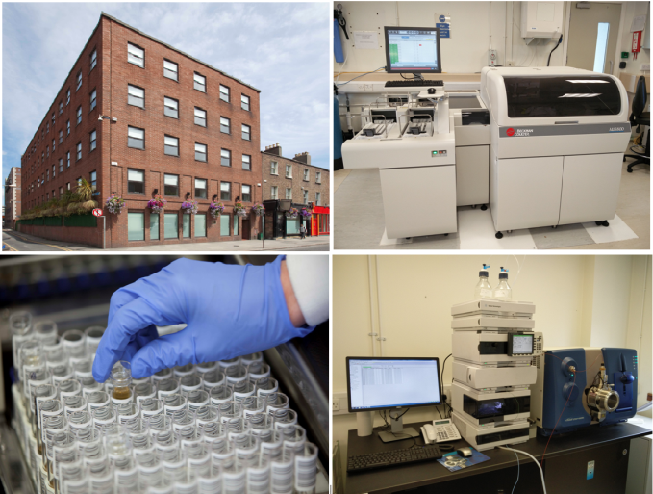

Copyright © HSE National Drug Treatment Centre Laboratory
This document shall not be reproduced, except in full, without the written approval of
The HSE National Drug Treatment Centre Laboratory

Table of Contents

1.0 GENERAL INFORMATION 4
1.1 Laboratory Address 4
1.2 Key Contact information 4
1.3 Laboratory Location 4
1.4 Laboratory Opening Hours 4
1.5 Customers 4
1.6 Customer Satisfaction, Comments and Complaints 5
2.0 REQUESTING LABORATORY TESTS 5
2.1 Consent 5
2.2 Sample labelling 5
2.3 Request forms 5
2.4 Verbal Requests 5
2.5 Use of email 6
2.6 Urgent Requests 6
3.0 SAMPLE COLLECTION 6
3.1 General Guidelines 6
3.2 Specific Guidelines 6
3.3 Compliant Sample Containers 7
3.4 Non-Compliant Samples 7
4.0 TRANSPORT OF SAMPLES TO THE LABORATORY 8
4.1 Internal customers 8
4.2 External customers 8
5.0 DRUG ANALYSIS 9
5.1 Integrity Testing 9
5.1.1 Creatinine Testing 9
5.1.2 pH Testing 9
5.1.3 Specific Gravity Testing 9
5.2 Routine Drug Screening 10
5.2.1 Amphetamines 10
5.2.2 Benzodiazepines 11
5.2.3 Cannabis 11
5.2.4 Cocaine 11
5.2.5 EDDP – Methadone metabolite 11
5.2.6 6-AMOR – Heroin metabolite 11
5.2.7 Pregabalin 12
5.2.8 Opiates 12
5.2.9 Alcohol 12
5.2.10 Ethyl Glucuronide 12
5.2.11 Buprenorphine 12
5.3 Non-routine drug screens, drug metabolite testing & other tests. 13
5.4 LC/MS Analysis 13
5.5 Drug detection windows 13
5.6 Result interpretation on screening assays 16
5.7 Accreditation 16
5.8 Subcontracted testing 16
5.9 Quality Control and Quality Assurance 17
5.10 Drug Substance Testing (Emerging Trends Laboratory) 17
6.0 STORAGE AND RETENTION OF SAMPLES 17
6.1 Storage prior to sending samples to the laboratory 17
6.2 Timeframe of sample retention in the laboratory 17
6.3 GDPR 17
6.4 Retention of Records 18
7.0 REPORTING OF RESULTS 18
7.1 Report Format 18
7.2 Mode of reporting 18
8.0 UNCERTAINTY OF MEASUREMENT 19
8.1 Urine Assay UoM Calculations 19
9.0 MEMBERSHIP & REPRESENTATION 20
APPENDICES 21
Appendix 1 - Urine Immunoassay Cross Reactivity Tables 21
Appendix 2 - Benzodiazepine Identifications (Benz ID) 23
Appendix 3 - Opioid Identifications (Opi ID) 25
Metabolism of Opioids 25
Appendix 4 - New Psychoactive substances (NPS) 26
Appendix 5 - NDTC Publications 27
Journal Articles 27
Poster Submissions 28
Appendix 6 - Sample labelling and packaging posters (printable) 30
Appendix 7- Substance Analysis Request Form 32

1.0 GENERAL INFORMATION

1.1 Laboratory Address

HSE National Drug Treatment Centre Laboratory
30-31 Pearse Street
Dublin 2
D02 NY26

1.2 Key Contact information

Contact | Name | Telephone Number
General Enquiries | Laboratory Office | 01 6488 645
NDTC Reception | Main switchboard | 01 6488 600
Email |  | Details
Laboratory email |  | laboratory.ndtc@hse.ie
Table 1: Contact details.

Please use email rather than phone, if possible, for queries. If you need to contact a member of staff, please call the laboratory office directly at 01 648 8645 and your call will be transferred to a staff member who will assist you with your query. Email queries from hse.ie and healthmail.ie email addresses are encrypted.

1.3 Laboratory Location

The laboratory is located on the third floor and can be accessed from the reception lobby via lift or stairs. Access to the ground floor lobby can be gained by pressing the intercom buzzer at the front door of the building (Pearse Street entrance). The laboratory sample reception area is accessed via the hatch adjacent to the laboratory door, on the third floor.

1.4 Laboratory Opening Hours

Monday - Friday 9:00 - 17:00
Saturday & Sunday CLOSED
Bank/Public Holidays CLOSED

1.5 Customers

The NDTC Laboratory provides a national drug analysis service to the HSE Addiction Services, General Practitioners, Hospitals (general, psychiatric and maternity), Juvenile Detention Centres, Voluntary Organisations, and the Dublin Drug Court Service. A customer database is in place and new clinics/centres can become registered as customers by contacting the laboratory to request a customer set-up form (AF21) Users must be registered before sending samples to the laboratory for testing. Users of the laboratory service should ensure that their contact details i.e., name, address, telephone number, email remain up to date. Any changes should be notified in writing, as soon as possible to the laboratory.

1.6 Customer Satisfaction, Comments and Complaints

The goal of the NDTC laboratory is to ensure that our users receive accurate, reliable, meaningful and timely laboratory results. If customers encounter any problems with the service, or have suggestions for service improvement, please contact the laboratory using any of the contact details above. The laboratory conducts annual customer satisfaction surveys; however, customers may be surveyed more frequently in response to the implementation of major laboratory changes, or identification of non-conformities or complaints. The investigation of complaints shall be carried out confidentially, reviewed, and approved by persons not involved in the subject of the complaint in question.

2.0 REQUESTING LABORATORY TESTS

2.1 Consent

The HSE NDTC laboratory does not take responsibility for obtaining “consent to test” for samples received for drug testing. The doctor or organisation requesting the test, prior to sending samples to the laboratory should obtain consent. If the client is under 18 years old, consent should be obtained from a parent or guardian. Written consent forms do not need to accompany samples.

2.2 Sample labelling

The criteria for sample acceptance, as described below, are strictly adhered to in order to comply with accreditation standards and in the interest of patient safety. Failure to provide the required data may lead to rejection of the sample. Laboratory personnel are acting correctly when they take action to ensure that the minimum standards set out in this policy are met at all times.

The following information is mandatory and must be included on each sample container;
- Patient’s full name (ideally put surname in CAPITALS)
- Date of Birth (DD/MM/YYYY format)
- Clinic or hospital name/code
- Date of sample collection (DD/MM/YYYY format)

In addition, the following information may be required on some samples;
- Name of Doctor
- DAIS Code (DAIS addiction clinics only)

2.3 Request forms

The NDTC laboratory strives to be a paper-free laboratory as much as possible, therefore request cards are not necessary for the majority of samples. If extra testing is required, the extra tests can be requested by writing the test name on the sample label (e.g., EtG, see the abbreviation list in table 3).

2.4 Verbal Requests

Additional tests or re-tests can be requested verbally by contacting the laboratory by email or by phone, see section 5.3. When requesting additional tests retrospectively, please be mindful of the relevant storage period for the sample, see section 6.1, as tests can only be added if the sample is still available in the laboratory and if there is sufficient sample left to carry out the extra tests. All telephone requests conversations will be logged by the laboratory staff during the process of adding the test/retest.

2.5 Use of email

Do not include patient details in emails to the laboratory unless you are using a hse.ie or a healthmail.ie email.

2.6 Urgent Requests

External samples: All maternity hospital samples are treated as urgent. If sending an urgent sample from another location, please telephone the laboratory with the specific details of the urgent sample.
In house samples: Please inform the laboratory that a sample is urgent by either by labelling it as STAT on the container lid, or by informing the laboratory staff in person/by phone.

3.0 SAMPLE COLLECTION

3.1 General Guidelines

The procedure for collecting these sample types is detailed in figure 2 below. Standard Health & Safety precautions and procedures should be followed when collecting biological samples.

It is the responsibility of the person collecting the sample to ensure that it is;
collected from the correct patient.
correctly labelled with sufficient information to allow analysis (see section 2.2).
correctly closed i.e., not leaking. Leaking samples will not be tested.
correctly packaged for delivery to the laboratory (see section 4 below).

3.2 Specific Guidelines

Please follow the guidelines below when collecting the various sample types. If further specific information is required, please contact the laboratory (see section 1.2).

Urine Collection Details

- Use clean plastic container without preservative (e.g., yellow lidded 70 mL urine pots as per figure 3)
- 20-30 mL urine where possible. Minimum volume: 3 mL
- Ensure the sample is correctly labelled and that the details match those of the patient

- Where temperature strip is used, temperature of freshly voided urine should be between 34-39° C
- Store the sample in a cool, dry dark place (preferably refrigerated) pending dispatch to the laboratory
- Sample should be dispatched to the laboratory as soon as possible
- Point of Care test devices are not suitable for laboratory testing and will not be tested.

It is essential that the container is properly closed, as leaking samples will not be tested due to potential sample to sample contamination, as well as posing a health & safety risk.

Figure 1: Urine sample collection procedure.

3.3 Compliant Sample Containers

Compliant Containers | Details | Tests
  Urine container  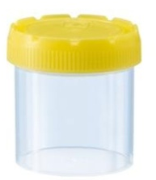 | Clean, non-preservative added container required. (Sterility not required).  Several container brands fulfil these criteria; however, the preferred container is displayed in the image (with a label attached).  Please ensure that the minimum 4 pieces of info is given on the sample label (see section 2.2).  NB: Ensure all sample lids are correctly closed - leaking samples will not be tested. | All routine and non-routine urine tests and LC/MS testing such as; Full drug screen, Opiate ID etc.  See section 5 for a full list.
Figure 2: Recommended container type.

3.4 Non-Compliant Samples

Non-compliant samples, such as those which do not give all the mandatory information required to unambiguously identify them, i.e., full name, date of birth, clinic location; or samples in unsuitable containers (e.g., Point of Care Testing devices) cannot be analysed. If the sample date is not provided, the ‘date received’ is used as the sample date and a non-compliance comment will be included on the report.

Non-Compliant Containers | Details | Tests
POCT container example  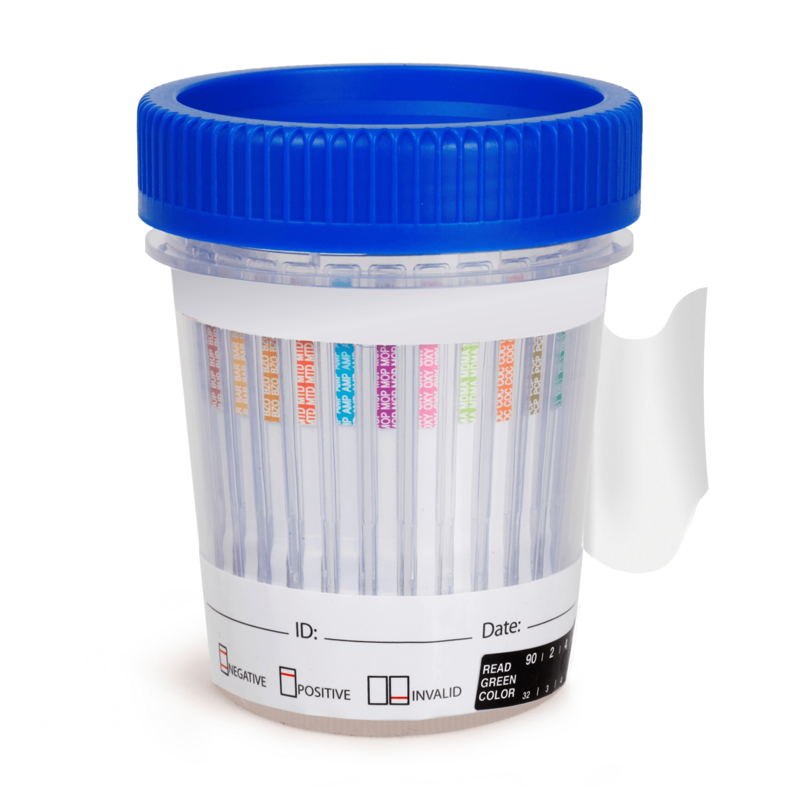 | There are many variations of POCT containers and all are deemed ‘non-compliant for analysis by the laboratory as they may affect the results of the analysis.  Pictured on the left is a generic version of these containers. If POCT testing is needed, first collect the sample in a non-POCT container (see Figure 3) and transfer the desired volume to the POCT container as required. | Please note that urine samples delivered in these containers are deemed unsuitable and will not be tested.
Figure 3: Non-Compliant Containers. POCT = ‘Point of Care Testing’

The laboratory will endeavour to obtain the correct sample identification in order to proceed with analysis, however if this is not possible the sample will be logged as non-compliant and will not be analysed. Leaking sample containers are also non-compliant and will not be analysed.

Notification of non-compliances will be sent to the customer by means of a comment on the report, detailing the nature of the non-compliance. Please read these non-compliance comments carefully and contact the laboratory if requested to do so.

4.0 TRANSPORT OF SAMPLES TO THE LABORATORY

The transport of human materials intended for diagnosis/investigation is regulated by ADR (Accord Dangereux Routier), a UN document which defines how such substances should be classified, packaged and transported. Biological diagnostic substances are classified as UN3373 and according to the guidelines, should be packaged and transported in line with Packaging Instruction P650.
Samples are sent to the laboratory from a variety of customers however they can be summarised as ‘Internal’ and ‘External’ customers. Irrespective of the source of the sample, it remains the responsibility of the sender to ensure the sample is correctly sealed and packaged to allow it to be transported safely and to arrive intact to the laboratory.

4.1 Internal customers

Samples can be delivered by hand, or via the pneumatic chute system. In both cases the sample must be checked to ensure the sample lid is securely closed and the sample is enclosed within an individual biohazard bag. This is particularly important when using the chute, as a leaking sample within a transport canister/pod can affect all other samples within the pod and this may lead to all samples being rejected for analysis if there is a possibility of cross-contamination amongst those samples.

4.2 External customers

If a diagnostic substance has been classified as belonging to UN3373, then it must be packed for transport according to the Packing Instruction 650 guidelines. This is a list of requirements covering the quality and construction of the packaging used for transport of liquid substances, which state:

- The primary receptacle(s) shall be leak proof
- The secondary packaging shall be leak proof
- If multiple fragile primary receptacles are placed in a single secondary packaging, they shall be either individually wrapped or separated to prevent contact between them
- Absorbent material shall be placed between the primary receptacle(s) and the secondary packaging. The absorbent material shall be in quantity sufficient to absorb the entire contents of the primary receptacle(s) so that any release of the liquid substance will not compromise the integrity of the cushioning material or of the outer packaging
- The primary receptacle or the secondary packaging shall be capable of withstanding, without leakage, an internal pressure of 95 kPa (0.95 bar)

Packaging which fulfils the above requirements can be purchased from a number of commercial providers and is marked with the symbol below in Figure 5. See also ‘HSE National Guidelines for the Preparation for Transport of Patient Specimens and other Biological Materials 2023’

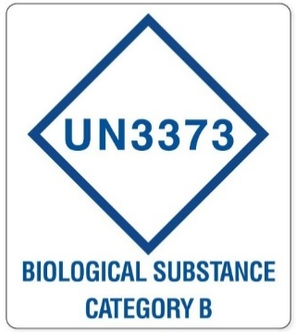
Figure 4: The UN3373 symbol.

5.0 DRUG ANALYSIS

The NDTC laboratory carries out analyses on urine for drug and drug metabolites using the following methodologies: Immunoassay, enzymatic assay, chemical analysis and LC-MS. Further details on the range of assays are given in tables 2, 3 and 4. It should be noted that all analytical results are subject to Uncertainty of Measurement (UoM), see section 8.

5.1 Integrity Testing

Integrity/Adulteration testing refers to tests carried out to determine whether a sample is genuine or if it may have been tampered with. In the NDTC laboratory three types of urine integrity testing may be performed; Creatinine (performed on all urine samples), pH and Specific Gravity testing (performed when appropriate).

5.1.1 Creatinine Testing

Creatinine in urine is tested by a chemical method. Creatinine is a normal constituent of urine. Its concentration in urine varies from day to day and is dependent on the patient’s hydration status. Most urine samples have a creatinine level in the ‘normal’ range; however, some samples may have a lower level of creatinine i.e., ‘dilute’ urine. This may reflect recent high intake of fluid, but it could also be caused by addition of fluid to the urine. Dilute urine is valid for drug testing but a comment indicating that the urine is dilute will accompany the report. If the level of creatinine falls below 2 mg/dl this urine is considered invalid for testing and is reported as ‘abnormal’. Table 2 details the creatinine levels in ‘normal’, ‘dilute’ and ‘abnormal’ urine.

Urine Status | Creatinine concentration | Comment on patient report
‘Normal’ | >20 mg/dL | No comment (as CREA level is within expected range)
‘Dilute’ | 2-20 mg/dL | ‘Sample is dilute - interpret results with caution’
‘Abnormal’ | <2 mg/dL | ‘Abnormal urine - Creatinine level is too low to qualify as urine’
Table 2: Creatinine (CREA) levels in urine.
Please note that the above creatinine ranges are adult ranges. We do not use paediatric creatinine ranges when testing neonatal samples – therefore neonatal urine samples are often classed as ‘Dilute’ by our I.T. system, due to the naturally low creatinine levels in neonates.

5.1.2 pH Testing

pH is measured on a scale of 0 to 14. It is a measure of how acidic or alkaline a liquid is, with more acidic solutions having a lower pH (<7) and more alkaline solutions having a higher pH (>7). Neutral solutions have a pH of 7. The NDTC laboratory defines a urinary pH level of 3 to 11 as ‘normal’. pH readings outside this range may indicate tampering of a sample by the addition of, or substitution by, another substance or liquid. When pH values outside the laboratory’s normal range are detected in a patient’s sample, no toxicology results will be reported, and notification of the failed pH test will be given.

5.1.3 Specific Gravity Testing

Urinary specific gravity (SG) is a measure of the concentration of solutes in the urine and compares the urine’s density to water. SG testing is carried out when appropriate, using a ‘normal’ range of 1.005 - 1.030.

5.2 Routine Drug Screening

All samples are routinely tested by immunoassay screening tests, producing a qualitative result (i.e., reported as ‘positive’ or ‘negative’) or in the case of alcohol, a quantitative result.
Qualitative immunoassays yield results which indicate only the presence or absence of a drug/drug class in a sample, based on a defined cut-off level. If a test result falls below the cut-off level, the result is deemed negative indicating that the drug/drug class was not detected above the cut-off, and positive if it was detected above the cut-off.
Cut-off levels are detailed on Page 1 of every test report. The Alcohol assay provides a quantitative result if alcohol is present above the cut-off value, and a qualitative negative result if below the cut-off.

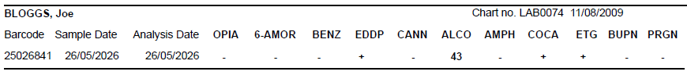
Figure 5: Routine screen assay display example.

Drug/Drug Metabolite | Test Name | Assay Type
Amphetamine (class) | AMPH | Immunoassay, Qualitative
Benzodiazepine (class) | BENZ | Immunoassay, Qualitative
Cannabis | CANN | Immunoassay, Qualitative
Cocaine | COCA | Immunoassay, Qualitative
EDDP (Methadone metabolite) | EDDP | Immunoassay, Qualitative
6 Acetyl Morphine (Heroin metabolite) | 6-AMOR | Immunoassay, Qualitative
*Pregabalin | PRGN | Immunoassay, Qualitative
Opiate (class) | OPIA | Immunoassay, Qualitative
Alcohol | ALCO | Chemical, Quantitative
Table 3: Routine assay types, and abbreviations. Pregabalin* is currently only carried out on first sample from each patient - contact the lab for extended testing.

Amphetamines

Amphetamines, amphetamine derivatives and ecstasy drugs are classified as sympathomimetic amines with CNS stimulant activity. They are psychologically and physiologically addicting, their effects include excitement, alertness, euphoria, decreased appetite, and reduced sense of fatigue. Side effects at low doses include irritability, anxiety, insomnia, blurred vision, increased blood pressure, and heart palpitations. Chronic, high dose users may develop a psychosis that can be indistinguishable from acute schizophrenia. Amphetamines are rapidly absorbed from the gastrointestinal tract and widely distributed throughout the body. Approximately 70% of a dose is eliminated in urine in the first 24 hours after administration, and depending on urinary pH, about 30% of the dose is excreted unchanged and the remainder as metabolites. Approximately 62% of a methamphetamine dose is eliminated in urine in the first 24 hours after administration, with about 43% of the dose excreted unchanged and the remainder as metabolites, including amphetamine. Amphetamines may remain detectable in urine for 3-4 days after administration. MDMA (3,4-methylenedioxymethamphetamine) is known to be metabolised to methylenedioxyamphetamine (MDA).

Benzodiazepines

Benzodiazepines belong to a broad classification of CNS-depressant drugs known as sedatives/ hypnotics. They are prescribed as anxiolytics, sleeping agents, anticonvulsants, muscle relaxers, and widely used for pre-anaesthetic medication and to supplement, induce, and maintain anaesthesia. Although widely prescribed, benzodiazepines are also abused. Chronic benzodiazepine use can cause physical dependence, with withdrawal symptoms of insomnia, agitation, irritability, muscle tension, and, in more severe cases, hallucinations, psychosis, and seizures.

Cannabis

Marijuana and hashish come from the hemp plant Cannabis sativa, which grows throughout the world. These drugs contain at least 61 cannabinoids (a class of chemicals unique to the cannabis plant), of which ∆9 -tetrahydrocannabinol (THC) is the primary psychoactive compound. THC acts as a mild sedative-hypnotic that may produce euphoria, heightened sensations, and, in higher doses, even hallucinations. THC is highly fat soluble and therefore readily stored in fatty tissues, where it may remain in the body for several days or even weeks. It is rapidly transformed by liver enzymes to over 24 metabolites, the primary one being 11-nor-∆9 -tetrahydrocannabinol-9-carboxylic acid, or THC Acid. This is an inactive metabolite. Approximately 70% of a THC dose is excreted in faeces and urine within 72 hours of administration. The concentrations of THC metabolites in urine are influenced by several factors: the frequency of prior use, the timing of urine specimen collection in relation to the last exposure to THC, and the rate of release of stored cannabinoids from fatty tissues. Heavy chronic THC users who stop using the drug may test positive for a month or more.

Cocaine

Cocaine (benzoylmethylecgonine), is derived from the plant species Erythroxylon coca, which is widely grown in South America. Cocaine is a very common illicit drug and is popularly abused. Cocaine abuse can produce euphoria, arousal, garrulousness, alertness, anxiety, insomnia, hyperactivity, paranoia, severe psychosis, and even suicide. Cocaine is rapidly metabolised, with less than 5% excreted unchanged in the urine. The two major metabolites are benzoylecgonine and ecgonine methyl ester. The metabolites may be detectable in urine for up to 3 weeks after long term, heavy use of cocaine.

EDDP – Methadone metabolite

EDDP is the primary metabolite of methadone. Methadone is a synthetic opiate agonist that is often used in detoxification programs as an oral substitute for heroin or other morphine-like drugs to suppress withdrawal symptoms and/or to maintain chronic relapsing heroin addicts. Measurement of EDDP instead of methadone for compliance can detect those individuals on the compliance program selling their methadone into the illicit drug market and spike their urine with a small quantity of methadone to cover their diversion. Their urine may test positive for methadone but not for EDDP, since the drug was not ingested and therefore not metabolised.

6-AMOR – Heroin metabolite

Heroin (3,6-diacetylmorphine) is produced by chemical modification of morphine, a naturally occurring alkaloid found in the unripe pods of the opium poppy Papaver somniferum. Heroin is the most abused opiate drug and its use is associated with a wide variety of health problems. Heroin is administered by intravenous or subcutaneous injection or by nasal insufflation. It is rapidly metabolized (half-life of 9 minutes) to 6-Acetylmorphine, or 6-AM in the blood, and then to morphine in the liver. The presence of 6-AMOR in urine is regarded as a specific marker for the illicit use of heroin. It is likely that even for higher doses of heroin the detection time is limited to 24 hours after use. 6-AMOR cannot be formed by acetylation of morphine in the body; thus, the presence of 6-AMOR cannot be caused by injection of legal opiate analgesics or large quantities of poppy seeds.

Pregabalin

In Europe, pregabalin is approved for the treatment of epilepsy (partial seizures), neuropathic pain and generalized anxiety disorder. Pregabalin is not metabolised in the body to a significant degree but is almost exclusively excreted unchanged in the urine by glomerular filtration. In the European Union, pregabalin is subjected to special or restricted prescription and a warning related to its abuse potential. The ARK Pregabalin II Assay tests for pregabalin in human urine and gives a positive result if this drug is present at concentrations equal to or greater than the cut-off.

Opiates

Opium is obtained from the unripe pods of the opium poppy Papaver somniferum. Morphine and codeine are naturally occurring alkaloids of opium. Both have widely accepted medical uses, principally as analgesics; however, both drugs are sometimes abused. Heroin is a compound synthesized from morphine and is the most commonly abused opiate. Opiates (morphine, codeine and heroin) are rapidly metabolized by the body, and the main site of metabolism is the liver. Morphine is excreted in urine as conjugated morphine, free morphine and other trace metabolites. Codeine is excreted in urine as free and conjugated codeine and free and conjugated morphine. After codeine administration, total codeine may be eliminated faster than total morphine so that some urine specimens of codeine users may show only the presence of total morphine or a ratio of total morphine to total codeine of greater than one. Heroin is rapidly metabolized in whole blood to 6-acetylmorphine, which is then hydrolysed to conjugated morphine in the liver. It is excreted in urine principally as conjugated morphine, but also in small amounts as free morphine and 6-acetylmorphine. Depending on the dose and the sensitivity of the analytical method, total morphine may be detected in urine up to 72 hours after last administration of morphine, codeine, or heroin.

Alcohol

In addition to beverages, ethyl alcohol (ethanol or alcohol) can also be found in high concentrations in a variety of products such as mouthwashes, colognes, candies and medicinal preparations. When alcohol is ingested, it will permeate all tissues of the body within one hour. About 95% of the alcohol is metabolised in the liver, and the remainder is excreted unchanged. Alcohol intoxication can lead to birth defects (e.g., foetal alcohol syndrome), loss of alertness, stupor, coma and death. Determination of ethyl alcohol concentration is commonly used for measuring legal impairment, investigating forensic evidence, diagnosing and/or treating alcohol dependency, as well as detecting alcohol poisoning.

Glucose

Fermentation is the process by which yeast and certain bacteria convert sugars to ethanol, carbon dioxide, and other metabolic by-products. If a collected urine sample contains Glucose (due to poorly controlled diabetes, for example) and is stored at room temperature for more than 12 hours, yeast may convert that urinary Glucose into ethanol, which can be further converted into EtG. Due to this possibility, urines showing high Alcohol values are tested for Glucose and the result (+/-) will be reported on a separate ‘barcode’ report.

Ethyl Glucuronide

Ethyl Glucuronide (EtG) is a direct metabolite of ethanol, which is formed by enzymatic conjugation of ethanol with glucuronic acid. Alcohol in urine is normally detected for only a few hours, whereas EtG can be detected up to several days even after complete elimination of alcohol from the body.

Buprenorphine

Buprenorphine is a synthetic thebaine derivative that has been used for analgesia and as an opiate antagonist. As an analgesic, buprenorphine has approximately 25 - 40 times the potency of morphine. Overdose symptoms of the drug include confusion, dizziness, pinpoint pupils, hallucinations, hypotension, respiratory difficulty, seizures and coma. Buprenorphine is predominantly metabolised to form norbuprenorphine and conjugates of buprenorphine and norbuprenorphine.

Non-routine drug screens, drug metabolite testing & other tests.

Most samples received for drug testing are tested only for the routine drug screen detailed in section 5.2. If required, samples may be further tested for the non-routine tests described in table 4 below. Non-routine drug screening tests are carried out by request only (e.g., by writing test abbreviation on the label).

Drug/Drug Metabolite/Analyte | Assay Type | Test Short Name
Ethyl Glucuronide | Immunoassay | EtG
Suboxone/Buprenorphine | Immunoassay | BUPN
Pregabalin | Immunoassay | AP or Pregab
Opioid Identification | LC-MS | OPIA ID
Tramadol | LC-MS | TRAM (part of the OPIA ID)
New psychoactive substances/Headshop drugs | LC-MS | HEAD or NPS
Oxycodone | LC-MS | OXY (part of the OPIA ID)
Benzodiazepine Identification | LC-MS | BENZ ID
Fentanyl | LC-MS | FENT (part of the OPIA ID)
pH | Chemical assay | pH
Glucose | Point of Care Test | Gluc
hcG (Pregnancy test) | Point of Care Test | Pregnancy
Table 4: List of non-routine tests available on request, and their abbreviations.

LC/MS Analysis

High performance liquid chromatography (HPLC) facilitates the rapid separation of compounds from each other and from the other constituents of complex mixtures or matrices. Mass spectrometry (MS) has the capability to separate organic molecules according to their molecular mass and permits their detection with extremely high sensitivity. Used in tandem, the two techniques, referred to as LC/MS, provide a unique capability for sensitive, selective measurement of molecules such as drugs, and can be used to confirm positive results from immunoassay screening. Additionally, there are some drugs which are only analysed using this technique; e.g., Tramadol, New Psychoactive Substances, Oxycodone, Fentanyl, etc

The categories of confirmatory tests available (with their common abbreviation) are summarised below;

- Opioid Identification (OPIA ID)
- Benzodiazepine Identification (BENZ ID)
- New Psychoactive substances (NPS/HEAD)

LC/MS analysis should be requested when unambiguous identification of the drug present is required or if the drug can only be identified by LC/MS. Please contact the laboratory with any LC/MS queries.

Drug detection windows

After ingestion, drugs are distributed throughout the body and appear in various body tissues in a time dependent manner. The time period which the drug can be reliably detected in any test matrix is called the ‘window of detection’. The window of detection of a drug is a function of a combination of many factors including the drug’s tendency to be distributed, the matrix/sample type (blood, urine etc), the metabolic pathway of the drug and the individual’s response to the drug. Table 5 gives a general indication of detection times in common test matrices. More specific individual drug information is given in table 6. Urine is the most commonly used specimen due to its ease of collection and long window of detection (drugs can be detected for a number of days, and in some cases, weeks, after last use). It is the universally preferred sample to screen for the presence/absence of drugs. Urine is unsuitable for determining drug levels, due to the many factors which affect the composition and concentration of urine.

Sample type/matrix | Detection time range  (Window of detection) | Drug use detected
Blood | 0-48 hours | Acute, under the influence
Urine | Days – weeks | Recent
Table 5: Drug detection windows in biological matrices.

Test Type | Method | Test | Window of Detection | Turnaround Times | Accreditation
Routine Screen | Immuno-assay | Opiate class | 2-4 days¹ | <48 hours | *Pending
Routine Screen | Immuno-assay | Benzodiazepine class | 3-30 days¹ | <48 hours | *Pending
Routine Screen | Immuno-assay | EDDP | Unknown | <48 hours | *Pending
Routine Screen | Immuno-assay | Cannabis class | 1-30 days¹ | <48 hours | *Pending
Routine Screen | Immuno-assay | Cocaine | 2-4 days¹ | <48 hours | *Pending
Routine Screen | Immuno-assay | Amphetamine class | 1-2 days¹ | <48 hours | *Pending
Routine Screen | Immuno-assay | 6-AMOR | 24 hours² | <48 hours | *Pending
Routine Screen | Immuno-assay | Pregabalin | Up to 6 days⁵ | <48 hours | *Pending
Routine Screen | Enzymatic | Alcohol | 7-12 hours¹ | <48 hours | *Pending
Routine Screen | Chemical | Creatinine | n/a | <48 hours | *Pending
Non-Routine | Enzymatic | Pregnancy (POCT) | n/a | <48 hours | No
Non-Routine | Chemical | pH | n/a | <48 hours | *Pending
Non-Routine | Chemical | Glucose (POCT) | n/a | <48 hours | No
Non-Routine | Immuno-assay | EtG: Alcohol marker | Up to 48 hours³ | <48 hours | *Pending
Non-Routine | Immuno-assay | Buprenorphine | 4-24 hours⁴ | <48 hours | *Pending
LC-MS | LC-MS | Opioid Identification | Variable | <10 days | No**
LC-MS | LC-MS | New psychoactive substances (incl. Cocaine & amphetamine-type drugs, but not synthetic cannabinoids) | Variable/unknown | <10 days | No**
LC-MS | LC-MS | Benzodiazepine Identification | Variable | <10 days | No**
Table 6: References: (1) Moeller, KE. Lee, KC. Kissack, JC. Urine Drug Screening: Practical Guidelines for Clinician Mayo Clin Proc. 2008 83(1):66-76 (2) Cedia Package Insert: CDTM Heroin Metabolite (6AM) Assay:10025100-1-EN 2019-01. (3) Hadland, SE. & Levy S. Objective testing - Urine & other drug tests. Child Adolesc Psychiat Clin N Am 2016 25(3) 549- 565. (4) Kronstrand R., Nyström, I., Andersson, M., Gunnarsson, L., Hägg, S., Josefsson M., Ahlner, J., Journal of Analytical Toxicology, Vol. 32, October 2008 (5) Spigset O, & Westin, AA. Detection times of pregabalin in urine after illicit use: when should a positive specimen be considered a new intake? Ther Drug Monitoring 2013 Feb; 35(1) 137-40. Please note: Turnaround time is measured from time of receipt of sample at the laboratory and is measured in working days. See Section 5.6 for more detail on Accreditation. * Pending – the laboratory is in the process of preparing for ISO 15189 accreditation assessment. **The current LC-MS testing will soon be replaced with a CE marked LC-MS assay which will incorporate all the above LC-MS tests and others not listed here. Abbreviations, LC-MS: Liquid Chromatography Mass Spectrometry, POCT: Point of Care Testing.

5.6 Result interpretation on screening assays

‘True and ‘False’ Positives

A positive result indicates that there is a detectable level of drug in the patient’s urine that is above the established cut-off for the assay. Appendix 1 details the compounds detected by the screening assays.

Care should be taken when interpreting immunoassay screening results. The assays for opiates, amphetamines and benzodiazepines are class assays i.e., there is more than one type of each drug in that class detectable whereas the assays for cannabis, cocaine, 6-AM and EDDP are highly specific for one drug or drug metabolite. Some commonly used medications can cause positive results on the opiate or amphetamine assay e.g., Solpadeine® (contains the opiate codeine) will cause a positive opiate result and lisdexamfetamine (an ADHD medication) gives an Amphetamine positive result.

Some drugs and medications can also produce ‘false’ positive results when tested using immunoassay, due to cross-reactivity with a similar compound in the patient urine e.g., over-the-counter decongestant medications can cause a false positive result on the amphetamine assay due to the presence of pseudoephedrine. Due to the possibility of cross-reactivity, screening results by immunoassay alone are not legally defensible and must be treated as ‘presumptive’ positives. Further testing of the sample can be requested in most cases, if requested within two weeks of the initial analysis. If you have any queries about a positive result, or if the result is unexpected, please contact the laboratory before acting on the result.

‘True’ and ‘False’ Negatives

‘True Negative’ results occur when the drug of interest is either not present in the sample or is present at levels lower than the assay’s cut-off level.

‘False Negative’ results can occur due to a range of factors including; limited assay sensitivity, sample adulteration and error.
If you have any queries about a negative result, or any unexpected result, please contact the laboratory.

Accreditation

Accreditation is the formal recognition of a body’s competence to conduct a specific activity such as testing, inspection or certification. This recognition is based on compliance with international and European standards. Compliance with these standards requires organisations to demonstrate competence, impartiality and integrity (www.inab.ie). Accreditation is provided by the national accreditation body for each Member State; in Ireland this is the Irish National Accreditation Board (INAB).
The NDTC laboratory was previously accredited to ISO/IEC 17025:2017 however we voluntarily withdrew accreditation recently to free up resources to prepare for ISO 15189:2022, which we aim to attain in 2027.

Subcontracted testing
4

When a request is received from a customer for a test which is not performed in NDTC, the laboratory may, as a service to the customer, subcontract the testing. In this instance, the laboratory will endeavour to subcontract the testing request to a competent external laboratory which complies with ISO 15189:2022 or equivalent. Once accredited, the NDTC will not subcontract tests within its own scope of accreditation.

Quality Control and Quality Assurance

To ensure the highest confidence in test results, the laboratory adheres to strict quality control (QC) and quality assurance (QA) standards. In order to achieve this, approx. 3% of all samples run are QC samples.

In order to assess performance of all our tests, the laboratory is currently involved in two external Quality Assurance schemes: LGC - Drugs of abuse in urine scheme (DU) and LGC - Ethanol in urine scheme (TX). Viewing of QC data, EQA data, and/or testing procedures will be accommodated on request by arrangement with the laboratory.

Drug Substance Testing (Emerging Trends Laboratory)

The HSE Emerging Drug Trend Laboratory provides analytical support for harm reduction by examining drug substances and related materials to identify their chemical composition, potency, and potential risks. Using FTIR and GC/MS, the laboratory analyses samples submitted through surveillance and drug-checking pathways to detect active compounds, adulterants, and novel psychoactive substances. Results are interpreted within a public health framework, with a focus on timely identification of emerging trends, unusual contaminants, and substances associated with increased risk of harm. The laboratory’s findings inform early warning systems, clinical guidance, and targeted harm reduction messaging, supporting evidence-based responses to changes in the illicit drug market.

Drug substances can be submitted to the laboratory for testing for harm reduction purposes. A completed form ‘CT24’ should be submitted with each substance tested (see appendix 7).

The laboratory is contactable at emergingtrendslab@hse.ie

6.0 STORAGE AND RETENTION OF SAMPLES

6.1 Storage prior to sending samples to the laboratory

Samples should be sent to the laboratory at the earliest opportunity. If there is any delay, it is recommended that samples are stored in a refrigerator at 4º C, or if refrigeration is not available, in a cool dark place.

6.2 Timeframe of sample retention in the laboratory

Post routine immunoassay analysis, the laboratory will retain samples for 14 days in refrigerated conditions, after which they will be safely disposed of, unless further testing is also part of the original request. Upon completion of the further testing, the sample will be held for a further 14 days, after which it will be disposed. If add-on tests are required (either routine or LC-MS), it is very important that requests are made as soon as possible within the 14-day period, as requests after this are unlikely to be accommodated.

6.3 GDPR

As a part of the HSE, the NDTC laboratory must comply with the Data Protection Acts 1988-2018 and the General Data Protection Regulations (GDPR). We endeavour to protect the patient’s right to privacy in all our activities. To maintain this privacy and to protect personal information, laboratory staff follow strict guidelines and procedures when accepting, logging, processing and reporting of patient samples to ensure the correct patient receives the correct result. The laboratory requests only the minimum amount of information on each patient sample in order to meet our log-in requirements (see sections 2.2 and 3.4 above) and we ask that request cards and other extra information/notes are not sent with the patient sample (see section 2.3). Any GDPR breaches in relation to laboratory activities are reported to, and investigated by, the local HSE DPO.

6.4 Retention of Records

We will only retain patient information and laboratory records based on the current HSE Record Retention Periods Policy. At time of writing, the current version is version 4, published 2025, viewable at; https://www2.healthservice.hse.ie/files/275/

7.0 REPORTING OF RESULTS

Samples are logged, analysed and reported in order of receipt, with the exception of STAT (urgent) samples, which are prioritised.

7.1 Report Format

The front page, Page 1, of each report details the customer’s name and address, the date on which each report is generated and the scope of INAB accreditation, if applicable. Page 1 also includes useful information with regards to uncertainty of measurement, abbreviations used, integrity tests etc.

Page 2 (and onwards) contain the toxicology results for each patient. Each patient is identified by name, date of birth, clinic code and chart number.

Each individual sample is identified by a unique barcode (8 digits, starting with the year e.g., 26123456) and sample date.

If a drug/drug class is detected in a sample, the result will appear as a "+" (positive), indicating the presence of the drug. The only exception to this is Alcohol, which is reported numerically if >30 mg/dL. When no drug/drug class has been detected, it will be reported as a "-" (negative), indicating that the drug/drug class has not been detected above the cut-off concentration. A blank space indicates that no test was carried out.

Screening results will usually be available within 24-48 hours of receipt of samples in the laboratory. LCMS testing usually takes longer to perform due to the complexity of the methodology, up to 10 days.

Each report contains a unique ID number in the footer section of the page – please quote this ID number, e.g., 25/08/2025-075(1) if querying a particular report with the laboratory.

7.2 Mode of reporting

The method of report transmission used must be agreed in advance with the laboratory. The main methods of reporting are via email, electronic systems and post. All HSE customers are encouraged to use electronic reporting i.e., either via HSE email or the LER (see below).

Electronic Reporting

- LER (Laboratory Electronic Reporting): This is a web-based system which allows HSE account holders to access patient results electronically, immediately after result release by the laboratory.
DAIS (Drugs Aids Information System): HSE Addiction Services access laboratory results via DAIS.
HSE email: reports can be emailed securely between HSE email addresses.
Healthmail: is a secure clinical email that allows healthcare providers to send and receive clinical information in a secure manner. Users are issued with @healthmail.ie email accounts which allows them to communicate patient identifiable information with clinicians in primary and secondary care. Contact Healthmail Registration Portal - Register Support Staff for registration

Paper Based reporting

POST: Reports sent by post will be dispatched as soon as possible after completion of analysis.

Verbal reporting

- Verbal reporting can only be accommodated in urgent cases, to a known contact.

8.0 UNCERTAINTY OF MEASUREMENT

When interpreting laboratory reports, consideration should always be given to the Uncertainty of Measurement (UoM) associated with the test result, because no measurement is absolutely exact. When a quantity is measured, the outcome depends on the measuring system, e.g., test procedure, environmental conditions, volumetric effects, reference values, sampling matrix, operator etc. therefore all measurements are subject to uncertainty and this should be taken into account in the interpretation of laboratory results. This can have a bearing on immunoassay test results which are close to their cut-off point and therefore within the range of measurement uncertainty for the test cut-off.

Clinical consideration and judgment should be applied to any immunoassay test result. Repeat testing or confirmatory analysis may be requested if required. The tests reported are qualitative with the exception of Alcohol which is quantitative when present above the cut-off (30 mg/dL).

8.1 Urine Assay UoM Calculations

The UoM figures for each test are given below in table 7.

UoM Values

OPIATE^{(A)} | ± 15.6% | ALCO^{(A)} | ± 9.5%
6-AMOR^{(A)} | ± 18.0% | ETG^{(A)} | ± 23.1%
BENZ^{(A)} | ± 12.1% | BUPN^{(A)} | ± 37.3%
EDDP^{(A)} | ± 11.4% | pH^{(A)} | ± 2.1%
CANN^{(A)} | ± 19.5% | Pregabalin^{(A)} | ± 16.1%
AMPH^{(A)} | ± 15.1% | CREA^{(B)} | ± 34.6%
COCA^{(A)} | ± 10.6%
Table 7: Uncertainty of Measurement values.
(A) calculated from 12 months QC data, Nov 2022 – Nov 2023.
(B) based on low CREA QC data (Nov 2022 - Nov 2023), at value closest to decision point.

9.0 MEMBERSHIP & REPRESENTATION

To ensure best practice, to maintain continuous professional development (CPD) and to keep up to date with the latest developments and trends in drug misuse, laboratory staff hold professional membership and attend meeting of various international societies.
These societies are listed in table 8.

Laboratory staff memberships include:
ACBI | Association of Clinical Biochemists of Ireland
EFLM | European Federation of Clinical Chemistry and Laboratory Medicine
TIAFT | The International Association of Forensic Toxicologists
UKIAFT | UK and Ireland Association of Forensic Toxicologists
ACSLM | Academy of Clinical Science and Laboratory Medicine
SOFT | Society of Forensic Toxicologists
IMSS | Irish Mass Spectrometry Society
Table 8: Laboratory professional/society memberships.
Membership and contribution to Early Warning Emerging Trends (EWET) Committee in Department of Health set up to fulfil the requirements of Regulation (EC) No 1920/2006 (as amended) and Council Framework Decision 2004/757/JHA (as amended) with respect to information exchange and the early warning system, as well as for the initial report, risk assessment, and control measures. (European Union Early Warning System on new psychoactive substances). Membership and contribution to the Working Group was set up by HSE under action 1.3.11 of the National Drug Strategy 2017-2025.

The NDTC laboratory is a member of the European Union Drugs Agency (EUDA) Network of forensic and toxicological laboratories (Network of labs). It is one of three laboratories in Ireland that is a member of this network including the State Laboratory and Forensic Science Ireland. The main objectives of the network are to improve how to:
  - Gather accurate, real-time data on drug trends
  - Detect new and/or dangerous substances
  - Share knowledge and best practices between countries and promote the implementation of quality assurance schemes.
  - Support rapid responses to drug related health threats
  - Support the adoption of innovative approaches to forensic and toxicological research, as well as precursor and drug profiling
  - Support the work of the EU Early Warning System (EWS) on new psychoactive substances, NPS, the European Drug Alert System, the European Threat Assessment System, and other data collection programmes, for example, wastewater analysis, syringe analysis, drug related hospital emergencies, and drug checking services.

APPENDICES

Appendix 1 - Urine Immunoassay Cross Reactivity Tables

CEDIA® Amphetamine/Ecstasy Assay (cut-off 1000 ng/ml)
Amphetamine  Methamphetamine | N-Methylbenzodioxazolylbutanamine (MBDB)  3,4-Methylenedioxyamphetamine (MDA) | 3,4 Methylenedioxyethylamphetamine (MDEA)  3,4 Methylenedioxymethamphetamine (MDMA)
CEDIA® Opiate Class (cut-off 300 ng/ml)
6-Monoacetylmorphine  Diacetylmorphine  Hydrocodone  Hydromorphone  Morphine | Morphine Sulphate  Nalorphine HCl  Naloxone |  |  | Naltrexone HCl  Oxycodone  Oxymorphone  Pholcodine  Thebaine
CEDIA® Benzodiazepine Class (cut-off 300 ng/ml)
Alprazolam  Bromazepam  Chlordiazepoxide  Citalopram  Clobazam  Clonazepam  Delorazepam  Demoxepam | Diazepam  Estazolam  Flunitrazepam  Flurazepam  Halazepam  Lormetazepam  Medazepam  Midazolam |  |  |  | Nimetazepam  Nitrazepam  Nordiazepam  Oxazepam  Prazepam  Temazepam  Tetrazepam  Triazolam
CEDIA® 6-Acetylmorphine (cut-off 10 ng/ml)
6-Acetylmorphine
CEDIA® Cannabis (cut-off 50 ng/ml)
11-Nor-9-carboxy-Δ⁹-tetrahydrocannabinol  11-nor- Δ⁸-THC-COOH  Δ 9-THC (Dronabinol) | 11-OH- Δ⁹-THC  1- Δ⁹-THC-Glucuronide  8β-OH-Δ⁹ THC  Efavirenz (Sustiva) |  |  |  | 8β,11-di-OH- Δ⁹ -THC  Cannabinol  5-Methyl-7-Methoxy-Isoflavone  Silymarin
CEDIA® Cocaine (cut-off 300 ng/ml)
Benzoylecgonine | Cocaine |  | Cocaethylene
DRI® Ethyl Alcohol (cut-off 30 mg/dl)
Ethanol
CEDIA® EDDP (cut-off 100 ng/ml)
2-Ethylidene-1,5-dimethyl-3,3-diphenylpyrrolidine (EDDP)
DRI® Ethyl glucuronide (cut-off 500 ng/ml)
Ethyl Glucuronide
Table 9: Drugs producing positive results in each assay. Ref: Thermofisher Scientific CEDIA Drugs of abuse I.F.U. documentation.

Immunalysis® Buprenorphine URINE HEIA™ (cut-off 5 ng/ml)
Buprenorphine
Norbuprenorphine

Table 10: Drugs producing positive results on Immunalysis assays. Ref: Immunalysis I.F.U. documentation. (Version: KI-336UR-IMM vAH 11/21).

ARK® Pregabalin (cut-off 500 ng/ml)
Pregabalin

Table 11: Drugs producing positive results on ARK assays. Ref: ARK Pregabalin I.F.U. documentation (version Revised November 2023 1600-0909-00 Rev 02).

NB: Lists are not exhaustive; please contact the laboratory if further testing is required.

We have found that CEDIA® Amphetamine/Ecstasy assay may cross-react with other compounds particularly new psychoactive substances (aka NPS, ‘Headshop’ Drugs/Bath Salts/Legal Highs). If you have any queries regarding an Amphetamine positive result, please contact the laboratory.

Appendix 2 - Benzodiazepine Identifications (Benz ID)

Routine immunoassay screening method for benzodiazepines is unable to distinguish between the various benzodiazepines and their metabolites; therefore, urinary benzodiazepine identifications are carried out when required using LC/MS in order to specifically determine the drug or metabolite present (see Figure 16 below).

Benzodiazepines can be short-acting or long acting and depending on the drug taken they can persist for an extended time in the urine of habitual users, even after use has ceased. A further consideration is that the metabolic pathways of benzodiazepines can often result in common metabolites (the most significant being Oxazepam), meaning that in many cases it may not be possible to unambiguously determine the parent drug.

Many factors such as how much fluid has been consumed prior to giving the sample, the time since the drug was taken, the physical condition and metabolism of the patient etc. may influence the dilution of a urine sample and therefore the drug level present. Therefore, drug levels in urine may be subject to large fluctuations. If urine is dilute, drug levels will be lowered, therefore urinary levels of benzodiazepines are not performed in the NDTC Laboratory.

Benzodiazepine | Trade name | Metabolites
Flurazepam | Dalmane, Dalmapam | 2-hydroxyethylflurazepam
Flunitrazepam | Rohypnol | 7-aminoflunitrazepam, nifoxipam
Alprazolam | Xanax, Gerax | α-hydroxyalprazolam
Chlordiazepoxide | Librium | demoxepam, nordiazepam, oxazepam
Clobazam | Frisium | desmethylclobazam
Lorazepam | Ativan | Lorazepam
Midazolam | Buccolam | α-hydroxymidazolam
Prazepam | Centrax | oxazepam
Triazolam | Halcion | α-hydroxytrazolam
Temazepam | Insomniger, Nortem | oxazepam
Diazepam | Valium, Anxicalm | oxazepam, temazepam,  nordiazepam
Bromazepam | Lexotan | 3-hydroxybromazepam
Clonazepam | Rivotril | 7-aminodonazepam
Oxazepam | Serax | oxazepam
Nitrazepam | Mogadon | 7-acetamidonitrazepam, 7-aminonitrazepam
Lormetazepam | Noctamid | Lorazepam
Estazolam |  | 3-hydroxyestazolam
Etizolam |  | α-hydroxyetizolam
Phenazepam |  | 3-hydroxyphenazepam
Deschloroetizolam |  | 9-OH-methyl-,2OH-ethyl,6-OH-deschloroetizolam
Didazepam |  | delorazepam, lorazepam, lometazepam
Flubromazepam |  | hydroxy-flubromazepam
Pyrazolam |  | Pyrazolam
Clonazolam |  | 7-aminodonazolam
Flunitrazolam |  | 7-acetamidoflunitrazolam, 7-aminoflunitrazolam
Benzodiazepine | Trade name | Metabolites
Flubromazolam |  | Flubromazolam
Nifoxipam |  | 3-OH-7-aminodesmethylflunitrazepam, 3-OH-7-acetamidoflunitrazepam
Flualprazolam |  | Unknown
Ketazolam | Anxon | norketazolam, diazepam, nordiazepam, oxazepam
Adinazolam | Deracyn | N-desmethyladinazolam, α-hydroxalprazolam, estazolam
Halazepam | Paxipam | nordiazepam, 3-OH halazepam
Table 12: Benzodiazepines and their metabolites.

Appendix 3 - Opioid Identifications (Opi ID)

The routine screen by immunoassay will be positive when certain opiates are present in the urine sample at a concentration above the cut-off concentration of 300 ng/ml Heroin. Morphine, Codeine and Dihydrocodeine will cause a positive result in the screening assay when present at levels above the cut-off.

Naloxone (present in Suboxone) may cause an immunoassay opiate positive if present at very high levels.
Oxycodone has also been known to cause an opiate positive at very high levels; at therapeutic levels it should not cause a positive and normally requires Opi ID analysis for detection. Tramadol and Fentanyl do NOT cause an immunoassay opiate positive, therefore require Opi ID analysis for detection.

6-AM is a unique metabolite of Heroin and is only present in urine after recent ingestion of Heroin. A positive 6-AM result indicates that Heroin has been taken in the recent past (within 24 hours). A 6-AM negative result may indicate either that the ingestion of Heroin is not recent, or that the individual has not taken Heroin. An ‘opiate positive, 6-AM negative’ result can be due to a non-Heroin opiate ingestion. When required, sample can be subjected to further testing by LC/MS in order to determine what opiate has been taken.

Metabolism of Opioids

Because of the similar metabolic pathways of some opiates, it can be difficult to distinguish between the use of heroin, morphine or codeine. The unique metabolite of heroin (6-acetyl morphine) has a short half-life and may no longer be present in urine. Both morphine and codeine may be present after heroin use, morphine use, or codeine use. The ratio of codeine to morphine is then used to indicate the drug initially taken. If more codeine than morphine is present in a sample it would indicate that codeine has been ingested. If more or similar levels of morphine and codeine are present in a sample it is not possible to definitively determine which drug was taken.

Drug Taken | Metabolites/Drugs found
Heroin | 6-AM, Morphine, Codeine (as an impurity)
Codeine | Codeine, Morphine
Dihydrocodeine | Dihydrocodeine
Morphine | Morphine
Fentanyl | Fentanyl
Oxycodone | Oxycodone, Oxymorphone
Naloxone | Naloxone
Tramadol | Tramadol, O-desmethyltramadol
Tapentadol | Tapentadol, N-desmethyltapentadol
Table 13: Opioids and their metabolites.
NB: If Tramadol, Oxycodone, Fentanyl or Tapentadol analysis is required, this must be specifically requested by listing the drug e.g., Fentanyl.

Appendix 4 - New Psychoactive substances (NPS)

New psychoactive substances (NPS) are a diverse group of synthetic or semi-synthetic compounds designed to mimic the pharmacological effects of controlled drugs while often falling outside existing drug control legislation. They include, but are not limited to, synthetic cannabinoids, synthetic cathinones, novel opioids, dissociatives, stimulants, and benzodiazepine analogues. NPS are characterised by rapid structural modification, high chemical diversity, and frequent emergence of new analogues, which complicates analytical identification and risk assessment.

These were known as “Head Shop” drugs when they first emerged due to them being sold legally in Head Shops around Ireland. Various legislative changes led to these being controlled drugs and the so called ‘Head Shops’ were closed down. Unfortunately, the controls put in place have not eliminated the use of these substances and they are still in use in the illicit drug market.

The parent drug is looked for in these analyses, as little is known about the metabolism of these drugs. There may be metabolites of these compounds that are present in higher concentrations than the parent in the urine and present for a longer time than the metabolite. It is not known how long any of these compounds are present in the urine.

A negative result for the ‘Head Shop’ test does not mean that an individual has not taken a so-called ‘Head Shop’ drug, it just means that they have not taken one of the compounds tested for in our assay.

For the latest information on these products and the legislation relating to them, refer to www.drugs.ie and the Irish Legislation website http://www.irishstatutebook.ie.

For the latest information on NPS in Europe see the EUDA annual report and other publications on their website https://www.euda.europa.eu/publications/european-drug-report/2025_en

Appendix 5 - NDTC Publications

Copies of articles and posters (below) can be forwarded to customers, if requested.

Journal Articles

Year | Reference
2009 | "1-Benzyl piperazine (BZP) Abuse Amongst Attendees of The Drug Treatment Centre Board"; S McNamara; The Irish Medical Journal, Jun 2009; Vol. 102, No. 6.
2010 | "Head Shop Compound abuse amongst attendees of The Drug Treatment Centre Board"; S McNamara, S Stokes, N Coleman; The Irish Medical Journal, May 2010 Vol. 103: 5
2011 | "Quantitative evidence of a heroin drought" S Stokes; Drug Net Ireland, Issue 40, Winter 2011
2013 | "Screening of Stimulants Including Designer Drugs in Urine Using a Liquid Chromatography Tandem Mass Spectrometry System" P O'Byrne; P Kavanagh; S McNamara; S Stokes; Journal of Analytical Toxicology 2013; doi:10.1093/jat/bks091
2015 | "Injection of new psychoactive substance snow blow associated with recently acquired HIV infections among homeless people who inject drugs in Dublin, 2015" Eurosurveillance, Volume 20, Issue 40, 08 October 2015, Rapid communication, C Giese, D Igoe, Z Gibbons, C Hurley, S Stokes, S McNamara, O Ennis, K O'Donnell, E Keenan, C De Gascun, F Lyons, M Ward, K Danis, R Glynn, A Waters, M Fitzgerald on behalf of the outbreak control team
2015 | "Pregabalin Abuse amongst Opioid Substitution Treatment Patients" S McNamara, S Stokes, R Kilduff, A Shine; Irish Medical Journal, Nov/Dec 2015 Vol. 108 No. 10
2017 | "New Psychoactive Substances in Europe Conference", Poznan.  S Stokes, Drug Net Ireland, Issue 60, Winter 2017
2017 | "Increase in cocaine use among OST patients".  S Stokes, Drugnet Ireland, Issue 63, Autumn 2017
2019 | "The Emergence of New Psychoactive Substance (NPS) Benzodiazepines. A Survey of their Prevalence in Opioid Substitution Patients using LC-MS", S Mc Namara, J Nolan, S Stokes, Ir Med J, 2019 Aug 1;112 (7):970.
2020 | "Does Opioid Substitution Treatment have a protective effect on the clinical Manifestation of COVID-19?" M. Eagleton, S. Stokes, F. Fenton, E. Keenan, Br J, Anaesthesia 2020 125: e382-3
2021 | No Publications
2022 | “HSE Safer Nightlife Programme 2022 Results from ‘back of house’ drug testing”  Technical Report; October 2022, S McNamara, S Stokes, E Keenan, N Killeen.
2022 | Irish Syringe Analysis Pilot Project: “The identification of current injecting trends in the Dublin and Midland Region through the application of syringe analysis”, Technical Report, August 2022, S McNamara, N Killeen, S Stokes, E Keenan
2023 | HSE Emerging Drug Trend Monitoring Year 2 Results from The Syringe Analysis Programme 2022 “The identification of injecting trends in the Dublin and Midland Region through the application of syringe analysis methodology”; ESCAPE Syringe analysis report 2022 Ireland - Technical Report. Dec 2023; S McNamara, N Killeen, M Eagleton, E Keenan.
2023 | “‘K culture’, ketamine’s prominent yet overlooked role on the Irish drug scene and implications for health”; Irish Journal of Medical Science, December 2023, 193(4), N Killeen, S McNamara, E Keenan
2024 | “Identification of N-pyrrolidino protonitazene in powders sold as heroin and associated with overdose clusters in Dublin and Cork, Ireland”; Drug Testing & Analysis, 20 May 2024, S Killoran, S McNamara, P Kavanagh, J O'Brien, R Lakes. doi.org/10.1002/dta.3707
2024 | “The emergence of nitazenes on the Irish heroin market and national preparation for possible future outbreaks”; Addiction, May 2024. doi: 10.1111/add.16525
2025 | No Publications
2026 | Urinary alcohol and ethyl glucuronide as a screening tool for alcohol use in pregnancy: A multi-centre prospective study. McCormick CA, Mealy G, Donaghy C, et al.  Acta Obstet Gynecol Scand. 2026; 00:1-5. doi:10.1111/aogs.70164

Poster Submissions

Year | Article details
2010 | Study of "Head Shop" drugs in samples analysed by The Drug Treatment Centre Board Laboratory, Dublin. UKIAFT Glasgow, S Mc Namara, S Stokes, A Shine, J Hannon
2010 | Investigation into Oxycodone use in a cohort of Methadone maintenance patients using immunoassay. Association of Clinical Biochemists of Ireland Conference, 2010 M Kehoe, L Lawlor, S Stokes
2010 | Drug Analysis Results from the Laboratory of the Drug Treatment Centre Board 2005 -10. Association of Clinical Biochemists of Ireland Conference, 2010, S Stokes, J Burdett, L Lawlor, M Kehoe, S Mc Namara
2011 | Ethyl Glucuronide: A marker for alcohol use in methadone maintenance patients. Association of Clinical Biochemists of Ireland Conference 2011, L Lawlor, S Stokes, G Smith
2012 | Positive CEDIA Drugs of Abuse Assay results arising from New Psychoactive Substances, Society of Forensic Toxicologists Annual Meeting 2012. S Stokes, S Mc Namara, I Walsh, P Kavanagh
2012 | Removing the ‘middleman’ in a clinical laboratory environment M Kehoe, L Lawlor, P Murray, S Stokes
2012 | Benzodiazepines: A survey of prevalence in methadone maintenance patients using LC/MS. S Mc Namara, P O’ Byrne, S Stokes, R Kilduff, N Coleman, E Burke, S Conroy, G Smith
2012 | “Spice Drug Prevalence in a Methadone Maintenance Treatment Centre” UKIAFT Annual General Meeting Dublin, 2012, L Lawlor, G Gaynor, S Stokes
2013 | Prevalence of Spice compounds in patients using drug addiction services in Ireland. UKIAFT 2013, L Lawlor, G Gaynor, S Stokes.
2014 | Prevalence of Fentanyl Use in patients using drug addiction services in Ireland, Association of Clinical Biochemists of Ireland Conference, 2014, E Burke, S McNamara, L Lawlor
2015 | New Psychoactive Substances Prevalence in Samples Tested in the NDTC laboratory 2010-2015, S McNamara, S Stokes, Á Shine, R Kilduff, P O’Byrne
2017 | Evaluation of a novel immunoassay for urinary Zopiclone testing, Association of Clinical Biochemists of Ireland Conference 2017, C Donaghy, S Mc Namara, S Stokes
2017 | Interferences in Proficiency Testing Samples, Association of Clinical Biochemists of Ireland Conference 2017, M Kehoe, C Donaghy, S Mc Namara, M Eagleton, S Stokes.
2017 | Better sample, better result – An Oral Fluid Sample Quality Improvement Project, Association of Clinical Biochemists of Ireland Conference 2017, C Donaghy, J Nolan, J Hannon, A Shine, S Stokes
2017 | New Psychoactive Substances Prevalence in Samples Tested in the NDTC laboratory 2010-2016, Association of Clinical Biochemists of Ireland Conference 2017, S McNamara, S Stokes, Á Shine, R Kilduff, P O’Byrne
2018 | Benzodiazepines: “Are there new kids on the block”? A survey of prevalence in opioid substitution patients using LC/MS. UKIAFT Conference 2018, Dublin, S Mc Namara, S Stokes, J Nolan, M Eagleton.
2019 | A ‘pre-analytical’ audit of extra-laboratory errors in urine samples sent to HSE NDTC Laboratory. PALM conference, 2019, C Donaghy, N Mesinovic, S Stokes.
2020 | ISO/IEC 17025:2017 Risks & Opportunities, A focus on Pre-analytics, Analytics and Post-analytics. PALM conference, 2020. C Donaghy, M Kehoe, S Stokes.
2021 | No posters
2022 | No posters
2023 | No posters
2024 | ESCAPE syringe testing project – three years of data from Ireland. Presented at the National Drugs Forum, Nov 2024. S Mc Namara, J Nolan, J Hannon, O O’Byrne, R Conlon, A Keenan, N Killeen, E Keenan.
2025 | No posters

Appendix 6 - Sample labelling and packaging posters (printable)

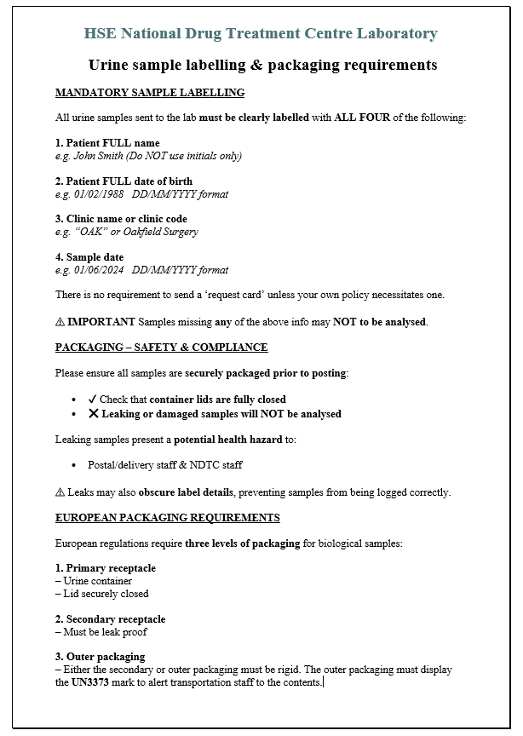

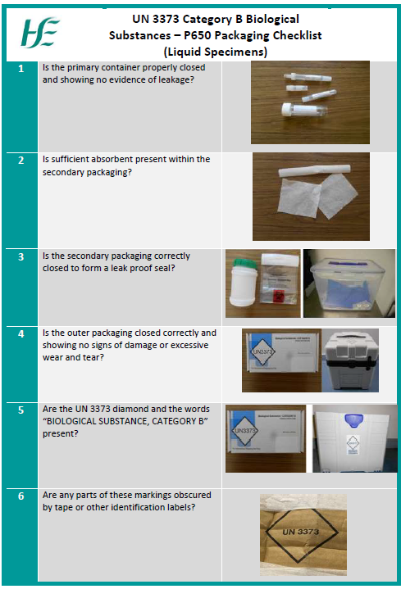

Appendix 7- Substance Analysis Request Form
