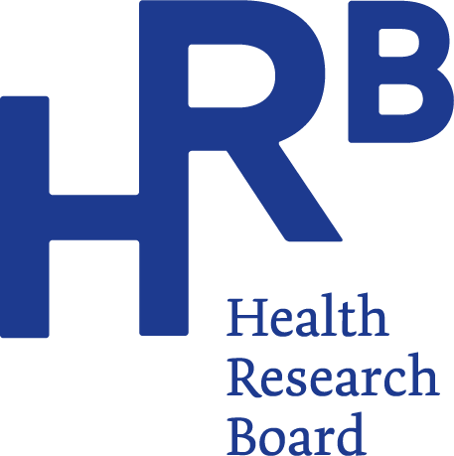
Press Release

Embargo: 25 September 2024, 00:01
HRB reports latest drug-poisoning deaths figures

The latest findings from the Health Research Board’s (HRB) report on drug-related deaths shows a decrease in poisonings for 2021 and highlights the risks of mixing drugs.
There were 354 drug poisoning deaths recorded in 2021, a decrease from 439 drug poisoning deaths in 2020. Opioids (mainly methadone) were the most common drug group reported, accounting for seven-in-ten deaths in 2021. Two-in-three deaths (64%) were among males and one-in-three (36%) were among females.
Main findings
- Opioids (69%), benzodiazepines (53%), and antidepressants (35%) were the three most common drug groups implicated in poisoning deaths overall
- The majority of deaths involved prescribable drugs, the most common being methadone (129), diazepam (112), alprazolam (107), pregabalin (83), and Zopiclone (59)
- The most common illicit drugs involved in the deaths were cocaine (107) and heroin (79)
- Eight-in-ten deaths involved more than one drug (polysubstance poisonings)
- Alcohol was implicated in one-in-three polysubstance poisonings
- Opioids were implicated in seven-in-ten deaths of those who were alone at the time of death
- One-in-five (18%) of the deceased were known to have ever injected drugs. 23 people (7%) were known to be injecting at the time of death
- Almost one-in-two of the deceased had a recorded history of mental health issues.
Commenting on the key findings in the report, HRB Chief Executive, Dr Mairéad O’Driscoll, said
“It is encouraging to see a decrease in the number of drug poisoning deaths recorded in 2021. However, behind each of these numbers is a person, their family and a life lost.
By monitoring these trends over time, the HRB can report on the impact that drugs have on our society, as well as identifying changes in use and behaviour. Understanding the factors influencing poisoning deaths is key to informing future responses and preventative measures.”
Commenting on the findings, Dr Suzi Lyons, Senior Researcher at the HRB, said:
“Polysubstance use, or using more than one drug, continues to play a major role in drug poisoning deaths. In 2021, eight-in-ten deaths involved more than one drug - which represents an increase of 10% since 2012. This highlights the increased risk of fatal overdose if a person is mixing or using more than one drug.
The data also highlights the risks of misuse of prescribable drugs. In 2021, nine-in-ten deaths had one or more prescribable drugs implicated. Of the top six drugs implicated overall in 2021, four of these were prescribable drugs.”
The main specific drugs implicated in poisoning deaths were:
- 1 in 3 of involved methadone
- 1 in 5 involved heroin; these deaths were mostly among males (8 in 10)
- Diazepam and alprazolam were the most common benzodiazepines, and each was implicated in 3 in 10 deaths overall
- Cocaine was implicated in 3 in 10 poisoning deaths overall; the majority (4 in 5) of which were among males
- 1 in 4 involved pregabalin;
      - pregabalin was implicated in a greater proportion of deaths among females (28%) than among males (21%)
- 1 in 3 deaths involved antidepressants.
      - Antidepressants were implicated in a greater proportion of deaths among females (47%) than among males (28%)
      - Mirtazapine (14%) was the most common antidepressant.
Sociodemographic profile
- The median age of the deceased was 42.5 years (41 years for males and 47 years for females)
- One in two deaths were among people aged 35 to 54 years
- Most (77%) of the deceased were living in stable accommodation
- More than 1 in 10 of the deceased were experiencing homelessness
- Most were residing in the HSE Dublin and North East (28.5%) health region, followed by HSE Dublin and Midlands (23%), and HSE Dublin and South East (18%)
Trend 2012 to 2021
An overall upward trend in the number of drug poisoning deaths over the period 2012 to 2021 appears to have plateaued in 2019 to 2021.
- Over the ten-year period, 3,379 poisoning deaths were recorded by the NDRDI
- In 2021, there were 354 poisoning deaths, 85 fewer than recorded for 2020
- Between 2019 and 2020, the number of deaths increased by 64, the largest increase over the period
- Males are continually in the majority, accounting for at least 6 in 10 drug poisoning deaths every year since 2012
- 7 in 10 drug poisoning deaths were polysubstance poisonings compared to 8 in 10 in 2021.
Drugs implicated in drug poisoning deaths 2012 to 2021
- Opioids increased by 34% (from 182 to 244 deaths)
- Benzodiazepines increased by 45% (from 129 to 187 deaths), mainly attributable to an almost fivefold increase in alprazolam (from 18 to 107 deaths)
- The number of deaths in which cocaine is implicated has more than trebled in ten years (2012-2021). These deaths are mostly among males and are typically polysubstance poisonings
- Pregabalin increased almost fivefold in just nine years (2013 to 2021)
- Antidepressants increased by 55% (from 80 to 124 deaths).

ENDS
For more information, infographics or interviews please contact:
Aileen Gaskin, The Communications Clinic
e aileen@communicationsclinic.ie m 087 7724 717
Suzanne Kenny, Communications Officer, Health Research Board
e skenny@hrb.ie m 085 8500494
Notes for editors
The Health Research Board (HRB) is Ireland’s lead funding agency supporting innovative health research and delivering data and evidence that improves people’s health and patient care. We are committed to putting people first, and ensuring data and evidence are used in policy and practice to overcome health challenges, advance health systems, and benefit society and economy.
In response to calls from families who had lost someone to a drug-related death and wanted to have these deaths recorded correctly, the National Drug Strategy (2001 to 2008) included an action to develop an accurate mechanism for recording the number of drug-related deaths in Ireland. This led to the establishment of the National Drug-Related Deaths Index (NDRDI) by the Health Research Board.

