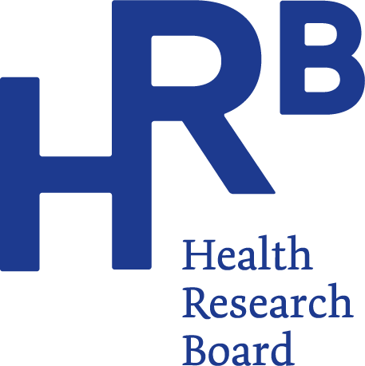
HRB reports increase in alcohol treatment

Embargo: 24 July 2024, 00:01
A total of 8,163 cases were treated for problem alcohol use in 2023, according to the latest data from the Health Research Board (HRB) – an increase of 10% on 2022 figures and the highest annual total in over a decade.
One in four cases also reported problem use of another drug along with alcohol in 2023. Cocaine remains the most common additional drug reported with 1,310 cases mixing alcohol and cocaine in 2023 compared to 607 in 2017.
Speaking about the findings, HRB Chief Executive Dr Mairéad O’Driscoll said:
“Alcohol continues to be the drug that most people seek treatment for. By monitoring demand for treatment and which drugs people mix with alcohol we can identify changes in behaviour over time. This helps to inform policy and provision of treatment in line with people’s needs.”

Dr Suzi Lyons, Senior Researcher at the HRB, said:
“This report highlights an increase in the number of alcohol treatment cases reported compared to 2022 with cases at the highest level in over a decade. We are seeing a rise in the proportion of cases whose alcohol use was classified as hazardous or harmful along with a decrease in the proportion classified as dependent. This is positive as it means that people are accessing treatment services before they become dependent. The earlier people present for treatment the more successful outcomes are likely to be.”
The report from the HRB National Drug Treatment Reporting System (NDTRS) presents data on alcohol treatment demand in 2023 and looks at trends in treatment for the seven-year period from 2017 to 2023.
Key findings 2023
Level of problem alcohol use
- A total of 8,163 cases were treated for problem alcohol use in 2023, the highest level in over a decade.
- Among cases seeking treatment for alcohol use for the first time in 2023, the majority (three in five) were classified as alcohol dependent.
- The proportion of all cases that were classified as alcohol dependent has decreased from 72% in 2017, to 61% in 2023.
- The proportion of all cases whose alcohol use was classified as hazardous has increased from 10% in 2017, to 13% in 2023.
- The proportion of all cases whose alcohol use was classified as harmful has increased from 16% in 2017, to 22% in 2023.

Frequency and amount of alcohol consumed
- Among those who consumed alcohol in the 30 days prior to treatment:
  - One in two (51.5%) consumed alcohol daily over the seven-year period 2017 - 2023.
  - The proportion who consumed alcohol daily increased from 43% in 2017 to 56% in 2023.
- Many cases in treatment had been drinking more in a typical day than is outlined for a week based on HSE low risk guidelines.
  - Females were drinking on average more than two bottles of wine in a typical drinking session (15 standard drinks).
  - Males were drinking on average nine pints of beer or over a half litre of spirts in a typical drinking session (18 standard drinks).
Socio-demographic characteristics
A typical case is likely to be in their early forties, male and likely to be unemployed.
Females entering treatment are likely to be in mid-forties, almost half are unemployed and more than half live with a child under 17.
Overall, in 2023:
- The median age of cases was 43 years.
- The median age of females (44 years) was higher than that for males (42 years).
- Six in ten cases were male.
- Almost one in twelve one-in-twelve cases were homeless.
- The proportion of cases with Irish Traveller ethnicity was almost 2%.
- Almost half of cases were recorded as unemployed.
- One in three cases were in paid employment.
- Among parents with children aged 17 years or under, more than half (51%) had at least one child residing with them at the time of they entered treatment.

Polydrug use
According to Dr Suzi Lyons, “The increase in the proportion of cases using other drugs with alcohol is a concern. Mixing drugs complicates treatment and can impede recovery.”
- One in four cases reported using another drug along with alcohol. The proportion of cases reporting polydrug use increased from one in five in 2017 to one in four in 2023.
- Cocaine was the most common additional drug used alongside alcohol, followed by cannabis, benzodiazepines, and opioids.
- The number of cases reporting cocaine as an additional drug more than doubled since 2017, from 607 to 1310 cases.
- The most common drugs used together were (1) alcohol plus cocaine; (2) alcohol plus cannabis; and (3) alcohol plus cocaine and cannabis.
- The type of additional problem drugs used with alcohol varied by age.
  - For young cases aged 19 years or under, it was cannabis
  - Among those aged 20–34 years, it was cocaine
  - Among those aged 35 years or over, it was also cannabis

Download the publication in full.
Download the infographic.

For more information, infographics or interviews please contact:
Suzanne Kenny, Communication Officer, Health Research Board
e skenny@hrb.ie m 085 8500494
Notes for editors
This paper describes trends in treated problem alcohol use in Ireland over the seven-year period 2017 to 2023, as recorded by the National Drug Treatment Reporting System (NDTRS). This information will assist policy makers, service planners and public health practitioners to develop appropriate responses to problem alcohol use in the future.
The Health Research Board (HRB) is Ireland’s lead funding agency supporting innovative health research and delivering data and evidence that improves people’s health and patient care. We are committed to putting people first, and ensuring data and evidence are used in policy and practice to overcome health challenges, advance health systems, and benefit society and economy.
Each case refers to an episode of treatment, not an individual service user. NDTRS data are case based which means there is a possibility that individuals appear more than once in the database; for example, where a person receives treatment at more than one centre, or at the same centre more than once in a calendar year.
Definitions
Alcohol dependence: Strong desire to consume alcohol, impaired control over use, persistent drinking in spite of harmful consequences, a higher priority given to alcohol than any other activities or obligations, increased tolerance and showing withdrawal reaction when alcohol use is discontinued. Source WHO: The Alcohol Use Disorders Identification Test (2001).
What is a standard drink? In Ireland a standard drink contains 10 grams of pure alcohol. For example, one standard drink is equal to a half pint of normal beer, a small glass of wine (12.5% in volume) or a pub measure of spirits (35mls): https://www2.hse.ie/wellbeing/alcohol/improve-your-health/weekly-low-risk-alcohol-guidelines.html
Low-risk drinking guidelines from the HSE say up to 11 standard drinks in a week for women, and up to 17 standard drinks in a week for men. That is half pint of normal beer, a small glass of wine (12.5% in volume) a or a pub measure (35mls) of spirits. Drinks should be spaced out over the week, with two to three alcohol free days per week.

24 July 2024

