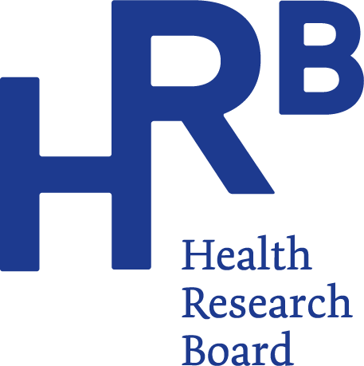
HRB releases 2022 alcohol treatment data

Embargo: 9.00 am, 1 August 2023
A total of 7,421 cases were treated for problem alcohol use in 2022, according to the latest data from the Health Research Board (HRB) – an increase of 8% on 2021 figures.
Since 2016, there has been a 35% increase in the number of cases reporting problem use of one or more drugs in addition to alcohol, rising from 1,328 cases in 2016 to 1,796 cases in 2022. Cocaine surpassed cannabis as the most common additional drug reported in 2022, increasing by 135% between 2016 and 2022.
Speaking about the findings, HRB Chief Executive Dr Mairéad O’Driscoll said: “By demonstrating increased demand in treatment for problem alcohol use along with a rise in polydrug use, our data points to a shift in behaviour over time. By continuing to monitor these trends, the HRB can help inform policy and treatment paths to provide the right support to those who need it.”
Dr Suzi Lyons, Senior Researcher at the HRB, said: “Over 4 in 10 of the cases recorded in 2022 were entering treatment for the first time, and almost 2 in 3 of these new cases were classified as alcohol dependent when they entered treatment.”
Commenting on trends in the type and amount of alcohol consumed, Dr Suzi Lyons said: “Of the 3 in 4 cases who had consumed alcohol in the 30 days prior to treatment, almost 6 in 10 consumed alcohol daily – an increase from just over 3 in 10 in 2016. Women seeking treatment for problem alcohol use are typically consuming 15 standard drinks every day, and show a preference for spirits followed by wine. For men, the figure is 20 standard drinks every day, but they prefer beer followed by spirits. This means many were drinking more in a typical day than HSE low-risk guidelines recommend for one week.”
The report from the HRB National Drug Treatment Reporting System (NDTRS) presents data on alcohol treatment demand in 2022, and looks at trends in treatment for the seven-year period from 2016 to 2022.
Key findings 2022
Level of problem alcohol use
- In 2022, the median age at which cases first started drinking alcohol was 16 years.
- Almost 2 in 3 cases were classified as alcohol dependent. This figure was similar across those entering treatment for the first time and previously treated cases.

Socio-demographic characteristics
- The median age of cases was 42 years.
- 6 in 10 cases were male.
- 1 in 13 cases were recorded as homeless.
- The proportion of cases with an Irish Traveller ethnicity was 2.5%.
- Almost half of cases were recorded as unemployed.
- 1 in 3 cases were in paid employment.
- Among parents with children aged 17 years or younger, just over half (51%) had at least one child residing with them at the time of treatment entry.

Polydrug use
- Polydrug use (problem use of more than one substance) was reported by almost 1 in 4 cases.
- Cocaine (61%) was the most common additional drug used alongside alcohol, followed by cannabis (49%), benzodiazepines (22%) and opioids (13%).
- In 2022, cocaine surpassed cannabis for the first time as the most common additional drug.
- The most common drugs used together were (1) alcohol plus cocaine, followed by (2) alcohol plus cannabis, followed by (3) alcohol plus cannabis and cocaine.
- The type of additional problem drugs varied by age: the main drug reported alongside alcohol was cannabis among cases aged 19 years or younger; for those aged 20-34 years and those aged 35 or older, it was cocaine.

ENDS

For more information, infographics or interviews please contact:
Aileen Gaskin – aileen@communicationsclinic.ie / 087 7724 717, or
Robyn Keleghan – robyn@communicationsclinic.ie / 085 8001 275.

Notes for editors
This paper describes trends in treated problem alcohol use in Ireland over the seven-year period 2016 to 2022, as recorded by the National Drug Treatment Reporting System (NDTRS). This information will assist policy makers, service planners and public health practitioners to develop appropriate responses to problem alcohol use in the future.
The Health Research Board (HRB) is Ireland’s lead funding agency supporting innovative health research and delivering data and evidence that improves people’s health and patient care. We are committed to putting people first, and ensuring data and evidence are used in policy and practice to overcome health challenges, advance health systems, and benefit society and economy.
Each case refers to an episode of treatment, not an individual service user. NDTRS data are case-based which means there is a possibility that individuals appear more than once in the database; for example, where a person receives treatment at more than one centre, or at the same centre more than once in a calendar year.
Alcohol dependence: Strong desire to consume alcohol, impaired control over use, persistent drinking in spite of harmful consequences, a higher priority given to alcohol than any other activities or obligations, increased tolerance and showing withdrawal reaction when alcohol use is discontinued. Source WHO: The Alcohol Use Disorders Identification Test (2001).
What is a standard drink? In Ireland a standard drink contains 10 grams of pure alcohol. For example, one standard drink is equal to a half pint of normal beer, a small glass of wine (12.5% in volume) or a pub measure of spirits (35mls): https://www2.hse.ie/wellbeing/alcohol/improve-your-health/weekly-low-risk-alcohol-guidelines.html
Low-risk drinking guidelines from the HSE say up to 11 standard drinks in a week for women, and up to 17 standard drinks in a week for men. That is half pint of normal beer, a small glass of wine (12.5% in volume) a or a pub measure (35mls) of spirits. Drinks should be spaced out over the week, with two to three alcohol free days per week.

1 August 2023

