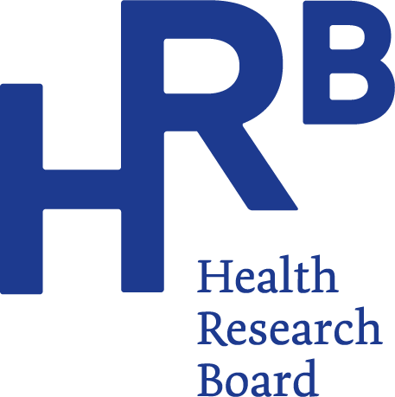

HRB releases 2021 alcohol treatment data
A total of 50,304 cases were treated for problem alcohol use in Ireland between 2015 and 2021, according to the latest figures published by the Health Research Board (HRB).
The 2021 report on data from the National Drug Treatment Reporting System (NDTRS) shows a decrease in treated cases from 7,618 in 2015 to 6,859 in 2021, together with a slight drop in the proportion of new cases reported.
- Almost two in every three cases reported in 2021 were classified as alcohol dependent. (2)
- Where alcohol treatment cases are using additional drugs, cannabis was the most common and cocaine the second most common additional drug recorded.
- In 2021, over one in five cases treated for alcohol were currently living with children aged 17 years or younger.(3)
Speaking about the findings, Dr Mairead O’Driscoll, HRB Chief Executive said: “Alcohol remains the main problem drug that people seek treatment for in Ireland. As the timeframe covered by the latest data spans the emergence of the COVID-19 pandemic and related restrictions, the HRB figures are all the more important to monitor the impact that lockdown may have had on problem alcohol use and treatment trends.”
Dr Suzi Lyons, Senior Researcher at the HRB, said: “While we have seen a decline in the number cases reported over the seven-year period, this must be viewed in the context of limited access to services due to COVID-19 restrictions. Even though the numbers have decreased, we are seeing that the trends remain consistent. For example, half of all cases treated started to drink alcohol by the age of 16 and two out of three cases who are new to treatment are already classified as alcohol dependent when they enter treatment. We are also continuing to see cases mixing alcohol with other drugs with almost one in four reporting problem use of other drugs. This is a concern as mixing drugs can impact recovery and increase risk of overdose.”

Key findings 2021
Level of problem alcohol use
- In 2021, the median age at which cases first started drinking alcohol was 16 years, unchanged from previous years.
- Almost two in every three cases were classified as alcohol dependent.
- In 2021, 62% of new cases were classified as alcohol dependent, compared to 57% in 2015.
- The proportion of previously treated cases classified as alcohol dependent increased from 67% in 2015 to 70% in 2021.
Commenting on the trends across male and female cases, Dr Suzi Lyons says: “Women seeking treatment for problem alcohol use are consuming a median number of 15 standard drinks (4) on a typical drinking day, with spirits and wine being the preferred alcohol. For men, that figure is 20 standard drinks, with beer followed closely by spirits as the alcohol of choice. When we consider that HSE low-risk guidelines (5) suggest a weekly limit for alcohol of 11 standard drinks over a week for women and 17 for men, these patterns will clearly have a significant impact on health and well-being.”

Socio-demographics
- In 2021, the median age of treated cases was 42 years, a small increase from 41 in previous years.
- The majority of cases in 2021 were male (63%).
- The proportion of cases aged 17 years or younger increased slightly from 1.4% in 2015 to 1.6% in 2021.
- The proportion of cases who identified as Irish Traveller ethnicity was 1.9% in 2015 and 2.4% in 2021.
- Almost half of cases in 2021 were unemployed.
- In 2021, 8% of cases were homeless – a slight increase from 7.5% in 2015.
- In 2021, one in five of cases treated for alcohol were currently living with children aged 17 years or younger. A further fifth of all cases had children aged 17 years or younger who were not currently living with them. (6)

Polydrug use
- Polydrug use was reported by almost one-quarter of those treated for problem alcohol use in 2021. This was an increase from under one-fifth in 2015.
- Cannabis was the most common additional drug used. The proportion of cases reporting cannabis use declined from 60% in 2015 to 55% in 2021.
- Cocaine was the second most common additional drug recorded. This increased from 33% in 2015 to 54% in 2021.
- 47% of female cases and 57% of male cases reported with cocaine as an additional problem in 2021.
- Benzodiazepines were the third most common additional drug reported (22%) in 2021.
- Opioids were the fourth most common additional drug reported (13%) in 2021.

For more information, infographics or interviews please contact:
Anna Dunne, Communications Officer, Health Research Board
m +353 85 8590339, e adunne@hrb.ie

Notes for editors
This paper describes trends in treated problem alcohol use in Ireland over the seven-year period 2015 to 2021, as recorded by the National Drug Treatment Reporting System (NDTRS). This information will assist policy makers, service planners and public health practitioners to develop appropriate responses to problem alcohol use in the future.
The Health Research Board (HRB) is Ireland’s lead funding agency supporting innovative health research and delivering data and evidence that improves people’s health and patient care. We are committed to putting people first, and ensuring data and evidence are used in policy and practice to overcome health challenges, advance health systems, and benefit society and economy.

Footnotes:
- Each case refers to an episode of treatment, not an individual service user. NDTRS data are case-based which means there is a possibility that individuals appear more than once in the database; for example, where a person receives treatment at more than one centre, or at the same centre more than once in a calendar year.

- Alcohol dependence: Strong desire to consume alcohol, impaired control over use, persistent drinking in spite of harmful consequences, a higher priority given to alcohol than any other activities or obligations, increased tolerance and showing withdrawal reaction when alcohol use is discontinued. Source WHO: The Alcohol Use Disorders Identification Test (2001).

- Service users currently residing with children refers to the 30 days prior to treatment. This includes children where the service user has a carer or guardianship role; nonrelated children such as foster children and stepchildren; and the children of a long-term cohabiting partner. Where the service user is a grandparent or other close relative and is the official guardian of a child with whom they are living, they are recorded as living with children.

- Low risk drinking guidelines from the HSE say up to 11 standard drinks in a week for women, and up to 17 standard drinks in a week for men. That is half pint of normal beer, a small glass of wine (12.5% in volume) a or a pub measure (35mls) of spirits. Drinks should be spaced out over the week, with two to three alcohol free days per week.

- What is a standard drink? In Ireland a standard drink contains 10 grams of pure alcohol. For example, one standard drink is equal to a half pint of normal beer, a small glass of wine (12.5% in volume) or a pub measure of spirits (35mls): https://www2.hse.ie/wellbeing/alcohol/improve-your-health/weekly-low-risk-alcohol-guidelines.html

- Children who are not residing with the service user refers to children currently living with another parent; children in formal care or informal care; and children living elsewhere who are biological children/adopted children, or children who are under the official guardianship of the service user. It also refers to children who have left home, and children who are living with other family members or friends temporarily, but who are not considered by the service user to be living in care.

