Issue 78 | Summer 2021

In this issue

European drug report, 2021
See page 12-13
16 Stigma among older users of MMT services
18 School-based interventions
09 Suspended sentences
Drugnet Ireland is
produced in collaboration with the HRB National Drugs Library. To have Drugnet Ireland delivered to your desktop, sign up at
www.drugsandalcohol.ie

Contents

Cover Story
Alcohol consumption, alcohol-related harm, and alcohol policy in Ireland 01

policy and legislation
New priorities for the British–Irish Council 08
Law Reform Commission report on
suspended sentences 09
European drug report, 2021 12

Recent research
Impact of Covid-19 on drug and alcohol
services and people who use drugs in
Ireland: a report of survey findings 14
Stigma of growing older on methadone maintenance treatment 16
New evidence on school-based
programmes 18
Development of the Healthy Addiction Treatment recovery model for nursing in addiction services 20

Prevalence and current situation
Trends in alcohol and drug admissions to psychiatric facilities 22
National Self-Harm Registry annual
report, 2019 24
Repeated self-harm among young people following hospital-presenting intentional
drug overdose 26

responses
Supporting quality standards in drug
demand reduction 27
Registries for quality in prevention
– Xchange and Healthy Nightlife Toolbox 30
Tabor Group annual report, 2019 32
Launch of AcoRN, the UK-Ireland Alcohol Research Network, 2021 35
The National Family Support Network 36
HRB National Drugs Library survey, 2021 38

updates
Recent publications 40

The policy, research, and other documents covered in this issue of Drugnet Ireland have
all been retrieved by the HRB National Drugs Library and may be accessed on its website
www.drugsandalcohol.ie

In brief

Substance use in young people (aged 10–24 years) is a significant health and social problem throughout the world. The 2013 Global Burden of Disease estimated that substance use among young men was responsible for 14% of total health burden. Recent findings have underlined the neurobiological vulnerability of young adults and the impact of co-occurring substance use disorders and mental health problems that emerge in adolescence. Adolescence is the peak period for initiation of substance use. A consistent finding from the international literature is that levels and frequency of use of drugs, alcohol, and tobacco begin to increase in mid-adolescence and peak in very early adulthood. These are key periods of change, cognitive and emotional development, and transitioning into employment, stable relationships, and parenthood.
Preventing, delaying or reducing young people’s use of alcohol and other drugs is a major part of all governments’ drug strategies. Unlike other interventions, which might be resisted for moral or ideological reasons, prevention programmes are widely supported by the general public. Yet, unlike evidence-based harm reduction policies that often face sustained opposition, many of the most common prevention programmes are supported by a very narrow evidence base. This is because most prevention options in place have not been evaluated. Those that have been evaluated are largely concentrated in school settings that facilitate research opportunities and the possibility to collect follow-up information on the participants in these programmes. It is an enormously difficult task to influence behaviour at the time of life when people go through rapid changes in neurobehavioural and psychosocial functioning. Entering early adulthood is a complex, challenging, and often bewildering experience for young people. Establishing a scientific approach to enable young people to navigate the many risks they face is probably the most difficult, and most important, task faced by decision-makers working on substance use policies.
This issue of Drugnet Ireland highlights some recent interesting developments in prevention studies. There is a strong correlation between diagnosed psychiatric disorder and substance use. Attention deficit hyperactivity disorder (ADHD), conduct, and personality disorder as well as affective disorders have been linked to increased substance use in adolescence. A systematic review published in 2020 finds that school-based programmes applying interventions based on positive psychology interventions can have positive effects on psychological wellbeing, and their inclusion in the school curriculum should be explored. Bullying is an important risk factor for poor mental health outcomes, and two 2020 reviews have found a small but significant effect from evaluations of anti-bullying interventions.
Prevention science has made great progress. Despite this, and the increasing availability of high-quality evidence in the field, it can be difficult for stakeholders to decide on the best approach. Selecting and implementing prevention interventions is a major undertaking and decisions can be difficult to reverse if new evidence emerges challenging the efficacy of programmes already in place. Initiatives like the Xchange Registry, described in an article in this issue, provide the type of valuable scientific and experiential information to support informed decision-making and more effective responses to substance use among young people.

Alcohol consumption, alcohol-related harm, and alcohol policy in Ireland

The Health Research Board (HRB) Alcohol Overview was published in April 2021, the fourth in a series that provides updates on alcohol consumption, its related harms, and policy responses in Ireland.¹ Using the HRB National Drugs Library, the overview is compiled using a variety of Irish data sources, published Irish literature, and existing information systems and surveys.
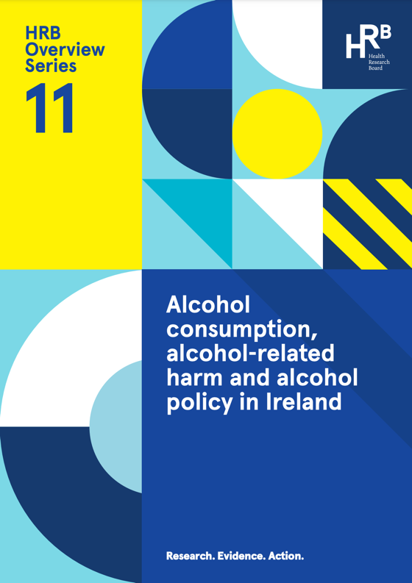

Introduction
Alcohol use is the seventh leading risk factor for both deaths and disability-adjusted life years globally, despite the fact that one-half of the world’s population does not drink. Ireland ranks ninth highest per capita alcohol consumption of all OECD (Organisation for Economic Co-operation and Development) member countries.²
Alcohol consumption
Since 2013, alcohol consumption levels in Ireland have remained stable but high: 19% higher than the stated aim of the Irish Government to reduce per capita alcohol consumption in Ireland to 9.1 litres by 2020. In 2019, per capita alcohol consumption per adult aged 15 and over was 10.8 litres of pure alcohol (see Figure 1).^{3,4,5} However, considering that one-quarter of the population do not drink alcohol at all, the number of litres consumed per person is even greater.
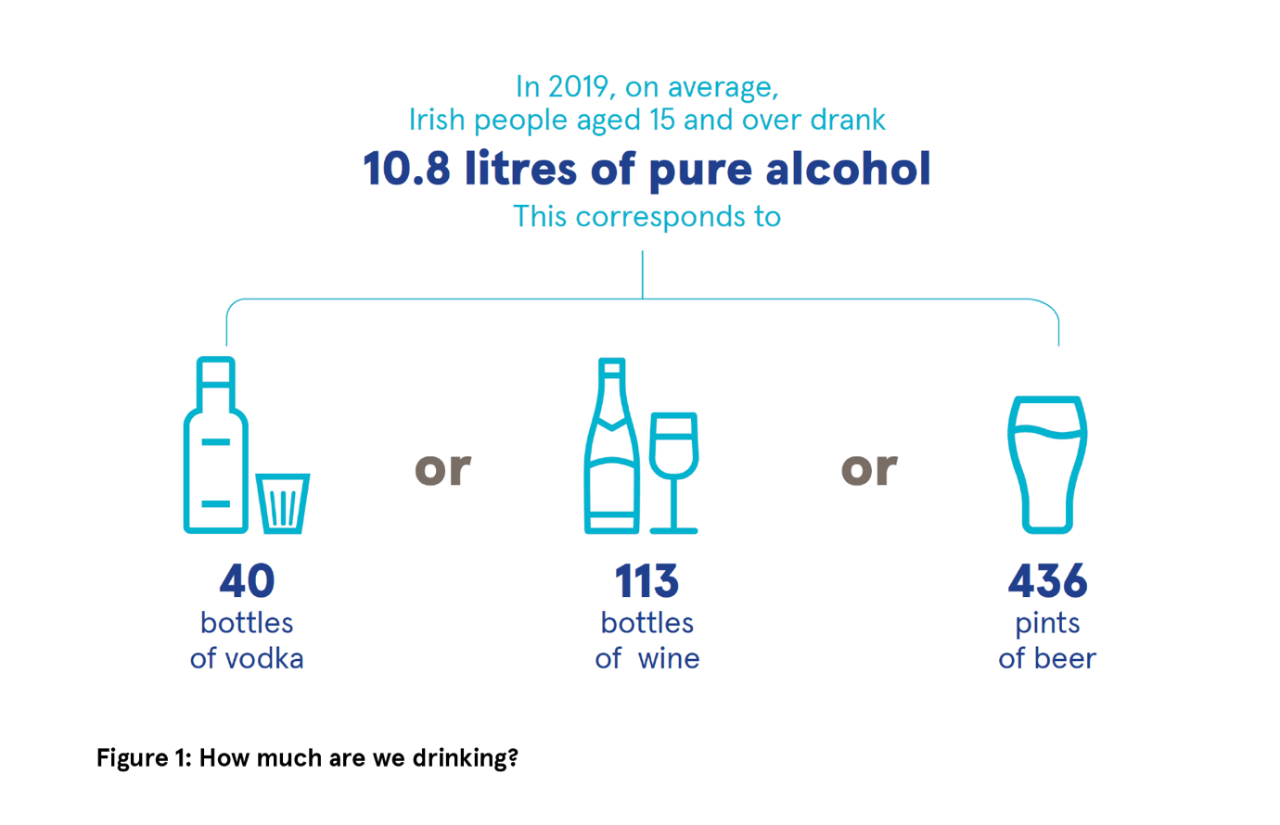
Consumption patterns
Patterns of alcohol consumption as well as high-volume drinking increases the risk of alcohol-related harm. Healthy Ireland Survey data showed that more than one-half (52%) of all drinkers were classified as hazardous drinkers using the World Health Organization’s AUDIT-C screening tool.⁶ This screening tool takes account of frequency and volume of drinking as well as heavy episodic drinking (HED), defined as consuming six standard drinks or more on a single drinking occasion. Hazardous drinking was more common among men (70%) than women (34%), particularly younger men, with almost four in five (78%) of 25–34-year-old males meeting the criteria for hazardous drinking.⁷
Despite the level of hazardous drinking patterns among Irish drinkers, the majority of drinkers considered themselves as being a light or moderate drinker (74%), indicating an unawareness of what constitutes binge drinking and that their patterns of drinking may be considered hazardous.
Alcohol consumption among young people
Data from the Irish Health Behaviour in School-aged Children (HBSC) 2018 study indicate that 82% of schoolchildren have consumed their first alcoholic drink by the age of 17 years and for all ages, with the exception of 15-year-olds, getting alcohol from parents and guardians was the most common way children obtained alcohol (see Figure 2).⁸ Lifetime drunkenness ranged from 5% of 13-year-olds to 62% of 17-year-olds. Trends in alcohol consumption since 1998 show a continuous decline in the percentage of schoolchildren who drink alcohol, especially among 13–15-year-olds. This is encouraging, as this group is particularly vulnerable to experiencing alcohol-related harm. The same trend has not been observed among 17-year-olds, where there has been little change in alcohol use and drunkenness since 1998.
Alcohol consumption among parents
More than one-quarter of parents (28%) engaged in HED at least once a month, while 5% were classified as dependent on alcohol.⁶

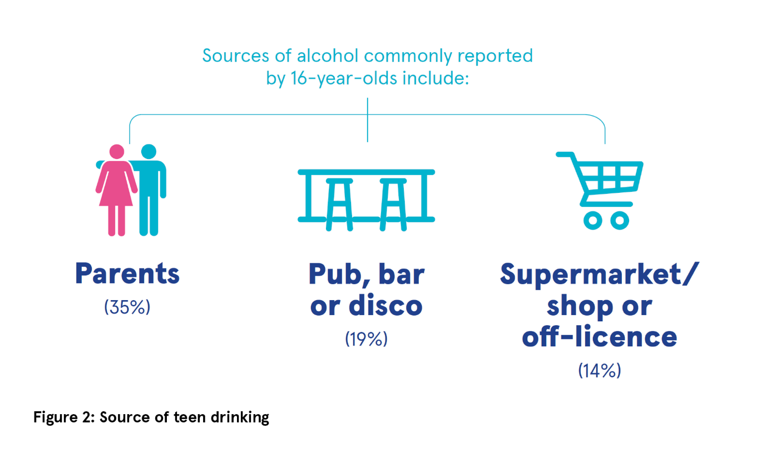
Alcohol-related harm in Ireland
The Hospital In-Patient Enquiry (HIPE) scheme collects clinical and administrative data on discharges (including deaths) from acute Irish hospitals. For the overview, all alcohol-related discharges that were either wholly attributable to alcohol (alcohol is a necessary cause for these conditions to manifest) or partially attributable (conditions where alcohol may be one of a range of causative factors) were analysed (see Figure 3).
Wholly attributable alcohol-related discharges
In 2018, acute conditions such as alcohol poisoning and intoxication accounted for 12% of wholly attributable alcohol-related discharges. Chronic diseases, such as liver disease, accounted for 23% of such discharges, while other chronic conditions, including alcohol dependence, accounted for 64%. Acute alcohol-related conditions were more common among younger people, whereas chronic diseases and other chronic conditions were more prevalent among the older age groups.
Alcoholic liver disease discharges
The number of discharges with a diagnosis of alcoholic liver disease has increased by 221% since 1995, to 90.8 per 100,000 persons. The increase was most pronounced among those aged 15–34 years and those aged 65 years or over. Of all discharges with a diagnosis of alcoholic liver disease, 8.4% died while in hospital.
Partially alcohol-attributable conditions
Between 2012 and 2017, there were 121,919 hospital discharges from partially alcohol-attributable conditions. In 2017, there were 20,201 hospital discharges due to partially alcohol-attributable conditions.
Males accounted for 87% of these discharges. Although females accounted for just 13% of all partially alcohol-attributable hospital discharges in 2017, more than one-third (37%) of alcohol attributable cancer discharges were female. This is primarily due to the high number of breast cancer discharges related to alcohol. The number of partially alcohol-attributable hospital discharges reported in this overview represent the minimum number of hospital discharges related to alcohol use; the true number is likely to be considerably higher.
Alcohol mortality
Between 2008 and 2017, there were 10,803 alcohol-related deaths recorded on the National Drug-Related Deaths Index (NDRDI): 8,000 male and 2,803 female. In 2017, there were 1,094 deaths recorded (see Figure 4).
In 2018, some 30% of self-harm cases were alcohol related. Alcohol was significantly more common in male presentations of self-harm (34%) compared with female presentations (27%). It was also associated with peaks in hospital attendances at night, at weekends, and on public holidays.
Alcohol treatment
Between 2013 and 2019, some 53,200 cases were recorded on the National Drug Treatment Reporting System (NDTRS) as attending for treatment with alcohol as their main problem drug. Those registered on the National Psychiatric Inpatient Reporting System (NPIRS) as attending psychiatric inpatient treatment for alcohol dependence has decreased by over 60% from 2006 (2,767 cases) to 2019 (1,090 cases), largely due to a move to outpatient settings for such treatment.

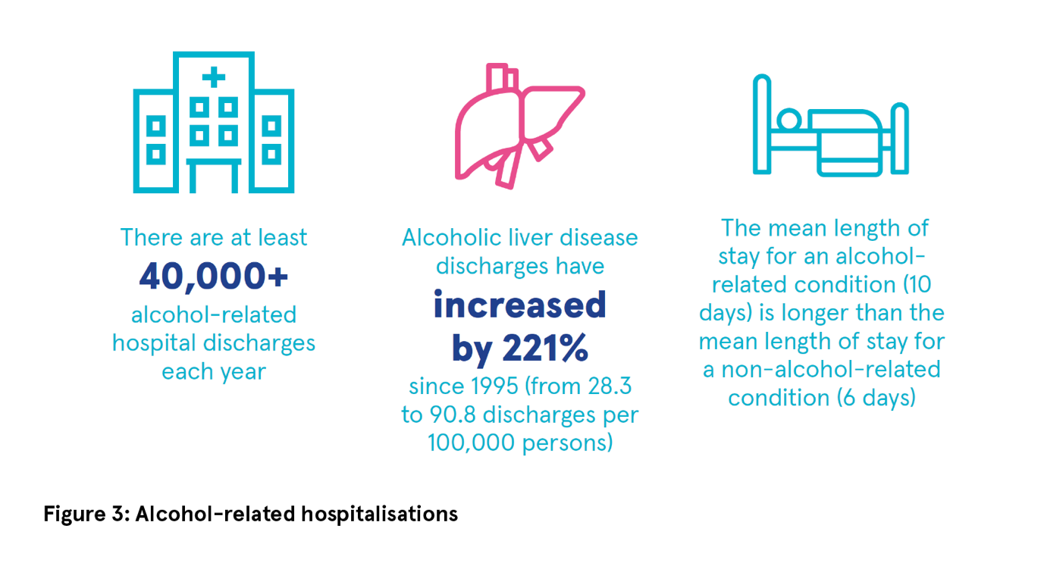

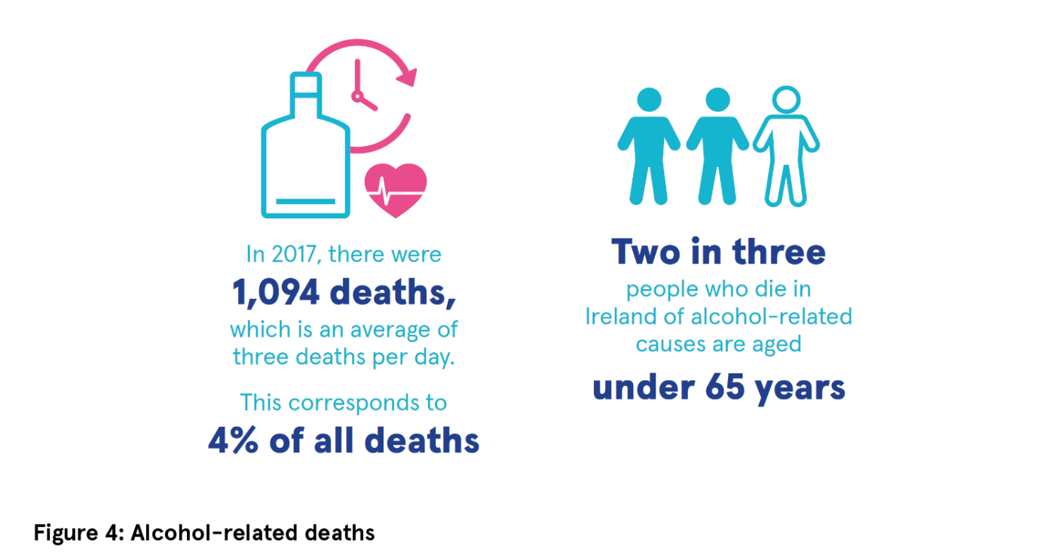

Alcohol policy response in Ireland
Since the most recent overview in 2016, the most important development in alcohol policy in Ireland has been the enactment of the Public Health (Alcohol) Act 2018. The main provisions of the Act include:
- Minimum unit price (MUP): A minimum price set at 10 cent per gram of alcohol in the product is compulsory.
- Structural separation of alcohol products: Physically separating alcohol products from other grocery items is compulsory.
- Restrictions around alcohol advertising: Restricting content of advertisements, involving a 9pm broadcast watershed for advertisements on television and radio; a ban on advertising alcohol products near schools, in parks, on public transport, in train and bus stations, and at bus or Luas stops are compulsory.
- Labelling of alcohol products: Labelling the direct link between alcohol and cancer; the number of grams of alcohol in the container; the calorie content; and details of a Health Service Executive (HSE) website providing public health information are compulsory. Health warning labels on alcohol products are subject to scrutiny at European Union (EU) level and have yet to be commenced.
Conclusion
Since the last Alcohol Overview was published in 2016, little has changed with regard to alcohol consumption and alcohol-related harm. Ireland still has a high level of per capita consumption and a majority of drinkers in Ireland consume alcohol in a manner risky to their health. The consequences of drinking patterns in Ireland are reflected in the mortality data, which show that on average there have been three alcohol-related deaths every day since 2008. The signing into law of the Public Health (Alcohol) Act in 2018 was an important first step in reducing alcohol-related harm; however, for real impact, the remaining sections need to be implemented in full as soon as possible.
Anne Doyle

1 O’Dwyer C, Mongan D, Doyle A and Galvin B (2021) Alcohol consumption, alcohol-related harm and alcohol policy in Ireland. HRB Overview Series 11. Dublin: Health Research Board.
https://www.drugsandalcohol.ie/33909/
2 Organisation for Economic Co-operation and Development (OECD) (2019) Alcohol consumption. Available online at:
https://data.oecd.org/healthrisk/alcohol-consumption.htm (accessed 20/12/2019)
3 Revenue Commissioners (2019) Excise receipts by commodity. Dublin: Office of the Revenue Commissioners. Available online at:
https://www.revenue.ie/en/corporate/information-about-revenue/statistics/excise/receipts-volume-and-price/excise-receipts-commodity.aspx
4 Central Statistics Office (2019) Population and migration estimates April 2019. Cork: Central Statistics Office. Available online at:
https://www.cso.ie/en/releasesandpublications/er/pme/populationandmigrationestimatesapril2019/
5 Central Statistics Office (2017) Census 2016
profile 3 – an age profile of Ireland. Cork:
Central Statistics Office. Available online at:
https://www.cso.ie/en/csolatestnews/presspages/2017/census2016profile3-anageprofileofireland/
6 Ipsos MRBI (2017) Healthy Ireland Survey 2017. Dublin: Department of Health.
https://www.drugsandalcohol.ie/28041/
7 National Advisory Committee on Drugs and Alcohol/Department of Health (UK) (2016) Prevalence of drug use and gambling in Ireland and drug use in Northern Ireland. Bulletin 1. Dublin: National Advisory Committee on Drugs and Alcohol. https://www.drugsandalcohol.ie/26364/
8 Költő A, Gavin A, Molcho M, Kelly C, Walker L and Nic Gabhainn S (2020) The Irish Health Behaviour in School-aged Children (HBSC) Study 2018. Dublin: Department of Health & Health Promotion Research Centre, National University of Ireland Galway. https://www.drugsandalcohol.ie/31531/

POLICY AND LEGISLATION
New priorities for the British–Irish Council
On 11 March 2021, a ministerial meeting of the Misuse of Substances work sector of the British–Irish Council (BIC) was held online. The Irish Government is the lead administration for this strand of work. The meeting was chaired by Frank Feighan TD, Minister of State for Public Health, Wellbeing and the National Drugs Strategy. The meeting was also attended by ministers from the Northern Ireland Executive, Scotland, Wales, the Isle of Man, Jersey, Guernsey, and the British Government.¹
British–Irish Council
As described in issue 72 of Drugnet Ireland,² BIC was established in 1999 as part of the Good Friday Agreement in order to further promote positive, practical relationships among the people of the islands as well as to provide a forum for consultation and cooperation. The formal purpose of BIC,³ as outlined in Strand 3 of the Agreement, is as follows:
To promote the harmonious and mutually beneficial development of the totality of relationships among the peoples of these islands... The BIC will exchange information, discuss, consult and use best endeavours to reach agreement on co-operation on matters of mutual interest within the competence of the relevant Administrations.⁴
Items covered and actions agreed
The communiqué published following the meeting lacks detail on the content of the discussions but notes that the ministers discussed two key topics:
- Financial mechanisms to reduce the consumption of alcohol: Ministers described the efforts of member administrations to decrease alcohol consumption and agreed that there was value in comparing approaches and sharing learnings from the emerging evidence base.

- Measure the effectiveness of addiction services and harm reduction strategies: The importance of effective monitoring and evaluation to ensure evidence-based policymaking and practice was recognised. It was agreed that sharing this diversity of knowledge, understanding, experiences, and learning across member administrations affords a unique resource for enhancing monitoring and evaluation.

Five topics were agreed as priorities for the group’s work moving forward:
- Consider the lessons of Covid-19 and the delivery of drug and alcohol services.
- Reduce the risk of drug-related deaths.
- Reduce alcohol-related harms through the use of financial mechanisms.
- Consider joined-up approaches to meeting the health and social needs of people who are homeless and use drugs and alcohol (in conjunction with the BIC Housing work sector).
- Engage with the voluntary and community sectors to consider their role in the provision of drug and alcohol services, and in the development and monitoring of policy.
No further detail was available on what this work would entail.
Lucy Dillon

1 British–Irish Council (2021) Ministerial meeting of the Misuse of Substances work sector: 11 March 2021 communiqué. Edinburgh: British–Irish Council. https://www.drugsandalcohol.ie/33916/
2 Dillon L (2020) British–Irish Council in Dublin. Drugnet Ireland, 72 (Winter): 5.
https://www.drugsandalcohol.ie/31712/
3 Further details on the work of BIC is available from its website: https://www.britishirishcouncil.org/
4 A copy of the Good Friday Agreement is available at: https://www.dfa.ie/media/dfa/alldfawebsitemedia/ourrolesandpolicies/northernireland/good-friday-agreement.pdf

Law Reform Commission report on suspended sentences
In August 2020, the Law Reform Commission (LRC) published a report on suspended sentences.¹ The report, which was carried out as part of the Fourth Programme of Law Reform, examines how the principles of suspended sentences are operated and applied in Ireland. It builds on the LRC 2017 document, Issues paper: Suspended sentences.² The overall aim of the report is to improve and supplement these principles from a practical and procedural perspective (p. 11).¹
Suspended sentences
A suspended sentence is a prison sentence which is not applied for a specified period on the condition that the individual who receives it adheres to the terms on which the sentence was suspended (p. 11). There are two kinds of suspended sentences:
- Fully suspended, where the individual may never undertake custody if he/she adheres to the conditions of the suspended sentence fully.

- Part-suspended, which involves two steps, time spent in prison followed by ‘conditional liberty’ time where the terms of part suspension must be adhered to (p. 11).
Statutory framework
Prior to the enactment of appropriate legislation, the ability to suspend imprisonment sentences in Ireland was evident in common law. Since 2006, two pieces of legislation provide for suspended sentences in Ireland. Initially, the Criminal Justice Act 2006 provided a statutory footing for the operation of suspended sentences. Section 99 provided an outline of the main steps for dealing with reoffending and any breaches of the conditions when the suspension is in operation. The High Court deemed aspects of Section 99 unconstitutional in 2016 (p. 25). This decision resulted in the enactment of the Criminal Justice (Suspended Sentences of Imprisonment) Act 2017, which amended and clarified several procedural issues in Section 99.
Hierarchy of criminal penalties
In the report, the LRC considers where the suspended sentence is positioned on the hierarchy of criminal penalties in relation to Irish law. Part and fully suspended sentences come second and third on this hierarchy (see Table 1).
Drugs crime
There are two types of minimum sentences that can be provided for drugs crime:
- Mandatory minimum sentence: Here a court is required to impose in all cases a minimum sentence expressed in years of imprisonment.

- Presumptive minimum sentence: Here a court is still required to impose a minimum imprisonment term for conviction of a guilty plea, however, the court is also permitted to consider exceptional and specific circumstances which may justify a ‘depart downwards’ (p. 150) by the court. Presumptive minimum sentences are prescribed under the Misuse of Drugs Act 1977 and the Firearms Acts. In its 2013 report³ on mandatory sentences, the LRC called for presumptive minimum sentences to be repealed and replaced with a more structured sentencing system. Their views were also acknowledged in the 2014 report⁴ of the Strategic Review Group on Penal Policy; however, to date these provisions have not been repealed.

Under the Misuse of Drugs Act 1977, there are two offences where a presumptive minimum sentence can be applied: Section 15A provides for possession offences and Section 15B provides for importation offences. Under Section 27(3C), both carry a presumptive minimum sentence of 10 years' imprisonment (p. 151). When deciding whether to implement a presumptive minimum sentence, a sentencing judge can take other factors into consideration, such as when and how the offender pleaded guilty and whether the offender helped in the investigation. Previous drug trafficking offences are also considered and whether it is in the public interest to impose a lesser sentence. There must also be exceptional and specific circumstances to depart from a presumptive sentence.
Recommendations
Several recommendations were put forward by the LRC in the report that aim to supplement and improve the principles that have emerged though Irish case law.⁵ These are:
- Judicial discretion: The LRC has recommended that the statutory discretion given to sentencing judges when selecting conditions of suspension and the duration of the suspended sentence operational period should be maintained. However, these need to be proportionate and reasonable such that the offender is able to comply.

- Data management and analysis: The LRC has recommended that relevant justice agencies should have the necessary resources to establish a dedicated data management and analysis unit. This would allow for the collection, collation, and dissemination of data related to the overall criminal justice system but also the operation of the suspended sentence.

- Information and communication technology (ICT) architecture within the criminal justice system: While there are several initiatives enhancing collaboration and cooperation between agencies within the Irish criminal justice system, the LRC has recommended an examination of ICT systems supporting court processes and has called for the modernisation and streamlining of these systems to enhance interoperability and efficiency.

- Sentencing guidance: Finally, the LRC has recommended that sentencing guidance for suspended sentences, specifically in relation to offenders and offences, be prepared by the Sentencing Guidelines and Information Committee, which was established under the Judicial Council Act 2019.
A summary of all recommendations can be found in Appendix A of the report.¹

Table 1: Findings of LRC 2020 study, by theme
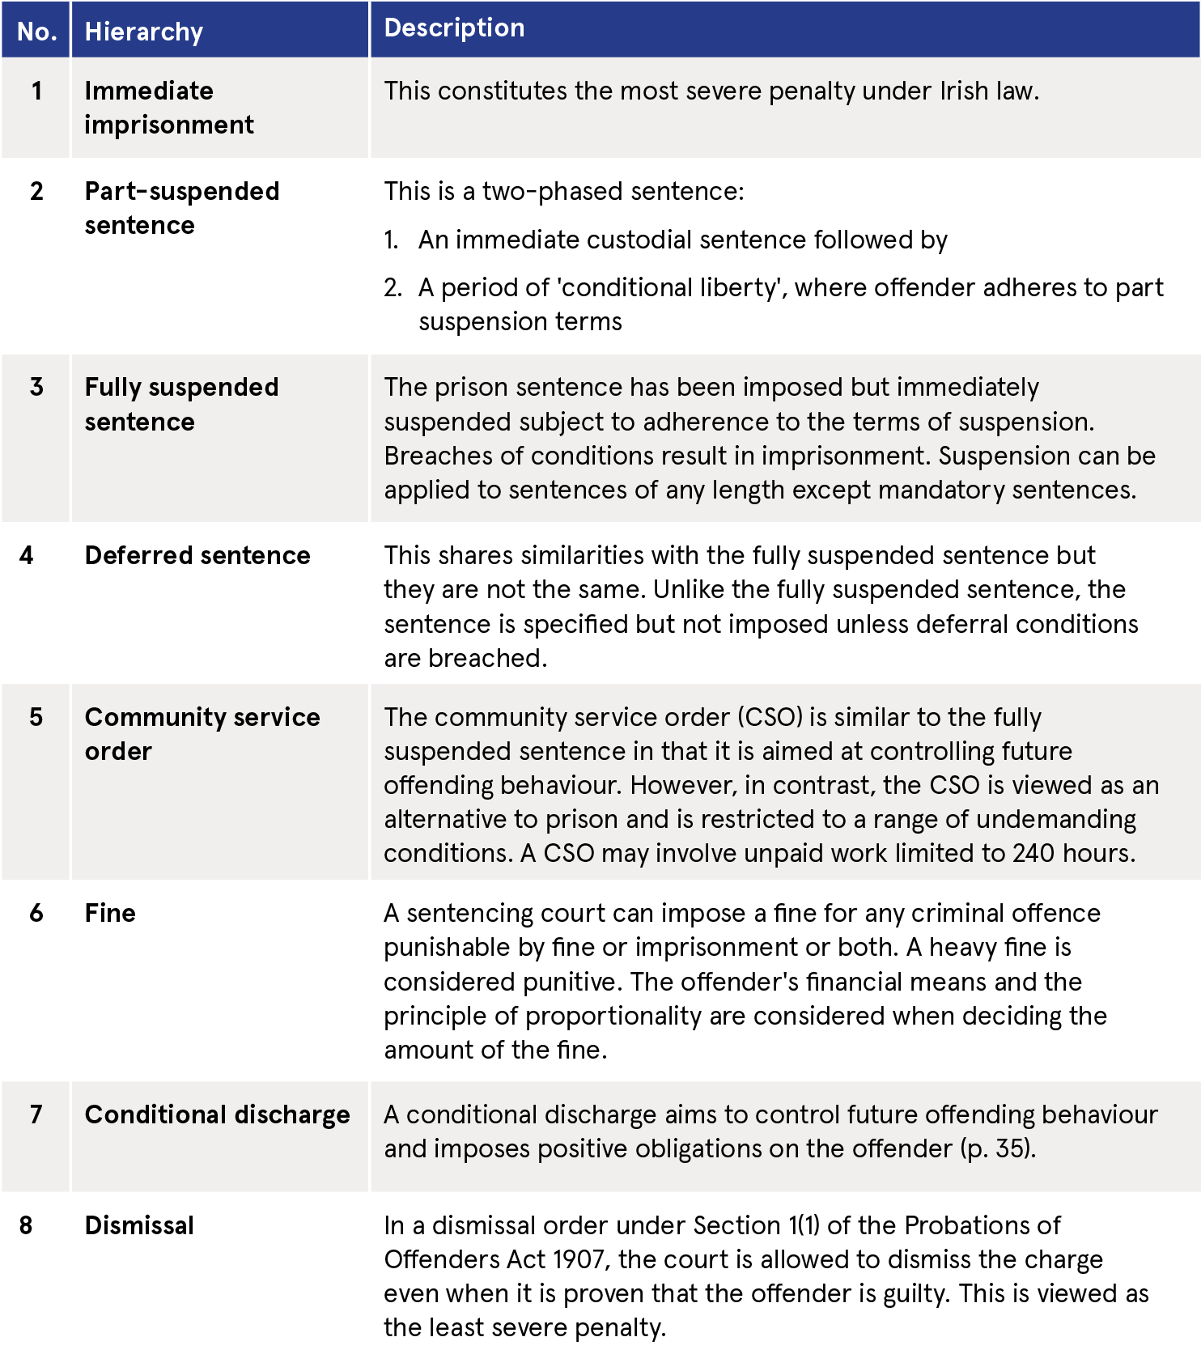
Ciara H Guiney

1 Law Reform Commission (2020) Report: Suspended sentences. Dublin: Law Reform Commission.
https://www.drugsandalcohol.ie/33140/
2 Law Reform Commission (2017) Issues paper: Suspended sentences. Dublin: Law Reform Commission.
https://www.drugsandalcohol.ie/27872/
3 Law Reform Commission (2013) Report: Mandatory sentences. Dublin: Law Reform Commission.
https://www.drugsandalcohol.ie/20242/
4 Strategic Review Group on Penal Policy (2014) Strategic review of penal policy: final report. Dublin: Department of Justice and Equality.
https://www.drugsandalcohol.ie/22657/
5 Law Reform Commission (2020) Law Reform Commission publishes report on suspended sentences [Press release]. Available online at:
https://www.lawreform.ie/_fileupload/press%20releases/Report%20on%20Suspended%20Sentences%20LRC-123%20-%20Press%20Release.pdf

European drug
report, 2021
The European Monitoring Centre for Drugs and Drug Addiction (EMCDDA) published the European drug report 2021: trends and developments¹ on 9 June 2021. The purpose of this report is to provide an overview and summary of the European drug situation up to the end of 2020. The analysis offered in the report must be regarded as preliminary due to the impact of Covid-19. The Health Research Board (HRB) provides the Irish data and research for the EMCDDA report.
Latest data
- Around 83 million or 28.9% of adults (aged 15–64 years) in the European Union (EU) are estimated to have used illicit drugs at least once in their lifetime.

- The most commonly tried drug is cannabis (47.6 million males and 30.9 million females).

- Much lower estimates are reported for the lifetime use of cocaine (9.6 million males and 4.3 million females), MDMA (6.8 million males and 3.5 million females), and amphetamines (5.9 million males and 2.7 million females).

- Levels of lifetime use of cannabis differ considerably between countries, ranging from around 4% of adults in Malta to 45% in France.

- Last-year drug use provides a measure of recent drug use and is largely concentrated among young adults. An estimated 17.4 million young adults (aged 15–34 years) used drugs in the last year (16.9%), with about twice as many males (21.6%) as females (12.1%) reporting doing so.

- The prevalence of high-risk opioid use among adults (aged 15–64 years) is estimated at 0.35% of the EU population, equivalent to 1 million high-risk opioid users in 2019.

- There were 510,000 clients in opioid substitution treatment in 2019 in the EU. Opioid users accounted for 26% of drug treatment requests.

- It is estimated that at least 5,141 overdose deaths, involving illicit drugs, occurred in the EU in 2019, representing an increase of 3% compared with 2018.

- Although injecting drug use has been declining in Europe for the past decade, it remains a major cause of drug-related harms.

- Opioids were involved in 76% of the fatal overdoses reported in the EU for 2019.

Covid-19
All routine indicators suggest that at the beginning of 2020 there was widespread availability of a diverse range of drugs of increasingly high purity or potency on the European drug market. Drug production and trafficking appears to have adapted rapidly to pandemic-related restrictions, and there is little evidence of any major disruptions in supply. Drug traffickers have adapted to travel restrictions and border closures with more reliance on smuggling via intermodal containers and commercial supply chains and less reliance on the use of human couriers. This is illustrated by the large seizures of cocaine and other drugs observed during 2020. Multi-tonne seizures of cocaine were reported in European ports in 2020 and early 2021, including 16 tonnes in Hamburg in Germany and 7.2 tonnes in Antwerp in Belgium. Although street-based retail drug markets were disrupted during the initial lockdowns, and some localised shortages were experienced, drug sellers and buyers appear to have adapted by increasing their use of encrypted messaging services, social media applications, online sources, and mail and home delivery services.
Information in 2021 suggests that reductions in drug consumption during the initial lockdowns are being reversed as social distancing measures reduce. Online surveys indicate less consumer interest in drugs usually associated with recreational events, such as MDMA, and greater interest in drugs linked with home use, such as LSD and 2C-B (2,5-dimethoxy-4-bromophenethylamine), and dissociative drugs such as ketamine.
Technology has also created opportunities for responding to drug problems. We can see this in the way that many drug services in Europe have also demonstrated resilience by adopting telemedicine approaches. While some services for those with drug problems have been disrupted due to the pandemic, the care sector has also adapted rather quickly, where services were able to introduce innovative working practices to mitigate the impact of the current crisis on their clients.
Diversity in supply and use of drugs
The patterns of use are becoming more complex, with people who use drugs being presented with a greater selection of substances. This is creating various health harms because of the use of more novel substances or from the interaction of multiple substances. Some countries are seeing an increase in crack cocaine availability and use. There are reports of the availability of smaller doses or cheaper packages of heroin, crack, and benzodiazepines. Benzodiazepines, either diverted from therapeutic use or not licenced for medical use in Europe, are appearing on the illicit drug market. Increased use of benzodiazepines was seen among high-risk drug users, prisoners, and some groups of recreational drug users, potentially reflecting the high availability and low cost of these substances and pandemic-related mental health issues.
New forms of cannabis and new ways of consuming them have emerged. There is increasing availability of high-potency products. Reports indicate that cannabis cultivation and synthetic drug production within the EU continued at pre-pandemic levels during 2020. The picture is complicated by highly potent synthetic cannabinoids, which have often been used to adulterate natural cannabis products.
Drug use prevalence and trends
Cannabis is the most commonly used drug – its prevalence is about five times that of other substances. While the use of heroin and other opioids remains relatively rare, these continue to be the drugs most commonly associated with the more harmful forms of use, including injecting. The extent of stimulant use and the types that are most common vary across countries, yet evidence is growing of a potential increase in stimulant injecting.
Brian Galvin

1 European Monitoring Centre for Drugs and Drug Addiction (EMCDDA) (2021) European drug report 2021: trends and developments. Luxembourg: Publications Office of the European Union.
https://www.drugsandalcohol.ie/34349/

Recent research
Impact of Covid-19 on drug and alcohol services and people who use drugs in Ireland: a report of survey findings
In January 2021, the Irish Government Economic and Evaluation Service (IGEES) published a report on the impact of the pandemic on services and people who use drugs.¹ The report was prepared by staff in the Research Services and Policy Unit and Health Analytics Division in the Department of Health on behalf of the department’s Drugs Policy and Social Inclusion Unit. The report is based on two surveys undertaken in 2020. An article outlining the findings of the first survey, the Mini-European Web Survey on Drugs: Covid-19, was published in issue 76 of Drugnet Ireland.² Data collection for the second, the Survey of Drug and Alcohol Services, was completed via an online survey and by email between August and September 2020.¹
The Survey of Drug and Alcohol Services was undertaken to assess the impact of Covid-19 on these services. In particular, the survey sought to capture how services have altered their operations in response to the pandemic and also to describe the effect on clients of services. Information on this final aspect of the survey was provided by services staff and service users were not directly involved in the survey. An invitation to participate in the survey was sent to over 500 email addresses for drug and alcohol services in Ireland and participants were given two and half weeks to complete the survey.
A total of 157 completed responses were submitted. Community Drugs Projects (n=86), family support services (n=53), and counselling services (n=50) were well represented, particularly those based in Dublin. Some respondents can be included in more than one of these categories. There were also responses from Drug and Alcohol Task Forces, low threshold services, peer support services, HSE Addiction Services, residential services, and general practitioners.
Effects of Covid-19 on clients
Regarding the direct effects of Covid-19, some 44 (28%) respondents said that clients were highly impacted by having to self-isolate or cocoon; 10 (7%) said a diagnosis of Covid-19 had highly impacted clients; with 4 (3%) saying that hospitalisation had had a high impact. The majority of services (n=133, 85%) had some experience of clients self-isolating in wave 1 of the pandemic, while just under one-half were aware of clients who had been diagnosed with Covid-19.
According to respondents, the most challenging aspects of the pandemic for clients were adhering to the restrictions concerning meeting people, self-isolating, restrictions on travel, and physical distancing. The majority of services responding (n=149, 96%) reported a negative impact on clients’ mental health, followed by the impact on family relationships (n=129, 83%). The numbers reporting a positive impact as a result of these factors was very small. Other negative effects reported by a majority of services were the physical health and financial situation of clients.
Most services (n=113, 77%) reported that social isolation impacted on clients to some extent, while 114 services (74%) said that increased domestic violence impacted on clients. Most services were also aware of the impact of increased drug-related intimidation and violence and increased overdoses. Fewer services (n=56, 37%) reported drug-related deaths among those using their services. Regarding the effect of the pandemic on particular population groups, 65% of services who responded said among those who were homeless that health and wellbeing was highly impacted, while 60% of services said women were highly impacted.
Increased alcohol consumption among clients was observed by 68% (n=104) of services, while 42% (n=61) of services reported increased drug use, with just 8% (n=14) reporting a reduction in drug use among clients. In relation to availability of drugs, 73% (n=108) of respondents had heard reports that clients were having difficulty getting drugs and had greater use of novel methods of acquisition such as online purchases, ‘drug drops’, and home deliveries.
Impact on services
Most of the survey respondents (n=116, 74%) said that their services had been highly impacted by Covid-19, with 25% (n=40) reporting lower levels of impacts. Nearly one-half of the services responding (n=70, 46%) said the numbers using their services had increased. Overall, harm reduction services had decreased for clients, with just 33% reporting increases. The majority of service types saw a reduction in face-to-face contact with clients. This was particularly true for Drug and Alcohol Task Forces, family support services, and peer support services. Most services are providing counselling and other supports by telephone or online. Residential treatment services were the type of service most likely to use video conferencing, an appropriate tool for group therapy sessions.
Drug and alcohol services adapted to a reduction in face-to-face contact, travel restrictions, and social distancing by prioritising the continuity of care for those who are opioid dependent; faster processing of clients into treatment; stabilisation of drug use in isolation; and providing Covid-19 prevention information as part of outreach services. Clients were enabled to access their medications by new methods provided under temporary changes to regulations and the vast majority of services have developed new ways of engaging with clients and providing for their needs.
The survey of services outlines the impacts of the Covid-19 pandemic on service capacity, staff, operations, and governance and reporting. Services described how they adapted to the challenges and communicated with their clients online or by telephone. There was detailed information on the typical responses of health services to the pandemic, including use of personal protective equipment and social distancing. Survey findings have also provided an indication of the negative impacts the pandemic has had on the health and wellbeing of clients and on their consumption behaviours.
Brian Galvin

1 Bruton L, Featherstone T and Gibney S (2021) Impact of COVID-19 on drug and alcohol services and people who use drugs in Ireland: a report of survey findings. Dublin: Government of Ireland. https://www.drugsandalcohol.ie/34128/
2 Mongan D (2021) Impact of Covid-19 on drug use in Ireland. Drugnet Ireland, 76 (Winter): 1–7.
https://www.drugsandalcohol.ie/33957/
Stigma of growing older on methadone maintenance treatment
Background
Following the opiate epidemic of the 1980s and 1990s, the United States (US) and many countries across Europe have seen a significant increase in the proportion of older individuals with a drug dependency and those receiving drug treatment. In 2017, the European Monitoring Centre for Drugs and Drug Addiction (EMCDDA) reported that clients over the age of 40 receiving methadone maintenance treatment (MMT) had increased from 20% to 40% between 2006 and 2015.¹ These trends are also reflected in Irish data, with a growing number of clients over the age of 35 receiving treatment for opiate use since 2009.²
The connection between drug use and the experience of stigma and discrimination in society is well known. However, there is also a growing recognition of stigmatisation against opioid agonist therapies, such as MMT, despite vast evidence of the public health benefits these interventions provide.^{3,4} In addition, increasing age is associated with stigma becoming further pronounced; however, with only limited research to date, the experiences of those interacting with drug treatment services over a prolonged timeframe are not well understood.
Stigma, classically defined as an ‘attribute that is deeply discrediting’ by Erving Goffman in 1963,⁵ has since been conceptualised on three interacting levels: institutional stigma, social stigma, and self-stigma. The complex and overlapping nature of stigma presents a significant barrier to individuals in which negative stereotyping at all levels serves to reinforce the structural inequalities in place.
In line with similar studies published in the US and the United Kingdom (UK) identifying age-related embarrassment and shame in older methadone patients, a 2021 research paper by Mayock and Butler, published in the journal Drugs: Education, Prevention and Policy, examined the intersecting levels of stigma experienced by service users who are growing older on long-term MMT in Ireland.⁶
Methods
In-depth qualitative interviews were recorded with 25 long-term clients who had been enrolled in MMT at least 10 years prior to participating in the study. Recruitment was guided by a purposive sampling strategy within a geographical area of South Dublin and focused primarily on clients of specialist addiction clinics. An interview schedule of topics and questions was prepared in advance but maintained flexibility to ensure collected data accurately reflected the respondents’ personal perspectives. Analysis did not separate the sources of stigma in order to reflect the interwoven nature of these experiences by study participants.
Results
In total, 16 male and nine female clients participated in the study, all of whom identified as Irish and were of white ethnicity. Greater than two-thirds of participants were over the age of 40 at the time of the research taking place and 16 of the 25 recruited had accessed MMT more than 20 years previously.
Methadone treatment system
While study participants had encountered kindness and empathy among some healthcare professionals, accounts overall summarised the methadone treatment regime to be ‘demoralising’ and unlike other healthcare services. For many, stigma was experienced and conveyed through an absence of trust from treatment providers and a sense of control exerted over the client. Privileges such as takeaway doses could be easily withdrawn and the requirement to provide urine samples under supervision was described by interviewees as ‘mortifying’ and ‘degrading’. The lack of agency and palpable divide felt by clients with their treatment professionals served to reinforce feelings of inferiority and the perception of clients as deviant and a ‘junkie’.
Secrecy and concealment
For many participants, fear of public scrutiny and negative responses from family, friends, and the community dictated their behaviour towards clinic or pharmacy attendance. The pressure to manage public perceptions was reported by women, in particular, with one respondent explaining how she would ‘go down at a certain time knowing that’s the time there won’t be many there and I’m in and out in a flash’. Many clients felt they were treated differently and had experienced public shaming in these settings. One interviewee described how she was ‘outed’ by a pharmacist due to lack of discretion in the presence of a neighbour and felt that ‘the ground couldn’t open up fast enough, I just wanted to die’.
Participants also believed that revealing their status as a methadone patient could jeopardise their employment opportunities, and opinions expressed in the workplace served to strengthen the need for secrecy. As one interviewee explained of her colleagues: ‘I’d be afraid for them to know. The things they say about drug addicts … It wouldn’t go down good.’
Private burden
For study participants, the stigmatising attitudes and experiences in their external environment had perpetuated a deep sense of self-stigma interwoven with their self-identity. This was highlighted by one interviewee who described their personal perspective on addiction as ‘that’s what you do as a drug addict – you let people down, you’re unreliable, you’re of fucking no use to nobody’.
Internalised shame also impacted participants’ ability to have close relationships or form new ones for fear for rejection, with one participant describing herself as a ‘junkie in disguise’. Such feelings of social isolation and loneliness were reinforced further with age, with participants already having experienced long periods of marginality. Many had resigned themselves to being cut off from wider society and felt they were now condemned to ostracisation: ‘That sort of loneliness is physically painful, as well as emotionally, but I just can’t see that ever changing.’
Conclusions
This study describes how long-term methadone treatment was punctuated by stigma intersecting at macro, meso, and micro levels in clients’ lives. Methadone use in older patients implicitly revealed their histories as drug users and carried negative connotations that marked them as different to other health service users. The authors acknowledge the small sample size and selection of participants primarily from specialist addiction clinics to be limitations of this work. They recommend that future studies engage with larger groups and wider treatment contexts. Nevertheless, these findings reveal that current practices and public perceptions severely hinder an improved quality of life for long-term clients of MMT.
Emma McGrath

1 European Monitoring Centre for Drugs and Drug Addiction (2017) Health and social responses to drug problems: a European guide. Luxembourg: Publications Office of the European Union.
https://www.drugsandalcohol.ie/28040/
2 Health Research Board National Drugs Library (2017) Treatment data tables. Dublin: Health Research Board.
http://www.drugsandalcohol.ie/treatment-data/
3 Lloyd C (2013) The stigmatization of problem drug users: a narrative literature review. Drugs Educ Prev Pol, 20(2): 85–95.
4 Carlsen SEL, Gaulen Z, Alpers SE and Fjaereide M (2019) Beyond medication: life situation of older patients in opioid maintenance treatment. Addict Res Theory, 27(4): 305–313.
5 Goffman E (1963) Stigma: notes on the management of spoiled identity. Englewood-Cliffs, NJ: Prentice-Hall.
6 Mayock P and Butler S (2021) ‘I’m always hiding and ducking and diving’: the stigma of growing older on methadone. Drugs Educ Prev Pol, Early online. https://www.drugsandalcohol.ie/33894/

New evidence on school-based programmes
Schools are an important setting for the delivery of prevention and harm reduction interventions to adolescents. In April 2021, based on the findings of systematic reviews published in 2020, the European Monitoring Centre for Drugs and Drug Addiction (EMCDDA) updated the evidence on its Best Practice Portal (BPP) concerning school-based programmes to improve young people’s mental health and wellbeing and reduce risks related to substance use. They relate to school-based multicomponent positive psychology interventions (MCPPIs), school anti-bullying interventions, and e-health school-based interventions.^{1,2}
Multicomponent positive psychology interventions
Positive psychology interventions (PPIs) are scientifically based interventions that focus on strengthening positive emotions, thoughts, and behaviours through activities that can be easily implemented in daily routines.³ They focus on one component of wellbeing such as gratitude. In their simplest terms, MCPPIs differ in that they focus on two or more components that target both the eudaimonic (wellbeing as the realisation of one’s true inner potential and virtue as a pathway to experiencing a meaningful and fulfilling life) and hedonic (wellbeing as pleasure maximisation and pain avoidance) components of wellbeing.⁴ School-based MCPPIs aim to increase wellbeing indicators of mental health (i.e. subjective and psychological wellbeing) and reduce the most common psychological distress indicators (i.e. depression, anxiety, and stress) in adolescents.
While meta-analyses have shown the efficacy of MCPPIs in adult samples, the study of Tejada-Gallardo et al.³ is the first to investigate the effects in adolescents. Through meta-analysis they aimed to examine the immediate and long-lasting effects of school-based MCPPIs aimed at increasing wellbeing (subjective and psychological) and reducing psychological distress symptoms (depression, anxiety, and stress) of pupils from the general population aged between 10 and 18 years of age. While all of the nine studies (4898 participants) included wellbeing outcomes, only four looked at those related to psychological distress. Seven of the studies were randomised control trials and two were non-randomised control trials.
The authors found that MCPPIs can be effective in improving subjective (g=0.24, 95% CI: 0.11–0.38, p=0.000) and psychological (g=0.25, 95% CI: 0.01–0.51, p<0.05) wellbeing and reducing depression symptoms (g=0.28, 95% CI: 0.13–0.43, p=0.000) in adolescents. However, no effects were found for symptoms of anxiety, and effects on stress could not be analysed due to a lack of studies looking at this outcome. The positive effects on psychological wellbeing and depression symptoms were found to have remained significant in the long term. Based on these findings, the BPP rates these programmes as ‘beneficial’ and the authors conclude that:
Multicomponent positive psychology interventions offer an opportunity to ensure mental health during adolescents’ development in schools. Academic policies and education practitioners should consider the inclusion of these interventions within the school curriculum to promote adolescents’ mental health and optimal development.
(p. 1957)³
Anti-bullying interventions
Universal prevention activities target bullying as it has high prevalence rates and is associated with an increased lifetime prevalence of mental health disorders and therefore increase the risk of substance use. Two recent systematic reviews with meta-analysis have found small yet significant effects from these interventions on related outcomes. The findings have led the BPP to rate these kinds of interventions as ‘likely to be beneficial’.

The first review by Ng et al.⁴ covered 17 studies (n=35 694 participants) and found the interventions to have very small to small yet significant effects in:
- Reducing traditional bullying and cyberbullying perpetration (traditional: standardised mean differences [SMD] –0.30; cyber: SMD –0.16)

- Reducing traditional bullying and cyberbullying victimisation (traditional: SMD –0.18; cyber: SMD –0.13).
The authors found that programme effectiveness was not affected by type of intervention (i.e. whole school-based or classroom-based), programme duration, or presence of parental involvement. However, cyberbullying programmes were found to be more effective when delivered by technology-savvy content experts compared with teachers.
The second review by Fraguas et al.⁵ covered 69 randomised control trials (111 659 participants). They found school anti-bullying interventions to have small but significant effects in:
- Reducing bullying (effect size: −0.150; 95% CI: −0.191 to −0.109)

- Improving mental health problems (effect size: −0.205; 95% CI: −0.277 to −0.133) at study end point.
The review also considered the population impact number (PIN). In its simplest terms, PIN is the number in the whole population among whom one case will be prevented by the intervention. The review found that an average anti-bullying intervention needs to include 147 (95% CI: 113–213) people to prevent one case of bullying; 107 (95% CI: 73–173) people to improve mental health problems; and 167 (95% CI: 100–360) people to prevent one case of cyberbullying perpetration or exposure.
e-health interventions
Champion et al.⁶ carried out a systematic review and meta-analysis on the effectiveness of eHealth school-based interventions targeting multiple lifestyle risk behaviours. They included 16 studies (n=18 873 participants), which involved randomised controlled trials of eHealth (internet, computers, tablets, mobile technology, or tele-health) interventions that targeted two or more of the following behaviours: alcohol use, smoking, diet, physical activity, sedentary behaviour, and sleep. The primary outcomes of interest for the meta-analysis were the prevention or reduction of unhealthy behaviours, or improvement in healthy behaviours of the six behaviours.
While they found some effectiveness in improving physical activity, screen time, and fruit and vegetable intake, the effects were small and only evident immediately after the intervention. There was no effect found for alcohol use or smoking. These findings led the BPP to rate eHealth interventions in school as having ‘unknown effectiveness’. The authors conclude that ‘further high quality, adolescent-informed research is needed to develop eHealth interventions that can modify multiple behaviours and sustain long-term effects’
(p. e206).
Concluding comment
The EMCDDA continues to draw on new evidence to provide stakeholders with an accessible and reliable evidence base through the BPP. The findings of the MCPPIs are of particular interest in the Irish context. The evidence suggests support for whole-school prevention programmes currently being delivered in Irish schools, for example, in Social, Personal and Health Education (SPHE) and the Wellbeing programme. Rigorous evaluation of these programmes would reflect international best practice, in line with European Union minimum quality standards for prevention, to which Ireland signed up:
Prevention interventions form part of a coherent long-term prevention plan, are appropriately monitored on an ongoing basis allowing for necessary adjustments, are evaluated and the results disseminated so as to learn from new experiences.⁷
Ireland’s school-based prevention programmes could make a valuable contribution to the evidence base for the effectiveness of such interventions.
Lucy Dillon

1 European Monitoring Centre for Drugs and Drug Addiction (2021) EMCDDA Best practice portal update (2/2021). Lisbon: EMCDDA. Available online at: https://www.emcdda.europa.eu/news/2021/best-practice-portal-update-April_en
2 EMCDDA (2021) Best practice portal: School-based multicomponent positive psychology interventions on well-being and distress — evidence summary. Lisbon: EMCDDA. Available online at:
https://www.emcdda.europa.eu/best-practice/evidence-summaries/school-based-multicomponent-positive-psychology-interventions-well-being-and-distress_en
3 For a more detailed description, see p. 1944 of Tejada-Gallardo C, Blasco-Belled A, Torrelles-Nadal C and Alsinet C (2020) Effects of school-based multicomponent positive psychology interventions on well-being and distress in adolescents: a systematic review and meta-analysis. J Youth Adolesc, 49(10): 1943–1960.
https://www.drugsandalcohol.ie/34097/
4 Ng ED, Chua JYX and Shorey S (2020) The effectiveness of educational interventions on traditional bullying and cyberbullying among adolescents: a systematic review and meta-analysis. Trauma, Violence, & Abuse, Early online.
https://www.drugsandalcohol.ie/34096/
5 Fraguas D, Díaz-Caneja CM, Ayora M, et al. (2021) Assessment of school anti-bullying interventions: a meta-analysis of randomized clinical trials. JAMA Pediatr, 175(1): 44–55. Available online at:
https://jamanetwork.com/journals/jamapediatrics/article-abstract/2772453
6 Champion KE, Parmenter B, McGowan C, Spring B, Wafford QE, Gardner LA, et al. (2019) Effectiveness of school-based eHealth interventions to prevent multiple lifestyle risk behaviours among adolescents: a systematic review and meta-analysis. Lancet Digital Health, 1(5): e206–e221.
https://www.drugsandalcohol.ie/34095/
7 Council of the European Union (2015) Council conclusions on the implementation of the EU Action Plan on Drugs 2013–2016 regarding minimum quality standards in drug demand reduction in the European Union. 11985/15. Brussels: Council of the European Union.
https://www.drugsandalcohol.ie/24317/

Development of the Healthy Addiction Treatment recovery model for nursing in addiction services
Background
The purpose of a nursing model is to define the underpinning theory and concepts that guide nursing practice. To date, there is no nursing model specific to addiction services; however, several general models of nursing are frequently used in this context. An external review undertaken by Strang¹ described current models used within addiction services internationally as task-oriented and reactive, with little time available for nurses to work flexibly to client need. This contrasts with the understanding that service provision should support a person-centred journey to recovery.
To address this gap, Comiskey et al.² set out to develop an evidence-based addiction nursing model based on a cross-sectional survey of client needs and by mapping the relevant features of current models in practice. The proposed nurse-led Heathy Addiction Treatment (HAT) model targets health and recovery need at the population level, while allowing adaptation to local needs and settings.
Methods
The health-related needs of 131 clients receiving opiate agonist treatment across six Dublin drug treatment clinics were objectively assessed using the Opiate Treatment Index (OTI)^{3,4} structured interview tool with the General Health Questionnaire.^{5,6} The OTI measures a range of attributes across six domains: drug use, infectious disease risk, physical health, social functioning, criminality, and psychological adjustment. A numerical score is calculated for each outcome domain, with higher scores indicating a higher level of dysfunction. Data were collected from the study participants between May and November 2017.
In addition, relevant features from established nursing models were identified and mapped by an expert practice group through a formative review process to aid the development of the new model.
Results
Survey outcomes
Of the 131 clients that participated in the study, 66% were male and 34% were female, with a mean age of 41 years. All participants were on a substitution treatment programme with a median treatment duration of six years. Both men and women self-reported using heroin and cocaine on average more than once a week and polydrug use occurred more than once a day in the 30 days prior to interview. The most common physical symptoms reported by both genders were fatigue and energy loss, with about 70% of men and about 80% of women experiencing these health symptoms. Notably, the study reported a mean psychological adjustment score of 11.07 for women and 7.59 for men. Given the recommended cut-off point in this outcome domain is a score of 4, mental health was therefore identified as a priority need for clients in addiction nursing services.

Nursing models
A review of current nursing models by expert practitioners determined that elements of three key models were relevant to the development of the addiction nursing model in this study. The group proposed to draw from the BRENDA model,⁷ which represents a biopsychosocial approach of medical management combined with a series of short and structured discussions between the client and practitioner; the FRAMES model,⁸ which focuses on brief interventions to initiate behavioural change in a single measurable outcome; and the Tidal model,⁹ which works to promote mental health and empower clients to lead their own recovery.
Healthy Addiction Treatment recovery model
Informed by the client assessment outcomes and the objective review of seminal nursing models, a collaborative nurse-led hybrid model was proposed. The conceptual HAT model places individual clients at the centre, while assessing health and recovery need and measuring impact at the population level. A manual and flowchart were developed for piloting of the model in practice and staff were allocated a working caseload of volunteering clients. Mental health was identified as a priority need for the participating client group on development of the HAT model; however, for wider implementation the model can be adapted and applied to the greatest nursing need determined in varied client cohorts and environments.
Conclusion
From this study the authors recommend the first nursing model specific to addiction services. The HAT recovery model is a practical and measurable approach to address objectively identified need and can be implemented within existing addiction service structures. Greatest nursing need is prioritised by directing nursing staff time towards client-focused tasks and eradicating entrenched practices. As the model is implemented over time, services can increase capacity in this approach and establish procedures and evaluation processes contextually appropriate to the local setting.
Emma McGrath

1 Strang J (2011) Recovery-orientated drug treatment: an interim report. London: National Treatment Agency for Substance Misuse.
https://www.drugsandalcohol.ie/15524/
2 Comiskey C, Galligan K, Flanagan J, et al. (2021) The healthy addiction treatment recovery model: developing a client-driven, nurse-led addiction nursing model. J Addict Nurs, 32(1): e11–e20.
https://www.drugsandalcohol.ie/33854/
3 Darke S, Ward J, Hall W, et al. (1991) The Opiate Treatment Index (OTI) manual. Technical Report 11. Sydney: National Drug and Alcohol Research Centre.
4 Darke S, Hall W, Wodak A, et al. (1992) Development and validation of a multi-dimensional instrument for assessing outcome of treatment among opiate users: the Opiate Treatment Index. Br J Addict, 87(5): 733–742.
5 Goldberg DP (1972) The detection of psychiatric illness by questionnaire: a technique for the identification and assessment of non-psychotic psychiatric illness. Oxford: Oxford University Press.
6 Goldberg DP (1978) Manual of the General Health Questionnaire. Windsor: NFER Publishing.
7 Kaempf G, O’Donnell C and Oslin DW (1999) The BRENDA model: a psychosocial addiction model to identify and treat alcohol disorders in elders. Geriatr Nurs, 20(6): 302–304.
8 Bien TH, Miller WR and Tonigan JS (1993) Brief interventions for alcohol problems: a review. Addiction, 88(3): 315–336.
9 Barker P (2001) The Tidal model: developing an empowering, person-centred approach to recovery within psychiatric and mental health nursing. J Psychiatr Ment Health Nurs, 8(3): 233–240.

Prevalence and current situation
Trends in alcohol and drug admissions to psychiatric facilities
The annual report published by the Mental Health Information Systems Unit of the Health Research Board, Activities of Irish psychiatric units and hospitals 2019,¹ shows that the rate of new admissions to inpatient care for alcohol disorders has decreased.
In 2019, some 1,090 cases were admitted to psychiatric facilities with an alcohol disorder, of whom 301 were treated for the first time. Figure 1 presents the rates of first admission between 1999 and 2019 for cases with a diagnosis of an alcohol disorder. The admission rate in 2019 was lower than the previous year, and trends over time indicate an overall decline in first admissions. Approximately one-third (33.6%) of cases hospitalised for an alcohol disorder in 2019 stayed just under one week, while 31.2% of cases were hospitalised for between one and three months, similar to previous years.
In 2019, some 1,090 cases were also admitted to psychiatric facilities with a drug disorder. Of these cases, 440 were treated for the first time. Figure 2 presents the rates of first admission between 1999 and 2019 of cases with a diagnosis of a drug disorder. The admission rate in 2019 was higher than the previous year, and trends over time indicate an overall increase in the rate of first admission with a drug disorder since 2011. It should be noted that the report does not present data on drug use and psychiatric comorbidity; it is therefore not possible to determine whether or not these admissions
were appropriate.
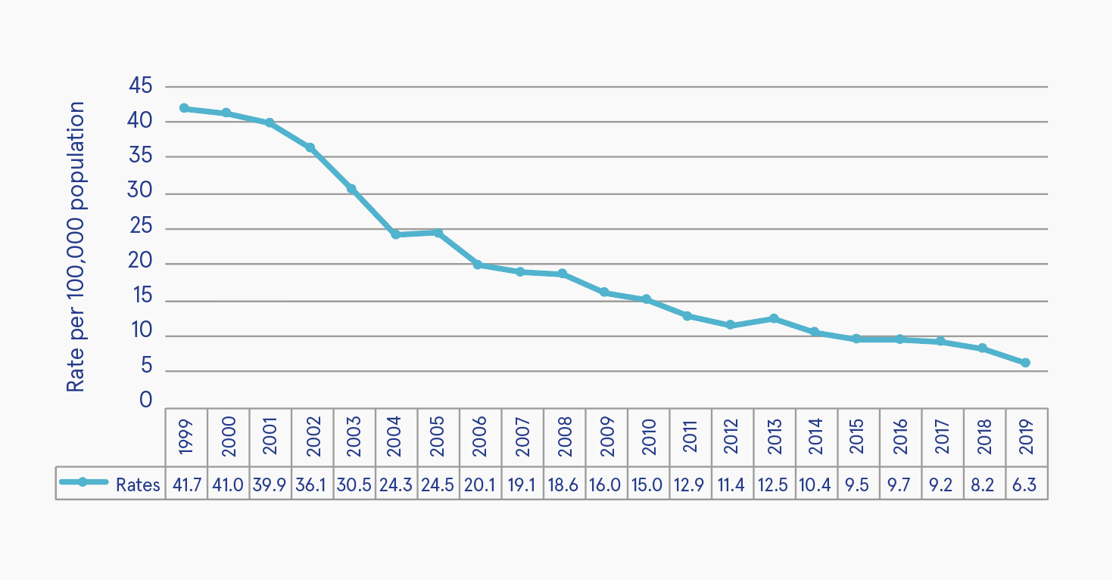
Source: Daly and Craig (2020)
Figure 1: Rates of psychiatric first admission of cases with a diagnosis of an alcohol disorder per 100,000 of population in Ireland, 1999-2019
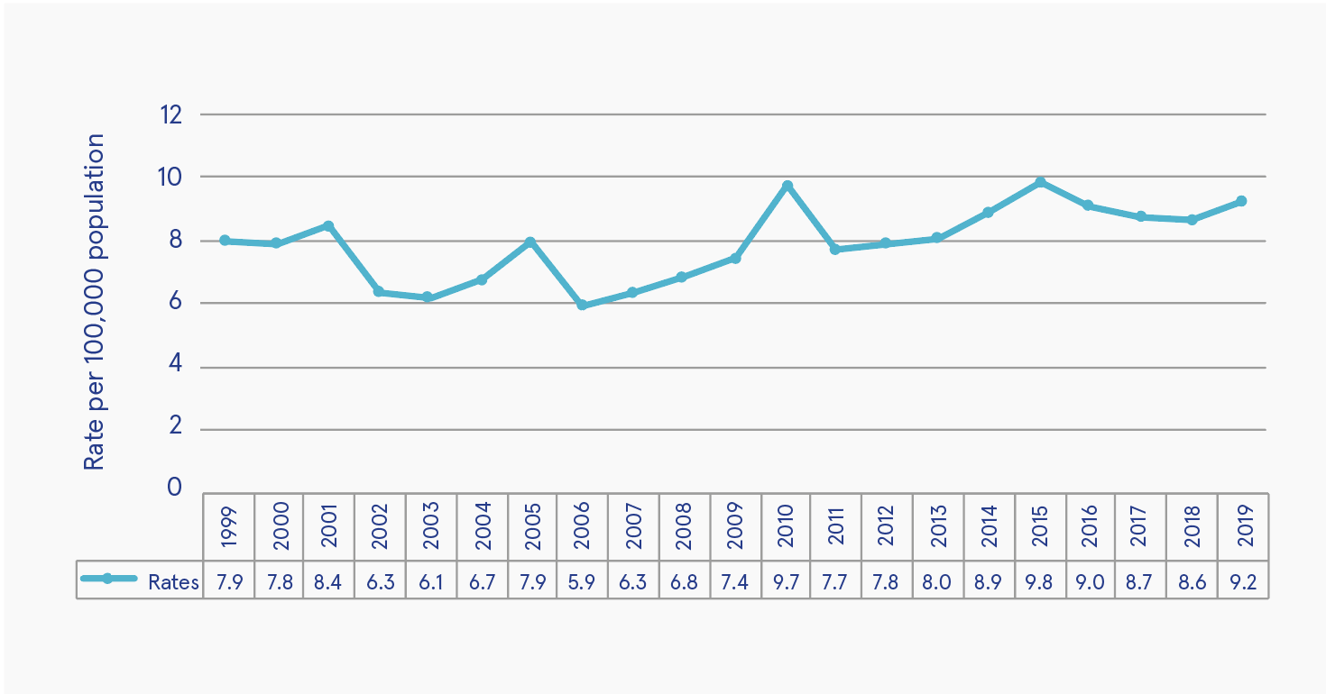
Source: Daly and Craig (2020)
Figure 2: Rates of psychiatric first admission of cases with a diagnosis of a drug disorder per 100,000 of population in Ireland, 1999-2019

Other notable statistics on admissions for a drug disorder in 2019 include the following:
- Less than one-half of cases hospitalised for a drug disorder stayed under one week (49.8%), while 98.7% were discharged within three months. It should be noted that admissions and discharges represent episodes or events and not persons.

- 17.3% of first-time admissions were involuntary.

- Similar to previous years, the rate of first-time admissions was higher for men (14.7 per 100,000) than for women (3.9 per 100,000).
Seán Millar

1 Daly A and Craig S (2020) Activities of Irish psychiatric units and hospitals 2019 main findings. Dublin: Health Research Board. https://www.drugsandalcohol.ie/32386/

National Self-Harm Registry annual report, 2019
The annual report from National Self-Harm Registry Ireland was published in 2020.¹ The report contains information relating to every recorded presentation of deliberate self-harm to acute hospital emergency departments in Ireland in 2019 and complete national coverage of cases treated. All individuals who were alive on admission to hospital following deliberate self-harm were included, along with the methods of deliberate self-harm that were used. Accidental overdoses of medication, street drugs, or alcohol were not included.
Rates of self-harm
There were 12,465 recorded presentations of deliberate self-harm in 2019, involving 9,705 individuals. Taking the population into account, the age-standardised rate of individuals presenting to hospital in the Republic of Ireland following self-harm was 206 per 100,000 population. This was a decrease of 2% compared with the rate recorded in 2018 (210 per 100,000) and 8% lower than the peak rate recorded by the registry in 2010 (223 per 100,000).
In 2019, the national male rate of self-harm was 187 per 100,000 population, 3% lower than in 2018. The female rate was 226 per 100,000 population, which was 1% lower than in 2018. With regard to age, the peak rate for men was in the 20-24 age group, at 485 per 100,000 population. The peak rate for women was among 15-19-year-olds, at 726 per 100,000 population.

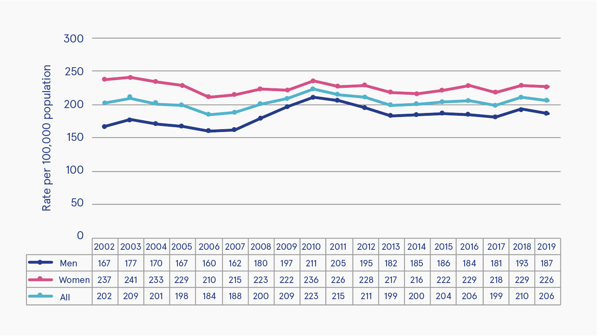
Source: National Suicide Research Foundation (2020)
‘All’ in the legend refers to the rate for both men and women per 100,000 population.
Figure 1: Person-based rate of deliberate self-harm from 2002 to 2019 by gender

Self-harm and drug and alcohol use
Intentional drug overdose was the most common form of deliberate self-harm reported in 2019, occurring in 7,763 (62.3%) of episodes. As observed in 2018, overdose rates were higher among women (67.1%) than among men (56.3%). Minor tranquillisers and major tranquilisers were involved in 33% and 9% of drug overdose acts, respectively. In total, 34% of male and 48% of female overdose cases involved analgesic drugs, most commonly paracetamol, which was involved in 31% of all drug overdose acts. In 69% of cases, the total number of tablets taken was known, with an average of 28 tablets taken in episodes of self-harm that involved a drug overdose.
In 2019, there was an increase in the number of self-harm presentations to hospital involving street drugs by 17% (from 742 to 870). Since 2007, the rate per 100,000 of intentional drug overdose involving street drugs has increased by 79% (from 9.9 to 17.8 per 100,000 population). Cocaine and cannabis were the most common street drugs recorded by the registry in 2019, present in 7% and 3% of overdose acts, respectively. Cocaine was most common among men, involved in 19% of overdose acts by 25-34-year-olds. Cannabis was most common among men aged 15-24 years and was present in 10% of overdose acts. Alcohol was involved in 31% of all self-harm presentations in 2019 and was more often involved in male episodes of self-harm than female episodes (36% vs 28%, respectively).
Recommendations
In 2019, there was a significant increase in presentations among persons experiencing homelessness, which is in line with previous trends identified in the period 2010-2014. The report authors noted that this group of individuals represent a particularly vulnerable population - at high risk of repetition and mortality from all causes. Although further work which examines factors associated with self-harm among persons experiencing homelessness is required, the authors suggest these findings underline the need for targeted suicide prevention interventions among this group.
Seán Millar

1 Joyce M, Daly C, McTernan N, et al. (2020) National Self-Harm Registry Ireland annual report 2019. Cork: National Suicide Research Foundation.
https://www.drugsandalcohol.ie/33511/

Repeated self-harm among young people following hospital-presenting intentional drug overdose
Background and methods
High rates of self-harm are consistently seen among young people in Ireland and other countries. The incidence of hospital-presenting self-harm peaks among young people, who most often engage in intentional drug overdose (IDO). In addition, the risk of self-harm repetition is also high among young people, with several countries reporting increases in youth self-harm since 2017.^{1,2,3} These trends are of concern, considering the association between self-harm and increased risk of suicide in young people, with repeated self-harm further elevating this risk. However, little is known about patterns of repetition and method-switching following IDO among young people.
An Irish study⁴ from 2020 investigated repeated self-harm and method-switching following hospital-presenting IDO among young people. In this research, published in the International Journal of Environmental Research and Public Health, data from National Self-Harm Registry Ireland on hospital-presenting self-harm by individuals aged 10–24 years during 2009–2018 were examined. Cox proportional hazards regression models with associated hazard ratios (HRs), survival curves, and Poisson regression models with risk ratios (RRs) were used to examine the risk factors for repetition and method-switching.
Results
During the period 2009–2018, some 16,800 young people presented following IDO. Of these hospital presentations, within 12 months, 2,136 young people repeated self-harm. Factors associated with repetition included being male (HR=1.13, 95% CI: 1.03–1.24); being aged 10–17 years (HR=1.29, 95% CI: 1.18–1.41); consuming 50 or more tablets (HR=1.27, 95% CI: 1.07–1.49); and taking benzodiazepines (HR=1.67, 95% CI: 1.40–1.98) or antidepressants (HR=1.36, 95% CI: 1.18–1.56). The cumulative risk for switching method was 2.4% (95% CI: 2.2–2.7). Method-switching was most likely to occur for males (RR=1.36; 95% CI: 1.09–1.69) and for those who took illegal drugs (RR=1.63; 95% CI: 1.19–2.25).
Conclusions
The authors discussed how young males were at increased risk of both repetition following IDO and method-switching – often to more potentially lethal methods of self-harm and that benzodiazepines and illegal drugs were associated with risk of repetition and method-switching among young people. They suggest that ensuring the provision of mental health assessments and regulating drug access are key action areas for the prevention of suicidal behaviour among young people.
Seán Millar

1 Griffin E, McMahon E, McNicholas F, Corcoran P, Perry IJ and Arensman E (2018) Increasing rates of self-harm among children, adolescents and young adults: a 10-year national registry study 2007–2016. Soc Psychiatry Psychiatr Epidemiol, 53: 663–671. https://www.drugsandalcohol.ie/29041/
2 Tyrrell EG, Orton E, Sayal K, Baker R and Kendrick D (2017) Differing patterns in intentional and unintentional poisonings among young people in England, 1998–2014: a population-based cohort study. J Public Health (Oxf), 39(2): e1–e9.
3 Cairns R, Karanges EA, Wong A, et al. (2019) Trends in self-poisoning and psychotropic drug use in people aged 5–19 years: a population-based retrospective cohort study in Australia. BMJ Open, 9(2): e026001.
4 Daly C, Griffin E, McMahon E, et al. (2020) Repeat self-harm following hospital-presenting intentional drug overdose among young people – a national registry study. Int J Environ Res Public Health, 17(17): 6159. https://www.drugsandalcohol.ie/32865/

Responses
Supporting quality standards in drug demand reduction
The Civil Society Forum on Drugs (CSFD) is an expert group of civil society organisations (CSOs) in the European Commission that supports the commission in its drug policy formulation and implementation.¹ One of its four working groups focuses on supporting and promoting the European Union’s (EU) 2015 minimum quality standards in drug demand reduction.² In January 2020, CSFD published its guidelines and recommendations for the implementation of minimum quality standards by CSOs,³ followed in 2021 by a CFSD advocacy plan for the promotion and implementation of minimum quality standards in drug demand reduction.⁴
Civil Society Forum on Drugs
The CSFD comprises 45 CSOs from across Europe. Ireland is represented by the Ana Liffey Drug Project and the CityWide Drugs Crisis Campaign. The group is described as ‘representing a variety of fields of drug policy, and a variety of stances within those fields’.¹ The purpose of the group is to facilitate a structured dialogue between the commission and European civil society to support drug policy formulation and implementation through practical advice. To meet this aim, CSFD is made up of four working groups, each of which focuses on a particular policy area: the EU Action Plan on Drugs; relations with international institutions; civil society involvement with national drug policies; and minimum quality standards. The focus of this article is on the work of the fourth group.

Minimum quality standards in drug demand reduction
The Council of the EU conclusions on the implementation of the EU Action Plan on Drugs 2013–2016 regarding minimum quality standards in drug demand reduction in the EU² were adopted by the council in 2015. It identified 16 quality standards to be met across the EU by drug demand reduction interventions in prevention; risk and harm reduction; and treatment, social integration, and rehabilitation. These standards are shown in Box 1 (overleaf). While there is no legal obligation on national governments to meet these standards, it is argued by the CSFD that they represent ‘the political will of EU countries to address demand reduction interventions through an evidence-based perspective’ (p. 4).³
Guidelines for quality standards
The CSFD working group on minimum quality standards has as its objectives to promote the implementation of the standards in EU member states (advocacy) and to improve knowledge
and skills among CSOs on how to implement
the standards at national level. Two of the activities carried out by the group to meet
these objectives were:
- To develop and apply an assessment tool through which CSOs could monitor and assess the implementation of the standards in their own countries and organisations

- To examine the feasibility of implementing the standards among CSOs.
In January 2020, the group published a set of guidelines and recommendations for the implementation of the standards grounded in
the earlier work of the group. The publication aims to support CSOs working in the drug demand reduction field to:
- Assess and implement their interventions according to the standards

- Identify potential barriers for incorporation

- Assess the potential need to provide training for practitioners and developers in the drug demand reduction field in line with these standards.

Box 1: Minimum quality standards in drug demand reduction
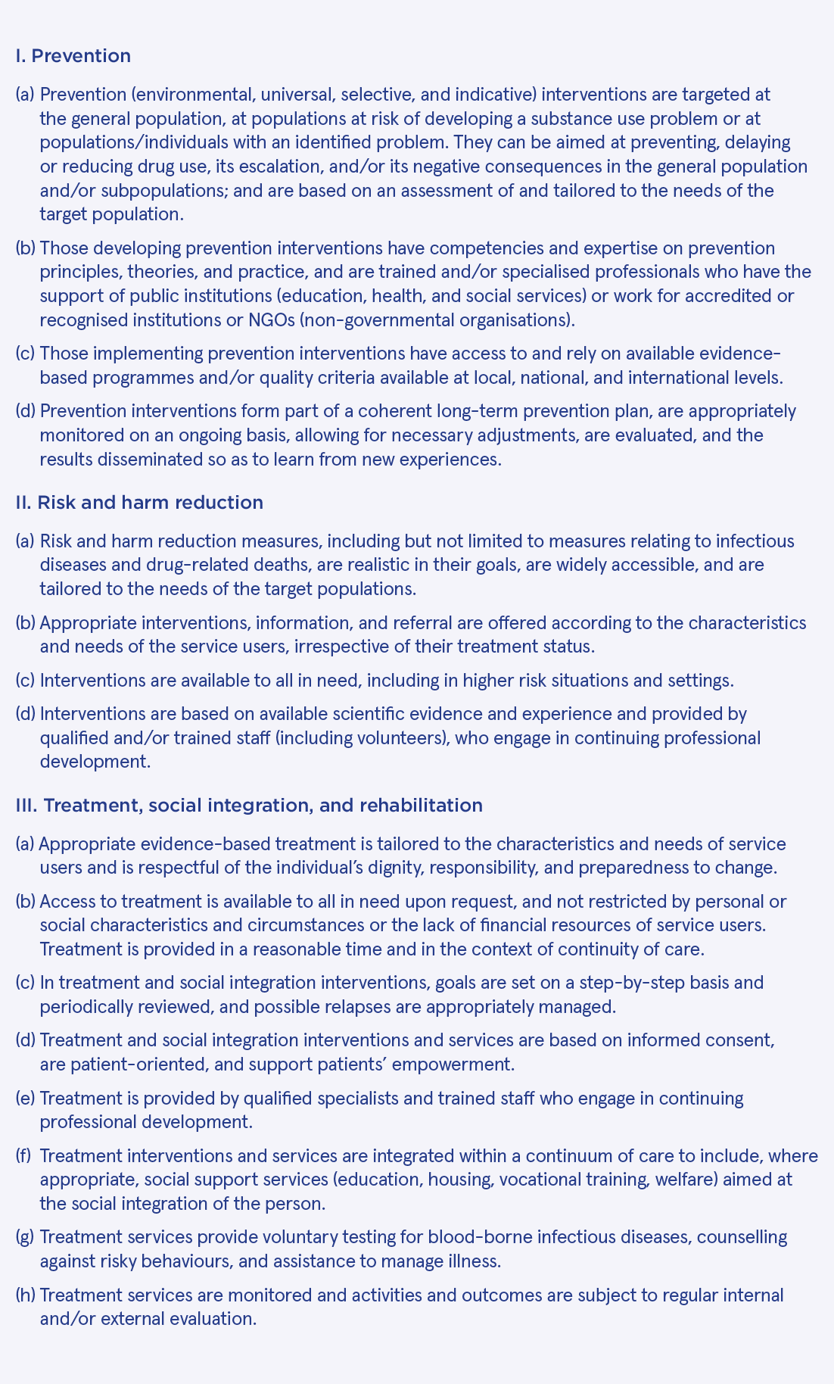
Source: Council of the European Union (2015)²

The guidelines are structured around the standards. Under each standard, the key findings of the assessment tool and feasibility analysis exercises are noted. Recommendations are then made for CSOs to consider when implementing that standard. For example, under prevention standard 3 on interventions being evidence based (see Box 1), it was found that this standard was poorly implemented both at the member state and CSO levels. There were almost no registries of evidence-based interventions found at national, regional or local level across member states. However, even where registries existed at an international level (e.g. the Xchange registry of the European Monitoring Centre for Drugs and Drug Addiction⁵), they were not being used to inform decisions about interventions. The guidelines recommend that CSOs draw on these registries as an integral element of their work and discuss them as a routine part of staff induction and training. Funders should require the CSO to provide evidence that any proposed intervention is consistent with good practice on registries such as Xchange.
Recommendations for improving quality
The guidelines provide a valuable overview of the situation in member states and illustrate the many ways in which they and their CSOs are failing to meet the minimum standards. Its conclusion captures four cross-cutting themes that best illustrate areas in urgent need of improvement.
- Disinvestment from ineffective and harmful interventions: Interventions which are known to be ineffective or even harmful for target populations continue to be funded across the EU. This is especially a feature in the fields of prevention and risk and harm reduction. Resources should be redirected towards the implementation of evidence-based and effective interventions.

- Education and training, and continuing professional development: A recurring theme throughout the report is a gap in quality education, training, and continuing professional development for the drug demand reduction workforce. This was found to be particularly acute in the fields of prevention and risk and harm reduction. It is recommended that governments and CSOs invest more resources in filling this gap.

- Monitoring and evaluation: The authors conclude that ‘the evaluation culture is weak in Europe in the field of drug demand reduction’ (p. 23).³ They argue for a balance in approach, whereby evaluation and monitoring become an integrated part of delivery but which do not take away from the delivery of quality services. Monitoring and evaluation would improve the quality of interventions and would motivate professionals delivering work found to be of good quality.

- Sustainable funding related to the implementation of standards: It was found that almost no sustainable funding was available to interventions in the field of drug demand reduction. It is recommended that this be addressed and that funding is linked to meeting the minimum quality standards. This would create a culture in which the knowledge and skills of the workforce and an evidence base of effective practice would be supported.
CSFD next steps
The CSFD’s work in this area is ongoing. Moving forward, the working group is to focus on ‘further dissemination and promotion of guidelines and recommendations across Europe, advocacy for assessment and implementation of standards in practice, and development and testing of training course for CSOs to improve the implementation of standards within civil society sector’ (p. 3).⁴ In February 2021, CSFD published an advocacy plan for the promotion and implementation of minimum quality standards in drug demand reduction by CSOs.⁴ This is a working document for the group of CSOs, which lays out specific activities that it is undertaking between 2020 and 2022 to meet their aim of advocating the implementation of the standards.
Conclusion
The work of CSFD highlights the need to improve quality in drug demand reduction interventions and to encourage stakeholders to make evidence-based decisions. In Ireland, advocacy for the implementation of the minimum quality standards needs to involve all stakeholders, such as policymakers, funders, and service providers, including CSOs. Advocacy needs to be complemented with training and support for those working in the sector. That way they can deliver services that meet these standards to ensure the most effective use of funding to deliver on the aims of interventions in this field. Training might include the European Prevention Curriculum (EUPC), which has been previously discussed in Drugnet Ireland. It is a programme of training, the primary goal of which is ‘to reduce the health, social and economic problems associated with substance use by building international prevention capacity through the expansion of the European professional prevention workforce’ (p. 10).⁶
Lucy Dillon

1 For further information on CSFD, visit:
http://www.civilsocietyforumondrugs.eu/
2 Council of the European Union (2015) Council conclusions on the implementation of the EU Action Plan on Drugs 2013–2016 regarding minimum quality standards in drug demand reduction in the European Union. 11985/15. Brussels: Council of the European Union.
https://www.drugsandalcohol.ie/24317/
3 Civil Society Forum on Drugs (2020) Guidelines and recommendations for the implementation of minimum quality standards by civil society organisations (CSOs). Amsterdam: Civil Society Forum on Drugs.
https://www.drugsandalcohol.ie/34040/
4 Civil Society Forum on Drugs (2021) CSFD advocacy plan for the promotion & implementation of minimum quality standards in drug demand reduction. Amsterdam: Civil Society Forum on Drugs. https://www.drugsandalcohol.ie/33833/
5 For further information on Xchange, visit:
http://www.emcdda.europa.eu/best-practice/xchange
6 European Monitoring Centre for Drugs and Drug Addiction (EMCDDA) (2019) European prevention curriculum: a handbook for decision-makers, opinion-makers and policy-makers in science-based prevention of substance use. Luxembourg: Publications Office of the European Union.
https://www.drugsandalcohol.ie/31119/

Registries for quality in prevention – Xchange and Healthy Nightlife Toolbox
As previously outlined in Drugnet Ireland, the Best Practice Portal of the European Monitoring Centre for Drugs and Drug Addiction (EMCDDA) is designed to help practitioners find practical and reliable information on what works (and what does not) in the areas of prevention, treatment, harm reduction, and social reintegration.¹ It aims to support these stakeholders to identify tried and tested interventions quickly, allocate resources to what is effective, and improve interventions applying tools, standards, and guidelines. As part of the portal, the EMCDDA hosts and maintains the Xchange prevention registry² and the Healthy Nightlife Toolbox (HNT).³ Stakeholders can use these registries to make evidence-based decisions about effective interventions.
Context
As discussed in the article on the Civil Society Forum on Drugs (CSFD) on page 27 in this publication, the Council conclusions on the implementation of the EU Action Plan on Drugs 2013–2016 regarding minimum quality standards in drug demand reduction in the European Union⁴ were adopted in 2015 by the Council of the European Union (EU). Among the standards adopted was that professionals have access to knowledge on effective drug demand reduction interventions. While there is a growing evidence base of what works, this often is not reflected in the interventions funded and delivered across Europe. The EMCDDA notes that ‘access to evidence-based prevention programmes is still limited and they remain under-utilised compared to prevention strategies with no empirical evidence for effectiveness’.⁵ The Xchange registry and the HNT aim to address
this problem.

Xchange prevention registry
Xchange is an online registry of evidence-based prevention interventions that aims to provide stakeholders with access to the evidence needed to make better decisions about which interventions to fund and implement. It includes:
- Manualised interventions for which European evaluation studies have shown beneficial outcomes relating to substance use as well as programmes for youth offending and bullying.

- Environmental prevention interventions, which are strategies that target the contexts for behaviour by changing the prompts and cues that guide behaviour. The purpose of environmental prevention policies and interventions is to limit the availability of unhealthy or risky behaviour opportunities or to promote the availability of healthy opportunities.
For each intervention on the registry there is:
- Information on the effectiveness of the programme/intervention from their evaluation(s)

- Information on the experiences of professionals who have implemented the programmes/interventions in Europe. The aim of this second strand is to help decision-makers assess the ease with which the approach could be implemented in different social, cultural, and organisational contexts.
Examples of Irish-delivered manualised programmes registered on Xchange and rated as ‘likely to be beneficial’ are: Good Behaviour Game; Functional Family Therapy; and Olweus Bullying Prevention Programme.
Healthy Nightlife Toolbox
Much like Xchange, the Healthy Nightlife Toolbox (HNT) provides evidence to support local, regional, and national policymakers and prevention workers in their decision-making about which interventions to select to help reduce harm among young people from alcohol and drug use in nightlife settings. At its core are three databases: evaluated interventions, literature on these interventions, and other literature within the field of nightlife alcohol and drug prevention. No Irish projects have been logged on the database to date. Interventions covered include pill testing, training for staff and professionals, legislative measures, and education for nightlife users.
Getting your intervention included
If you are a stakeholder who thinks an intervention you are involved with should be included on either of these registries, you can access more information on doing so.
- Xchange: Stakeholders are invited to carry out a self-assessment to see if their intervention qualifies for inclusion at: https://www.emcdda.europa.eu/best-practice/xchange

If they do not qualify, they can access an implementation toolbox which combines didactical elements with training tools and guidelines to help them make their interventions ready for inclusion in Xchange and fitter for real-life use: https://www.emcdda.europa.eu/best-practice/xchange/implementation-toolbox

- HNT: Stakeholders are invited to contribute
to the registry at: http://www.hntinfo.eu/contribute

Alternatively, stakeholders can send an email to: HNT@emcdda.europa.eu
Lucy Dillon

1 Dillon L (2021) EMCDDA Best Practice Portal. Drugnet Ireland, 76 (Winter): 13–14.
https://www.drugsandalcohol.ie/33960/
2 Further information on Xchange is available online at:
https://www.emcdda.europa.eu/best-practice/xchange
3 Further information on HNT is available online at:
http://www.hntinfo.eu/
4 Council of the European Union (2015) Council conclusions on the implementation of the EU Action Plan on Drugs 2013–2016 regarding minimum quality standards in drug demand reduction in the European Union. 11985/15. Brussels: Council of the European Union.
https://www.drugsandalcohol.ie/24317/
5 European Monitoring Centre for Drugs and Drug Addiction (EMCDDA) (2021) About the Xchange prevention registry. Lisbon: EMCDDA. Available online at:
https://www.emcdda.europa.eu/best-practice/xchange/about

Tabor Group annual report, 2019
The Tabor Group is a provider of residential addiction treatment services in Ireland. It aims to offer hope, healing, and recovery to clients suffering from addictions through integrated and caring services. In addition to three residential facilities, the organisation provides a continuing care programme to clients who have completed treatment in order to assist with their recovery. It also offers counselling to families whose loved ones are struggling with an addiction. In 2020, the Tabor Group published its annual report.¹ This article highlights services provided by the Tabor Group to individuals with a substance use addiction in 2019.
Tabor Lodge: residential addiction treatment centre
Tabor Lodge is a residential addiction treatment centre for the treatment of people addicted to alcohol, drugs, gambling, and food. It is situated 15 miles south of Cork city. Tabor Lodge is guided by the Minnesota Model of addiction treatment in delivering its treatment programme. This model is characterised by the understanding that addiction is primarily a substance use disorder. The primary focus of the treatment programme is to educate clients on the dynamics of this disorder as they manifest in the life of the individual. Another important focus of the treatment programme is to assist clients develop the skills necessary to manage their disorder while going forward in their lives.
A total of 185 clients (74% male) were admitted to Tabor Lodge for residential treatment of addiction in 2019, of whom 178 completed treatment. A breakdown of the specific drug of choice for admissions in 2019 is shown in Table 1. The report noted a 19% increase in clients reporting cocaine as their drug of choice compared with 2018.
Table 1: Specific drug of choice for clients admitted to Tabor Lodge: residential addiction treatment centre, in 2019
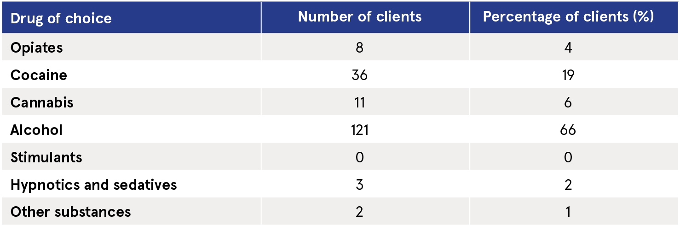
Source: Tabor Group (2020)

Table 2: Specific drug of choice for clients admitted to Tabor Fellowship: men’s residence extended treatment centre, in 2019
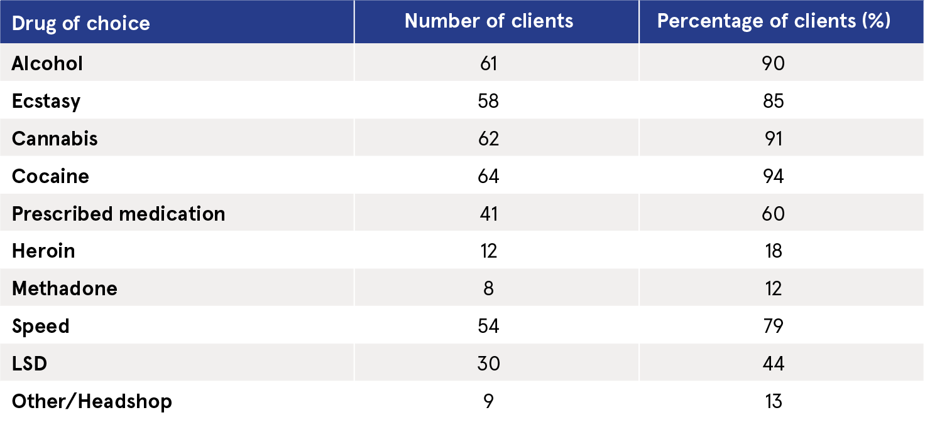
Source: Tabor Group (2020)

Table 3: Specific drug of choice for clients admitted to Tabor Renewal: women’s residence extended treatment centre, in 2019
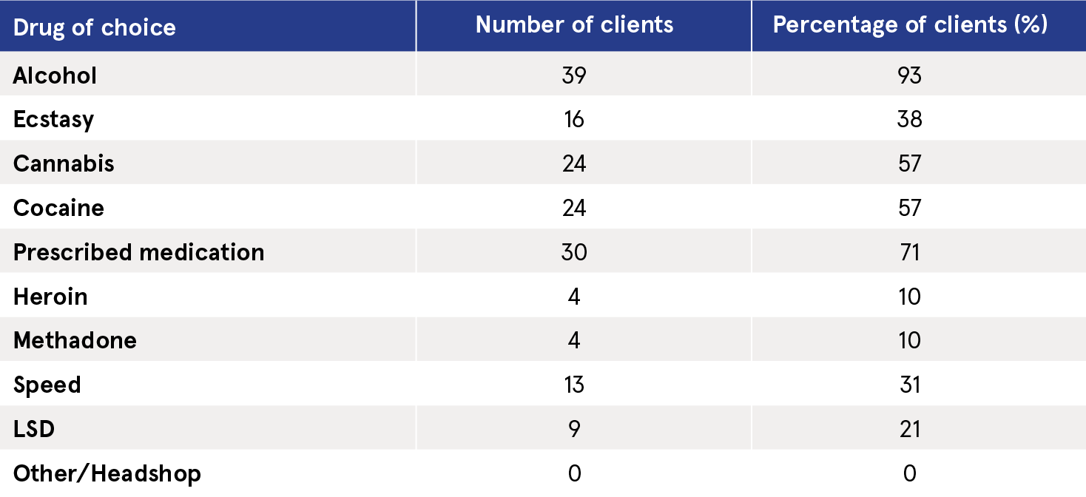
Source: Tabor Group (2020)

Tabor Fellowship: men’s residence extended treatment centre
The extended treatment programme for men is based on the Hazelden Minnesota Model and promotes ‘total abstinence’. The aim is to build on and consolidate the work of recovery already begun in primary treatment – even if that treatment was not in the recent past and the client is struggling to maintain sobriety.
In 2019, some 68 clients were admitted to Tabor Fellowship for extended treatment; a total of 43 individuals completed the programme. A breakdown of the specific drug of choice for admissions to Tabor Fellowship in 2019 is shown in Table 2. The report observed that 94% of clients reported cocaine as their specific choice of drug.
Tabor Renewal: women’s residence extended treatment centre
Tabor Renewal works with women who have already completed a primary 28-day treatment programme. It is a 12-week residential extended treatment programme, where clients learn to find routine, balance, and structure. Tabor Renewal is the only Minnesota Model extended treatment centre for women based in Ireland and was opened in 1999.
In 2019, some 42 clients were admitted to Tabor Renewal, of which 31 completed the programme. Sixty-two per cent of these clients were aged between 18 and 34 years. A breakdown of the specific drug of choice for admissions to Tabor Renewal in 2019 is shown in Table 3. That year, 93% of clients admitted presented with a history of alcohol abuse.
Seán Millar

1 Tabor Group (2020) Tabor Group annual report 2019. Cork: Tabor Group.
https://www.drugsandalcohol.ie/33529/

Launch of AcoRN,
the UK-Ireland Alcohol Research Network, 2021
What is AcoRN?
AcoRN, the UK-Ireland Alcohol Research Network, was formally launched on Thursday, 29 April 2021.¹ The aim of AcoRN is to generate and build capacity for interdisciplinary research into the development, adoption, implementation, and evaluation of alcohol policy innovation in Ireland and the United Kingdom (UK).
Why the need for this initiative?
Alcohol has become an increasingly important public health issue for both the Irish and UK governments. In Ireland, the Public Health (Alcohol) Act 2018 was a milestone in Government recognition that alcohol and its associated harms should be considered from a population health perspective. The passing of the Act demonstrated that while consuming alcohol is popular among Irish people and contributes to the Irish economy, it is also the cause of many social, criminal, and, of course, healthcare costs. Government policies were therefore needed to address this. But how do we quantify the intended and unintended effects of policies, not just on health, but on social, economic, and cultural aspects?
By combining the knowledge of alcohol policy researchers from a wide range of backgrounds interested in the study of alcohol policy, AcoRN aims to develop partnerships, promote the sharing of research ideas and methodologies, and identify common research priorities to deliver on the alcohol policy research needed in the UK and Ireland in the coming years.

Themes of AcoRN
The activities of AcoRN are organised around four themes:
Price – making alcohol less affordable through price policies
Availability – making alcohol less easily available
Marketing – by reducing how much alcohol is advertised and promoted
Politics – policymaking research.
AcoRN personnel
The initiative is the brainchild of Professor Joe Barry and Professor Niamh Fitzgerald and has been funded by the Economic and Social Research Council (UK) and the Irish Research Council. Professor Barry, a specialist in public health medicine in Trinity College Dublin, has worked in substance use for 30 years, while Professor Fitzgerald at the University of Stirling specialises in studies drawing on expertise across different academic disciplines to better understand intended and unintended consequences of policy interventions. They are joined in founding AcoRN by 14 co-applicants from 13 institutions across the UK and Ireland.
Launch of AcoRN
Suzanne Costello, CEO of the Public Health Institute of Ireland, commenced the online launch of AcoRN, which was attended by more than 60 researchers, policy and community colleagues, and other stakeholders. Professor Joe Barry delivered the first plenary presentation outlining the background and structure of the network. Attendees then chose two of the four breakout sessions based on the AcoRN themes.
Theme 1: Alcohol pricing
Colin Angus of the University of Sheffield led the first theme discussing alcohol pricing policy. Those attending had the opportunity to share their opinions, knowledge, and experiences in smaller groups. Minimum unit pricing (MUP) dominated the discussion, with Irish attendees raising their concerns of commencing MUP without it simultaneously commencing in Northern Ireland and the potential ramifications on the border areas in Ireland. Those from the UK spoke of the success of MUP in Scotland despite England not commencing at the same time.
Theme 2: Alcohol availability
Alcohol availability discussions were led by Professor Niamh Shortt of the University of Edinburgh. She outlined fascinating research investigating the impact of the high-density presence of alcohol premises and how exposure to branding and advertising shapes our behaviour. The group discussed how using small area data and consumption data can increase our knowledge of alcohol availability.
Theme 3: Alcohol marketing
The theme of alcohol marketing was led by Dr Pat Kenny of Technological University Dublin. Discussion focused on the Public Health (Alcohol) Act 2018 and how, as the components have been commenced in phases, the effect of each can be evaluated individually.
Theme 4: Alcohol politics
The final theme of alcohol politics/policymaking was led by Dr Matt Lesch of the University of York. Attendees discussed the conflict of interest when industry plays a role in policymaking and how we can better understand the role of ‘industry actors’ who focus on personal responsibility when it comes to alcohol consumption. Also discussed were how drinking at home has become the new norm and how work is being done on alcohol and homelessness.
Conclusion
In the final session, Professor Fitzgerald presented the next steps for AcoRN: a website, blog, and social media account;² a series of seminars to build teams for future research; early career researchers to be given opportunities to work with more experienced colleagues; a workshop to build capacity on alcohol policy research and allowing time for teams to develop funding applications; and a UK/Ireland open research symposium.
Professor Fitzgerald concluded the launch by outlining the aspirations and next steps of AcoRN:
By developing new partnerships between areas of research and different countries, sharing ideas and identifying common priorities, we will be able to effectively grow and diversify the strength of the vital research in this area.

Anne Doyle

1 Further information about the AcoRN initiative is available on their website:
http://alcoholresearch-uk-irl.net/
2 To follow the activities of AcoRN on social media, their twitter handle is @AcornAlcohol.

The National Family Support Network
The National Family Support Network (NFSN)¹ ceased operations on Monday, 26 April 2021. The original Family Support Network was established in 2000 following the successful organisation by family support groups of the first Service of Commemoration and Hope. This spiritual, multidenominational service is held in remembrance of loved ones lost to substance misuse and related causes and to publicly support and offer hope to families living with the devastation that substance misuse causes. Subsequent to the success of this event and the evident desire of families to continue with such events, the Family Support Network was formed under the auspices of the CityWide Drugs Crisis Campaign.
The Family Support Network membership consists of representatives of family support groups, individual family members, and those working directly with families of people who use drugs across the island of Ireland. The network was set up as an autonomous self-help organisation that provided support to families and respected the experiences of families affected by substance misuse in a welcoming non-judgemental atmosphere. In 2007, the Family Support Network gained recognition as an autonomous national organisation.
On Monday, 22 March 2021, the NFSN held its 22nd Annual Service of Commemoration and Hope in the Church of Our Lady of Lourdes, Sean MacDermott Street, Dublin, with this yearʼs service available online.² Speaking at the service, the networkʼs outgoing CEO Sadie Grace highlighted the ongoing devastation associated with drug use, including drug-related deaths, for families and communities across Ireland. She called for person-centred care, access to treatment, and early interventions for people who use drugs. Sadie emphasised that living with a family member who has an addiction to a substance(s) was a major life stressor, with other family members experiencing both physical and emotional health impacts as a result. She stressed that these families represent the hidden costs of the drug crisis in Ireland. She also called on the State to take meaningful action to combat the ‘horror’ of drug-related intimidation.
Achievements of NFSN
As Sadie retires from her role in NFSN after giving 27 years to family support, she outlined some of the achievements of the network during her leadership:
- Advocating and securing the development of the National Drug-Related Deaths Index (NDRDI)

- Advocating and assisting in achieving greater access to naloxone, including involvement in the HSE Naloxone Demonstration Project

- Assisting families pay for funeral expenses, with the generous support of the Archdiocese of Dublin

- Advocating and achieving advanced bereavement-specific supports and respite for families affected by drug-related deaths

- Developing interventions to help families experiencing drug-related intimidation
- Developing and operating a biannual bereavement support programme

- Reporting on the impact of drug-related deaths on families, which led to the first specific addiction bereavement support for families

- Conducting research into the outcomes, especially health outcomes for family members living with loved ones with addiction.
She said the network continued to call for:
- Family support coordinators to be based in every drug taskforce area; and she was encouraged by the support of Minister Frank Feighan TD in this regard

- Actions to be prioritised in the national drugs strategy for families, including supports for kinship carers and respite for families

- Specific national bereavement support services for families

- Meaningful action on the issue of drug-related intimidation.

Recognition of NFSN
In his address, Minister Feighan reinforced the message that drug addiction is a health issue and not a criminal issue, where focus must be on recovery options not punishment. Drug-related intimidation is an area of concern, which he believes requires special attention, and he welcomed the evaluation of the drug-related intimidation reporting programme carried out by the NFSN and An Garda Síochána. Minister Feighan supports the Government’s decision to develop a medically supervised drug injecting facility in Dublin and highlighted that, as a society, Ireland needs to have a more open and tolerant approach to drug use. An Taoiseach Micheál Martin, in his address, gave a commitment to fulfil the Government's responsibility in the national drugs strategy.
Many speakers on the night of the Service of Commemoration and Hope praised the work of NFSN and its dedicated staff, especially the unreserved dedication, commitment, and drive of Sadie Grace in her support to people and family members affected by drug use. They passed on their best wishes to Sadie while she moves to a new chapter in her life.
Following the service, panel discussions were held to discuss various aspects in relation to NFSN, the service itself, and the impact of drug use on families, which can be viewed online via the NFSN website.² Contact details for local and regional family support networks are currently available via the NFSN website.¹
Ena Lynn

1 The National Family Support Network ceased operations on Monday, 26 April 2021, as reported on their website: www.fsn.ie
2 To view the service, visit:
http://www.fsn.ie/news-events/events/service-of-commemoration-and-hope-22nd-march-2021
HRB National Drugs Library survey, 2021
The HRB National Drugs Library,¹ based within the Health Research Board, supports those working to develop the knowledge base around drug, alcohol, and tobacco use in Ireland. In February 2021, staff of the library asked visitors to its website to fill in a short survey about their experience of the website and library services. Forty-two responses were received and some of the survey findings are presented here.
Survey findings
In terms of what the respondents liked about the website, most considered it easy or simple to use, up-to-date, and user friendly. They liked that they could access this large collection in one place.
It is a fantastic and well curated resource and picks up relevant research across the country. It’s brilliant.
User-friendly, easy to find what I need.
In terms of what they thought could be improved upon, the search facility was the number one issue mentioned. Navigating the site was also a problem for some respondents. A few respondents mentioned that they would like to see more data, especially Irish data.
Sometimes [it’s] hard to pin down what I want to find.
Can be hard to find [an] exact match in search sometimes.
To assess the impact of the library on the work of those working in the area of substance use, we asked respondents if the library had contributed to, or changed, their work or study. Figure 1 shows how the library has enabled evidence-informed policy, practice, research or education among the 42 respondents.

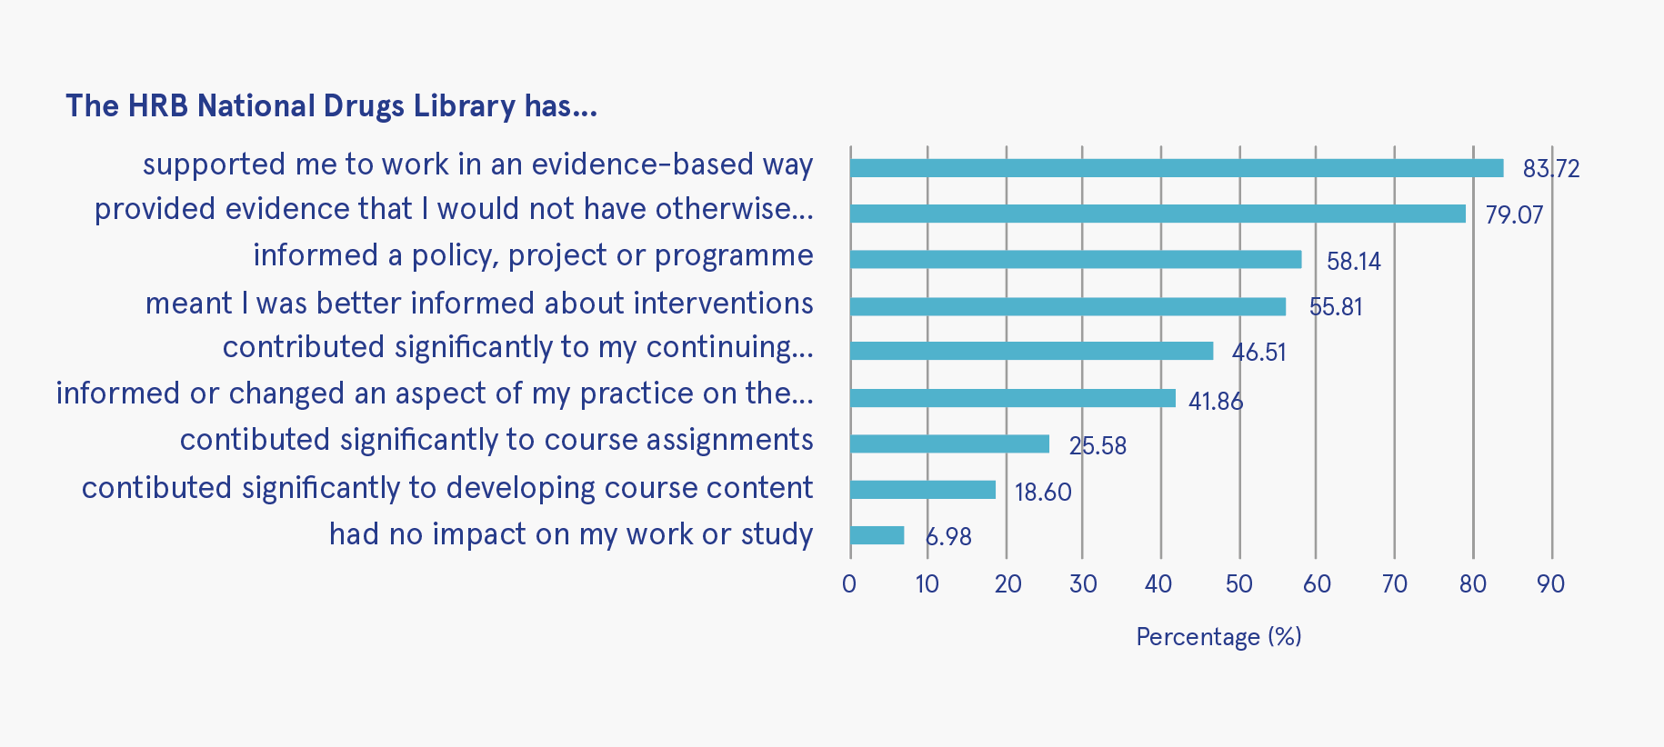
Figure 1: How the drugs library enabled evidence-informed policy, practice, research or education

Discussion
The wealth of information in responses is certainly guiding our developments. We know, for example, that finding good-quality research and relevant information can be difficult, especially as our collection grows. We are working on honing and improving our subjects (keywords) and search so that users can more easily refine their criteria. We hope that the recent addition of the advanced search options – ‘review’, ‘guideline’, ‘peer reviewed articles’, ‘Irish-related’ and ‘international’ – will assist with this.
The key Irish data page is designed to draw together published data on the situation in Ireland. It includes pages for Irish prevalence, treatment, and deaths data. As we identify other data sources, we will add them to this resource. We would like to thank all our respondents for their time, useful suggestions, and kind comments. Further feedback can be emailed to drugslibrary@hrb.ie
Mary Dunne

1 The HRB National Drugs Library website can be accessed at https://www.drugsandalcohol.ie/

updates
Recent publications
Prevalence and current situation
Civil society involvement in harm reduction drug policy: reflections on the past, expectations for the future
OʼGorman A and Schatz E (2021) Harm Reduction Journal, 18: 17.
https://www.drugsandalcohol.ie/33975/
This paper is based on the presentations and discussions from a workshop on ʼCivil Society Involvement in Drug Policyʼ hosted by the Correlation – European Harm Reduction Network at the International Society for the Study of Drugs Policy (ISSDP) annual conference in Paris, 2019. In the aftermath of the workshop, the authors analysed the papers and discussions and identified the key themes arising to inform CSI [civil society involvement] in developing future harm reduction policy and practice.
Civil society spaces are colonised by a broad range of civil society actors lobbying from different ideological standpoints including those advocating for a ’drug free world’ and those advocating for harm reduction. In these competitive arena, it may be difficult for harm reduction orientated CSOs [civil society organisations] to influence the policy process. However, the current Covid-19 public health crisis clearly demonstrates the benefits of partnership between CSOs and political institutions to address the harm reduction needs of people who use drugs. The lessons drawn from our workshop serve to inform all partners on this pathway.

Responses
How a moral panic influenced the world’s first blanket ban on new psychoactive substances
Windle J and Murphy P (2021) Drugs: Education Prevention and Policy, Early online.
https://www.drugsandalcohol.ie/34014/
This review found that head shops were largely tolerated when they sold cannabis paraphernalia (2000–2008), possibly indicating the normalisation of cannabis in Ireland. Some mild condemnatory language emerges between 2008 and 2009 when head shops began selling some new psychoactive substances [NPS]. The review suggests that the 2010 Act was partly a product of a moral panic, driven and managed by a range of moral entrepreneurs and involving both peaceful and violent protests. Unlike some traditional moral panics, young people were not identified as folk devils but rather as under threat from a new drug distribution model (head shops) and new drugs (NPS).

Prevalence and current situation
ADHD stimulant medication misuse and considerations for current prescribing practice: a literature review
Carolan D (2021) Irish Journal of Medical Science, Early online.
https://www.drugsandalcohol.ie/33754/
This study aimed to chronicle the development of medical and scientific opinion on the subject of substance use disorders (SUD) outcomes in ADHD [attention deficit hyperactivity disorder] and to appraise most recently published research in this sphere.
Consideration of the impact that variable treatment trajectories may have on the risk of later SUD development is recommended, with further research potentially leading to the development of different management pathways based on an individual's multivariate treatment profile.

College students’ perspectives on an alcohol prevention programme and student drinking
– a focus group study
Calnan S and Davoren MP (2021) Nordic Studies on Alcohol and Drugs, Early online
https://www.drugsandalcohol.ie/34130/
This qualitative study aimed to address this gap [in research] by examining college students’ perspectives in the context of an alcohol prevention programme for college students in Ireland.
Viewing the findings through a social-ecological lens, students seemed to collectively acknowledge the different layers of influence on student drinking, acknowledging the complex nature of this issue. Providing a greater variety of leisure spaces, including alcohol-free environments, was viewed particularly favourably by the student participants in terms of solutions proposed.

Trends in strong opioid prescribing in Ireland: a repeated cross-sectional analysis of a national pharmacy claims database between 2010 and 2019
Norris BA, Smith A, Doran S and Barry M (2021) Pharmacoepidemiology and Drug Safety,
30: 1003–1011.
https://www.drugsandalcohol.ie/34072/
This study investigated strong opioid prescribing in Irish General Medical Services (GMS) patients over a 10-year period.
This study found an overall increase in strong opioid prescribing in Ireland between 2010 and 2019, particularly in older adults. Tramadol was the most frequently prescribed product, with oxycodone and tapentadol prescribing increasing markedly over the study period.

Potential alcohol use disorder among MSM in Ireland - findings from the European MSM internet survey (EMIS 2017)
Daly FP, OʼDonnell K, Davoren MP, Noone C, Weatherburn P, Quinlan M, Foley B, Igoe D and Barrett PM (2021) Drug and Alcohol Dependence, 223: 108698
https://www.drugsandalcohol.ie/34090/
Alcohol consumption is a major public health concern in Ireland. Alcohol use disorder (AUD) disproportionately affects men who have sex with men (MSM). However, little is known about the prevalence of AUD in this group in Ireland specifically, and the characteristics of MSM who may struggle with this.
The prevalence of AUD appears to be higher in the MSM population compared to the general male population in Ireland. Targeted interventions may be warranted to reduce the burden of AUD among MSM.

Improvement in psychological wellbeing among adolescents with a substance use disorder attending an outpatient treatment programme
Gamage NM, Darker CD and Smyth BP (2021) Irish Journal of Psychological Medicine, Early online.
https://www.drugsandalcohol.ie/34026/
This study aimed to examine the impact of an outpatient substance use treatment programme upon the psychological wellbeing of adolescents.
The findings indicate that substance use treatment for adolescents is associated with important psychological and behavioural improvements.

Factors associated with changes in consumption among smokers and alcohol drinkers during the COVID-19 ʼlockdownʼ period
Reynolds CME, Purdy J, Rodriguez L and McAvoy H (2021) European Journal of Public Health, Early online.
https://www.drugsandalcohol.ie/34071/
This study aimed to identify factors associated with changes in alcohol and tobacco consumption during the strictest period of public health social measures (PHSM) ʼlockdownʼ.
A mixed picture was evident in terms of changes in consumption among current smokers and drinkers. Increased consumption was more commonly reported than reductions. Increased consumption was associated with psychological distress and socio-economic factors. Policies and services should consider a response to widening inequalities in harmful consumption.

Doctor–patient interactions that exclude patients experiencing homelessness from health services: an ethnographic exploration
OʼCarroll A and Wainwright D (2021) BJGP Open,
5(3): 0031.
https://www.drugsandalcohol.ie/34052/
This research sought to explore barriers to health service usage for people experiencing homelessness.
There are certain recurrent interactions between people experiencing homelessness and doctors that result in the exclusion of people experiencing homelessness from health services.

How punitive are the public? Attitudes towards crime and punishment in Ireland
Rice O (2021) The Dublin University Journal of Criminology, 1: 53-76.
https://www.drugsandalcohol.ie/34056/
This article explores the nature of public attitudes towards the use of imprisonment in Ireland in 2019 through the use of a quantitative survey.
The survey demonstrates that knowledge of the prison system and education level are positively correlated with rehabilitative attitudes towards crime and punishment, and in light of these findings, the article recommends a public information campaign to combat punitive rhetoric surrounding crime and punishment.

The healthy addiction treatment recovery model: developing a client-driven, nurse-led addiction nursing model
Comiskey C, Galligan K, Flanagan J, Deegan J, Farnann J and Hall A (2021) Journal of Addictions Nursing, 32(1): e11-e20.
https://www.drugsandalcohol.ie/33854/
The aim of this study was to address this gap [in research] within addiction nursing and to develop an evidence-based addiction nursing model.
Results informed the development of the Healthy Addiction Treatment Recovery Model. The model refocused services on clientsʼ objective needs and eradicated entrenched practices.

The reasons for the emergence of a drug market in rural Ireland in the period from 2009-2019. A case study of a small town in West Cork
White D (2021) The Dublin University Journal of Criminology 1: 77-95.
https://www.drugsandalcohol.ie/34055/
Cannabis has historically been Ireland’s most consumed illicit drug. Recent years, however, have witnessed a significant rise in cocaine consumption, with Gardaí and drug counsellors recently reporting the drug’s availability in every village, town and city in Ireland, as well as rural areas. The research site for this study is no different: interviews and media reports note the increasing availability of different drugs, including illegally obtained prescription drugs and MDMA, but especially cocaine.
The literature on Irish drug markets is slim, and almost non-existent for rural drug markets. As such, this article seeks to fill a gap in the literature by investigating the development of a rural Irish drug market in Ireland, its history and the form it currently takes. Within this discussion the article will critically explore the existence of county line-type operations in Ireland and migration patterns of Irish drug dealers.

Examining the alcohol-related consequences of adult drinkers who self-report medicating low mood with alcohol: an analysis of the 2001-2002 National Epidemiologic Survey on Alcohol and Related Conditions survey data
McHugh R and McBride O (2021) Alcohol, 94: 9–15.
https://www.drugsandalcohol.ie/34032/
The aim of this paper is to examine the alcohol-related consequences experienced by adults who experienced a two-week period of low mood and identify as a ʼself-medicatorʼ compared to those who do not.
It was revealed that the hazardous drinking group who self-medicated experienced more consequences even at low levels of severity. As the self-medicating hazardous drinking group also showed the highest estimates for alcohol use disorder severity, this may indicate that this group are high functioning self-medicators who are trying to regulate their drinking, and may not be as clinically high risk as expected, due to their drinking patterns.
New psychoactives within polydrug use trajectories – evidence from a mixed-method longitudinal study
Higgins K, OʼNeill N, OʼHara L, Jordan J-A, McCann M, OʼNeill T, Clarke M, OʼNeill T, Kelly G and Campbell A (2021) Addiction, 116(9): 2454–2462.
https://www.drugsandalcohol.ie/33716/
This study aimed to provide public health-related research evidence on types and usage patterns of new psychoactive substances (NPS), developmental pathways into NPS and decision-making factors for, and associated harms of, NPS use.
In Northern Ireland, new psychoactive substances appear to be a feature of broader polydrug use rather than a standalone class of drug use.

A qualitative study of the perceptions of mental health among the Traveller community in Ireland
Villani J and Barry MM (2021) Health Promotion International, Early online.
https://www.drugsandalcohol.ie/33798/
This study explores Travellersʼ perceptions of mental health and its determinants. It also identifies the most relevant factors for promoting positive mental health and wellbeing among this socially excluded group.
The findings suggest that Travellersʼ mental health is multidimensional and requires a socio-ecological approach that addresses the wider determinants of health. Community mental health promotion initiatives should focus on reducing discrimination, enhancing social and emotional wellbeing and self-esteem, improvement of living conditions, reduced mental health stigma, and the promotion of Traveller culture and positive self-identity.

E-cigarette-only and dual use among adolescents in Ireland: emerging behaviours
with different risk profiles
Bowe AK, Doyle F, Stanistreet D, OʼConnell E, Durcan M, Major E, OʼDonovan D and Kavanagh P (2021) International Journal of Environmental Research and Public Health, 18(1): 332.
https://www.drugsandalcohol.ie/33740/
The study is a cross-sectional analysis of the 2018 Planet Youth survey completed by 15-16 year olds in the West of Ireland in 2018. The outcome of interest was current nicotine product use, defined as use at least once in the past 30 days.
This is the first study to show, among a generalisable sample, that dual-use is the most prevalent behaviour among adolescent nicotine product users in Ireland. Risk factor profiles differ across categories of use and prevention initiatives must be cognisant of this.

Correlates of patterns of cannabis use, abuse and dependence: evidence from two national surveys in Ireland
Millar SR, Mongan D, OʼDwyer C, Long J, Smyth BP, Perry IJ and Galvin B (2021) European Journal of Public Health, 31(2): 441–447.
https://www.drugsandalcohol.ie/33859/
This study determined factors associated with recent and current cannabis use. In addition, we explored factors related to having a cannabis use disorder (CUD) – defined using the Diagnostic and Statistical Manual of Psychiatric Disorders – among current users.
Males, adolescents/young adults and individuals with lower educational levels are more likely to be current users of cannabis and are at a greater risk of having a CUD. Health professionals should be aware of these factors to improve detection and prevention of CUD.

ʼI’m always hiding and ducking and divingʼ: the stigma of growing older on methadone
Mayock P and Butler S (2021) Drugs: Education Prevention and Policy, Early online.
https://www.drugsandalcohol.ie/33894/
Conducted in Ireland and drawing on data from a qualitative study of 25 long-term clients of methadone treatment, this paper examines the stigma narratives of patients who are growing older as MMT [methadone maintenance treatment] patients.
The findings presented reflect the marginal position of addiction treatment within the wider healthcare system in Ireland and a failure to normalize methadone treatment.

Drugnet Ireland is the quarterly newsletter of Ireland’s focal point for the EMCDDA and is produced in collaboration with the HRB National Drugs Library. Drugnet Ireland is published by the Health Research Board.
Managing editor: Brian Galvin
Copy-editing: O’Hanlon Media
© Health Research Board, 2021
Health Research Board
Grattan House
67—72 Lower Mount Street
Dublin 2
D02 H638
T: 01 234 5168
E: drugnet@hrb.ie
W: www.hrb.ie

