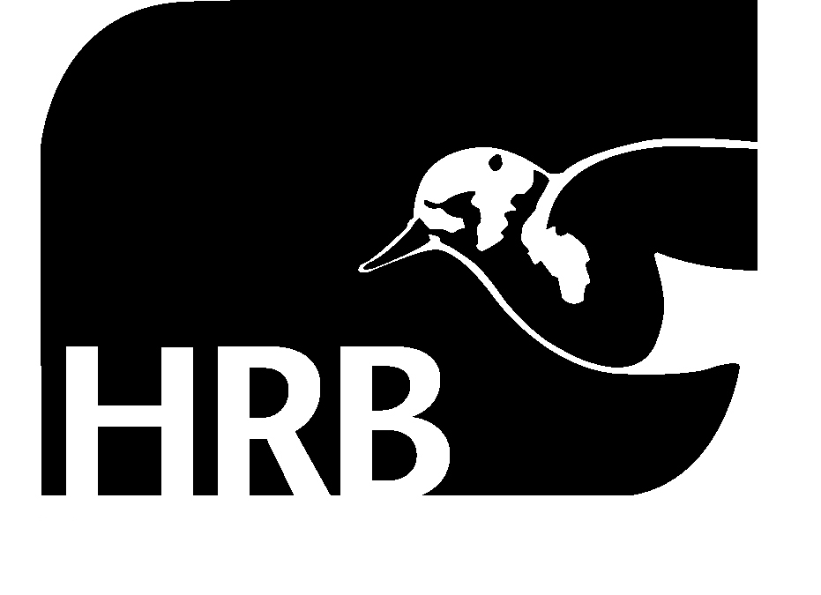
PRESS RELEASE
Increase in numbers seeking treatment for, or dying from, sedative misuse in Ireland

EMBARGO Wednesday 15 December 2010. There has been an increase in the number of cases* presenting for treatment, and people dying, as a result of misuse of sedatives (benzodiazepines), such as diazepam, in recent years.

The latest figures presented by the Health Research Board (HRB) indicate that the annual number of cases treated for problem benzodiazepine use has increased by just over 63%, from 1,054 in 2003 to 1,719 in 2008. These prescription drugs were also implicated in nearly one third of all deaths by drug poisoning between 1998 and 2007, with the annual number of deaths, rising from 65 in 1998 to 88 in 2007.

According to Dr Suzi Lyons, senior researcher at the HRB, the increases could reflect a combination of factors: an increase in the number of available treatment places, an increase in use of this drug in the population or an increase in the number of treatment centres reporting to the HRB National Drug Treatment Reporting System.

‘Benzodiazepines are prescription drugs which are legitimately used to treat a range of conditions such as anxiety, insomnia and seizures. However, while they are considered safe for short term use, the risk of overuse, abuse and dependence is well documented. There also needs to be a greater awareness among prescribers and users of the potentially fatal effects of benzodiazepines when used with other substances,’ says Dr Lyons.

When a case enters treatment, their main problem drug and up to three additional problem drugs are recorded. While the actual number of people reporting a benzodiazepine as their main problem drug is small, rising from 76 in 2003 to 167 in 2008, there has been an increase of 120% over the period 2003–2008. There has been a smaller increase (59%) of those reporting it as an additional drug, with overall numbers increasing from 982 to 1,562 during the same period.

‘From a regional perspective, we found that until 2007 the number of new cases reporting a benzodiazepine as their main problem drug were higher outside Dublin (city and county), however, the number of those reporting it as an additional substance was always higher in Dublin throughout the reporting period. This may reflect different patterns of drug use as well as differences in access to treatment,’ explains Dr Lyons.

The majority of cases, two thirds (64%), reported using benzodiazepines on a daily basis. When the figures were analysed by gender and age, 70% of all cases starting treatment between 2003 and 2008 were men. There were higher proportions of females in the older age groups (over 29 years of age) presenting for treatment for benzodiazepine as a main problem drug in contrast to higher proportions of males in the younger age groups.

The median age of new cases who reported benzodiazepines as their main problem drug decreased from 34 to 25 years over the reporting period. The median age of those returning to treatment remained at 29 years.

‘While the actual number of cases under 18 years-of-age were small, the statistics point out that an increasing proportion of both new and returning cases who were in this age group over the study period. This has implications for health promotion and drug awareness campaigns, as well as service provision for this vulnerable group’, says Dr Lyons.

Twice as many men died as a result of misuse of benzodiazepines than women in the period 1998 – 2007. The proportion of male deaths was highest in the younger age groups. The proportion of female deaths increased in age groups over 40 with more than half (54%) of females deaths over 40 years of age compared to just over a quarter (27%) for males deaths.

Almost all deaths where benzodiazepines were implicated involved the use of more than one substance.
The substances most frequently implicated in death alongside benzodiazepines were alcohol and opiates.

‘An overdose of benzodiazepines can cause respiratory depression, coma and death. However, very few deaths are reported from taking this drug on its’ own. As seen in the deaths statistics, more than one substance is usually involved; mainly alcohol and opiates. Benzodiazepines are known to amplify the depressant effects of other drugs, which increases the risk of overdose when using more than one drug. Problem use of benzodiazepines needs to be approached therefore in the context of people using more than one drug,’ she says.

There is a similar picture of multiple drug use among cases presenting for treatment as many reported opiates and alcohol as other problem drug, but, the breakdown is different. When a benzodiazepine was reported as the main problem drug, alcohol was the most common additional drug. However, 80% of cases reporting a benzodiazepine as an additional problem drug were opiate users.

The data presented in this press release is based on HRB Trends Series 9: Problem benzodiazepine use in Ireland: Treatment (2003 to 2008) and deaths (1998 – 2007), which is available online at www.hrb.ie in the publications section.

*One case does not necessarily represent one person. A proportion of people presented for treatment on more than one occasion during the period under review.

ENDS

For further information, contact:

Gillian Markey
Communications Manager
t +353 1 2345103
m+353 87 2288514
e gmarkey@hrb.ie

