Clondalkin Addiction Support Programme
Charity Number: CHY 15069 Company NUmber: 228716
CASP Annual Report 2024
Dignity Compassion & Support 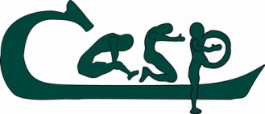 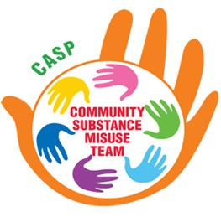

Contents
Foreword 3
About CASP (Dublin) 4
About CASP CSMT (Community Substance Misuse Team) 5
Vision and Mission 5
Core Values 6
What We Do 6
Regional Presence 7
Thank You 7
Introduction 8
Governance 10
About CASP (Dublin) 11
Aims of CASP 11
CASP Dublin in 2024 13
CASP Clondalkin services’ statistics in 2024 15
Counselling 16
Drop In 20
Prison Links 23
Key Working 26
Needle Exchange 30
Family Support 33
Recovery Café 38
Primary Care 41
Community Development 43
Quantum of services delivered by CASP Dublin Services 2024 45
CASP Dublin Service Users Feedback Report 2024 49
About CASP CSMT 66
Plans for the Future 67
1. Expanding Reach and Accessibility 67
2. Enhancing Therapeutic Interventions 67
3. Promoting Holistic Wellbeing 67
4. Strengthening Prevention and Early Intervention 67
5. Building Partnerships and Collaboration 68
6. Investing in Research and Evaluation 68
7. Supporting Staff Development 68
Our Commitment for 2025 68
CASP CSMT in the Mid-West 70
CASP CSMT in 2024 70
STATISTICAL SUMMARY 74
CSMT Service User Feedback Report 2024 89

Foreword: Eddie Darcy, Chairperson
It is with great pride that I present the Clondalkin Addiction Support Programme (CASP) Annual Report for 2024. This report highlights the collective work and impact of CASP in Clondalkin and the CASP Community Substance Misuse Team (CSMT) in the Mid-West region throughout the year.
Since its establishment in 1995, CASP has evolved from a small community response to the growing use of heroin among young people in North Clondalkin into a multidisciplinary organisation. Today, CASP provides a comprehensive range of services that support individuals, families, and communities affected by problem substance use—addressing needs across physical, psychological, social, and emotional dimensions. From our purpose-built centre on Fonthill Road, Clondalkin, we continue to offer person-centred care through services such as counselling, key working, recovery cafés, family support, holistic therapies, primary healthcare, and needle exchange.
Our ethos remains grounded in dignity, compassion, and inclusion. CASP’s integrated approach ensures that service users can access the supports they need under one roof, fostering connection, stability, and hope.
The CASP Community Substance Misuse Team (CSMT), established in 2012 at the invitation of the Mid-West Regional Drugs and Alcohol Forum (MWRDAF), extends CASP’s mission across Limerick, Clare, and North Tipperary. CSMT provides early intervention and therapeutic support for young people aged 13–24 and their families, focusing on reducing harm and promoting healthier coping strategies. Using evidence-based approaches such as the Adolescent Community Reinforcement Approach (A-CRA), the 5-Step Family Intervention Model, and Motivational Interviewing, the team helps young people develop resilience, strengthen family relationships, and build pathways to recovery.
During 2024, CSMT continued to expand its outreach through local clinics and community partnerships, delivering interventions to over a hundred clients and their families across urban and rural communities. The team also engaged in new collaborations with education, mental health, and youth organisations, and launched a research project to strengthen evidence-based practice.
Both CASP and CSMT are rooted in their communities and guided by shared values of respect, inclusion, and empowerment. Together, these services form a continuum of care that addresses substance use holistically—meeting people where they are and supporting them to reach their full potential.
Once again, we would like to thank all our stakeholders, funders, donors and strategic partners for their continuing support and engagement with the work of CASP and CSMT. Your support is invaluable in the provision of our vital services. Board Members played a significant role in 2024 and gave service, time, and expertise to CASP on a voluntary basis. I thank each one for their continued guidance, engagement, and commitment to achieving CASP’s objectives.
On behalf of the Board, I want to acknowledge and extend sincere thanks to the entire team in CASP and CASP CSMT for their dedication, professionalism, and exceptional effort in 2024.
2024 was a year of meaningful progress and innovation. As we look ahead, CASP remains committed to strengthening recovery pathways, supporting families, and building healthier, more connected communities across Clondalkin and the Mid-West.

About CASP (Dublin)
Clondalkin Addiction Support Programme (CASP) provides a range of community-based services designed to support individuals, families, and communities affected by substance use and related issues. Operating within the Clondalkin Local Drug and Alcohol Task Force (CLDATF) area—which includes Clondalkin, Lucan, Newcastle, and Palmerstown—CASP offers integrated, evidence-based interventions that respond to both immediate needs and long-term recovery goals.
CASP’s mission is to help individuals achieve an addiction-free life while empowering them to reach their full potential. The organisation works across the continuum of care, addressing the physical, psychological, social, and spiritual dimensions of recovery.
Our services include:
- Counselling – one-to-one and group therapy using approaches such as CBT and brief intervention.
- Key Working – personalised support plans and case management for individuals in recovery or active addiction.
- Family Support – programmes and one-to-one sessions for those affected by a loved one’s substance use.
- Drop-In Service – access to food, showers, laundry, and harm reduction supports for those most marginalised.
- Needle Exchange – a safe and confidential harm reduction service providing sterile equipment and health advice.
- Recovery Cafés – peer-led spaces fostering connection, encouragement, and community for people in recovery.
- Holistic Therapies – treatments such as acupuncture, reflexology, reiki, and meditation to support mental and physical well-being.
- Primary Care Clinic – methadone maintenance and nursing supports in partnership with the HSE.
- Community Development – collaborative engagement with local agencies and networks to strengthen community responses to addiction.
CASP’s holistic and integrated model allows service users to access multiple supports within one organisation, ensuring continuity of care and strong interagency collaboration. We actively participate in local and regional forums to promote effective, compassionate responses to substance misuse and to influence positive policy and social change.
At its core, CASP is a community development organisation—committed not only to helping individuals overcome addiction but also to addressing the broader social determinants of health and inequality that contribute to substance misuse. Our goal is a thriving, inclusive community where recovery is visible, supported, and celebrated.

About CASP CSMT (Community Substance Misuse Team)
The CASP Community Substance Misuse Team (CSMT) was established in 2012 at the invitation of the Mid-West Regional Drugs and Alcohol Forum (MWRDAF). Its purpose is to provide early intervention, prevention, and support services for young people aged 13–24 and their families who are affected—directly or indirectly—by problem substance use across the Mid-West region, including Limerick City and County, Clare, and North Tipperary.
Operating as an extension of CASP’s community ethos and holistic model, CSMT focuses on helping young people make positive life changes, strengthen family relationships, and reduce the harms associated with drug and alcohol use. The service also plays a vital preventative role by supporting families, schools, and communities to identify and address substance misuse at an early stage.

Vision and Mission
CASP CSMT believes that change begins from within. By working collaboratively with young people and their families, we aim to help them identify issues, explore solutions, and take the necessary steps towards personal growth and recovery.
Our mission is to provide a holistic, ethically based, and community-focused addiction service that addresses the physical, psychological, social, and emotional needs of service users and their families. Every aspect of our work is underpinned by empathy, respect, and non-judgmental support.

Core Values
- Empathy and Compassion – building trust and understanding with each client and their family.
- Respect and Inclusion – recognising the individuality and dignity of every person we work with.
- Collaboration – working alongside local services, families, and communities to achieve shared goals.
- Empowerment – helping young people and their families develop confidence, resilience, and hope.
- Evidence-Based Practice – ensuring all interventions are grounded in proven approaches that deliver measurable outcomes.

What We Do
The CASP CSMT team delivers a range of interventions and supports tailored to meet the specific needs of young people and families affected by substance use. Our approach combines therapeutic key working with education, practical support, and collaboration with other agencies.
Key elements of the service include:
- Therapeutic Key Working – one-to-one support based on the Adolescent Community Reinforcement Approach (A-CRA), helping young people understand their substance use, build coping skills, and engage in positive alternatives.
- Family Support and Education – using the 5-Step Family Intervention Model and Motivational Interviewing to help families manage challenges more effectively, improve communication, and reduce conflict.
- Outreach and Community Engagement – providing local access points throughout Limerick, Clare, and North Tipperary in both urban and rural settings to ensure accessibility for all.
- Prevention and Early Intervention – working with schools, youth organisations, and community groups to promote awareness, resilience, and protective behaviours.
- Partnership and Referral Work – collaborating closely with agencies such as Tusla, CAMHS, schools, youth justice teams, and local community organisations to coordinate wraparound care.

Regional Presence
CSMT’s main office is located at Arthurs Quay House, Limerick City, providing a central, easily accessible hub for young people and families. In addition, our outreach clinics operate throughout the Mid-West region, including:
- Limerick County: Newcastle West, Caherconlish, Kilmallock, Abbeyfeale, Rathkeale, Croom, Murroe, Cappamore, and Hospital.
- Clare: Kilrush, Shannon, Killaloe, Ennistymon, Lisdoonvarna, and Ennis.
- North Tipperary: Roscrea, Templemore, Thurles, Newport, and Nenagh.
This regional structure ensures that our services reach young people in both urban and rural communities, reducing barriers to access and supporting those who might otherwise fall through service gaps.

Introduction

2024 was a year of growth, innovation, and connection for both the Clondalkin Addiction Support Programme (CASP) and the CASP Community Substance Misuse Team (CSMT).
At the start of the year, CASP introduced a weekly drop-in acupuncture clinic, launched in January and continuing every Wednesday afternoon. This new service has been warmly received by our service users and has become a key addition to our holistic therapy offerings.
In March, CASP proudly launched three major initiatives: the Strategic Plan 2024–2027, the Independent Evaluation of our Recovery Cafés, and our Back-to-Basics Family Support Programme. We also officially opened Grizzly’s Cabin, a new on-site Wellness Cabin named in memory of John McCann (RIP), one of CASP’s founding members. The cabin provides a serene space for holistic therapies such as reiki, acupuncture, massage, and meditation, as well as additional rooms for appointments and group sessions.
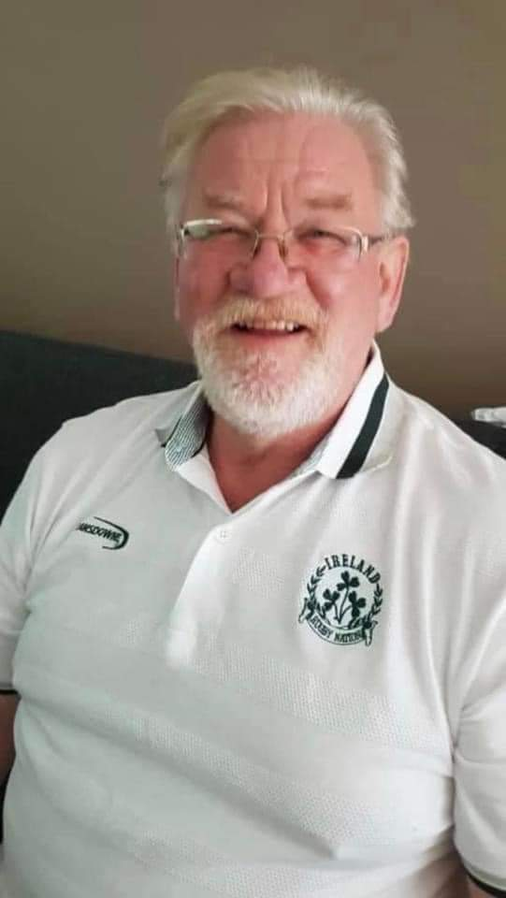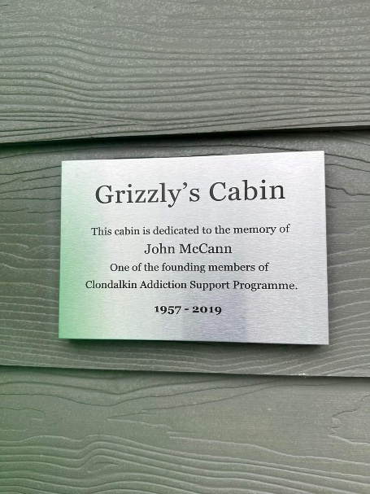

March also saw CASP host a vibrant International Women’s Day event under the theme “Inspire Inclusion.” The celebration brought women from across the community together to enjoy food, reiki, meditation, mindfulness, and inspiring talks by Professor Kathleen Lynch (UCD and CASP BOM Director) and Tara McNeill, Irish Homeless World Cup player and coach. These events do more than celebrate—they build community, promote empowerment, and often serve as a bridge for new service users to engage with CASP.
Our Recovery Cafés continued to thrive throughout 2024, providing safe, welcoming spaces for people in recovery and those exploring recovery. Activities such as forest walks, mindfulness and meditation workshops, and Reiki Level 1 and 2 training deepened the sense of belonging and personal growth among participants. To mark Recovery Month in September, CASP hosted a community breakfast and holistic therapies morning, followed by an inspirational talk by Dr. Katriona O’Sullivan from Maynooth University. Both events received outstanding feedback and strengthened the recovery community’s visibility in Clondalkin.
Other key highlights included the 12-week Pathway to Recovery Group, which began in May to support those transitioning from active addiction, and our Community Fun Day in July, attended by over 60 people. CASP also secured funding from the South Dublin County Council Climate Action Fund, enabling important sustainability upgrades including new windows and doors, solar panels, attic insulation, and eco-friendly gardening initiatives.
Meanwhile, the CASP Community Substance Misuse Team (CSMT) in the Mid-West made significant progress in its work with young people and families across Limerick, Clare, and North Tipperary. In 2024, CSMT began researching its impact and enhance evidence-based practice. The team expanded community outreach through partnerships with organisations such as CAMHS, Tusla, Doras, EPIC, YAP, and Foróige, ensuring that more young people could access support closer to home.
One CSMT staff member completed professional training in Eye Movement Desensitization and Reprocessing (EMDR) therapy, which is now used to support suitable service users over 18. The team also delivered numerous education and wellbeing initiatives, including participation in the Airmid Mental Health & Wellbeing Conference, the Tipperary CYPSC Development Day, and the Return to Exercise Group for young adults in recovery.
Together, CASP and CSMT continued to embody their shared mission—to provide dignity, compassion, and support to those affected by substance misuse. Through collaboration, innovation, and care, 2024 became a year that strengthened recovery pathways, deepened community connections, and laid the groundwork for continued progress in 2025.

Governance

CASP is a Company Limited by Guarantee and a registered charity. The organisation received funding from the HSE and Department of Justice in 2024. As such there are several governance frameworks that the organisation must comply with on an annual basis.

The Board of CASP is responsible for overseeing the performance and governance of the organisation. CASP applies a governance framework to how it makes decisions and achieves its goals. This framework consists of many legal, financial, and regulatory standards that must be adhered to, in order to govern the performance of CASP well.

As CASP is a registered charity it is obliged to provide an annual return to the Charities Regulatory Authority (CRA). This return outlines how the governance of CASP adheres to the Regulators governance code. There are six principles in the code. CASP has demonstrated its compliance with the code by developing a plan to adhere to the principles and have evidence of work towards this plan.

This compliance checklist is completed by the organisation and signed off annually by the CASP Board in advance of submitting the annual report to the Regulator. In 2024, CASP declared the organisation’s compliance with the CRA Governance Code as fully compliant.

Aims of CASP
CASP is built on the foundation of a common set of values

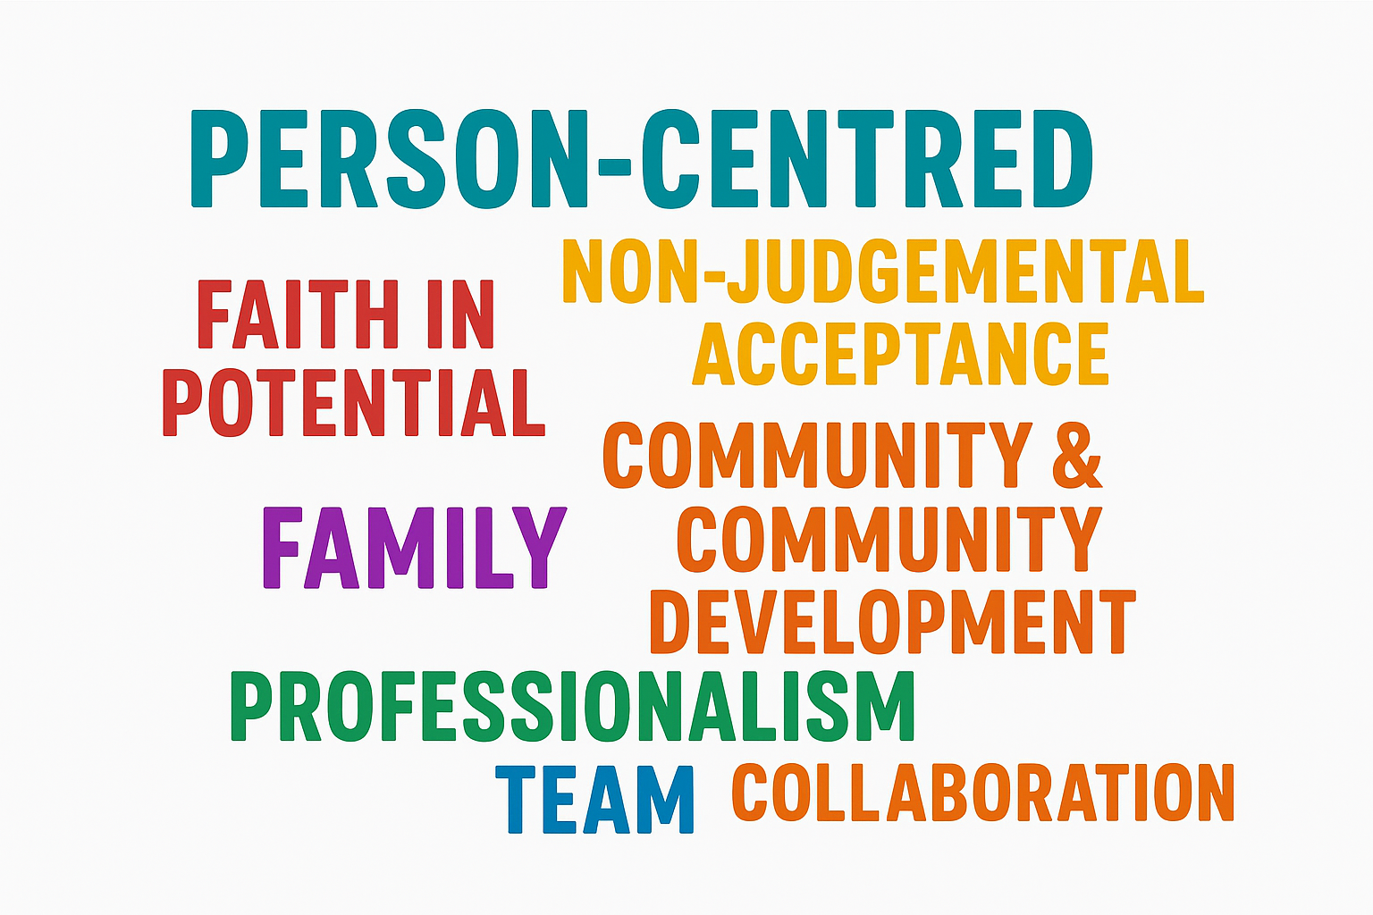

To fulfil our Mission, CASP aims to provide integrated interventions that engage with and make best use of both internal and external resources, including staff, referral agencies, planning and development forums, community groups, finance, etc. This partnership approach with the broader community of statutory, voluntary and community agencies ensures that all stakeholders are included in both the development and implementation of all actions that can positively impact our target group.
The objectives of CASP are:
- Comprehensive service provision for substance misusers, parents, partners, siblings, and the community members over the age of 18.
- Holistic, progression-based substance abuse treatment in a community setting.
- Support for substance misusers and their families in working towards experiencing the most meaningful, healthiest, and fulfilling lifestyles possible.
- Provision of service-user access to educational, vocational, and self-improvement resources, and support throughout the process.
- Continued development of substance-use prevention programmes, and constant review, monitoring of, and adaptation to changing trends.
- Access to information and supports regarding referral resources offering necessary services to our client groups.
- Engagement and cooperation with other relevant agencies and groups providing pertinent support services.
- Development and maintenance of relationships with relevant state agencies and governmental departments with regard to policies and actions effecting drug and rehabilitation services within the community.
- Supporting service-users towards integration of their own journeys and decision-making processes, and the creation of future opportunities for positive growth and development.

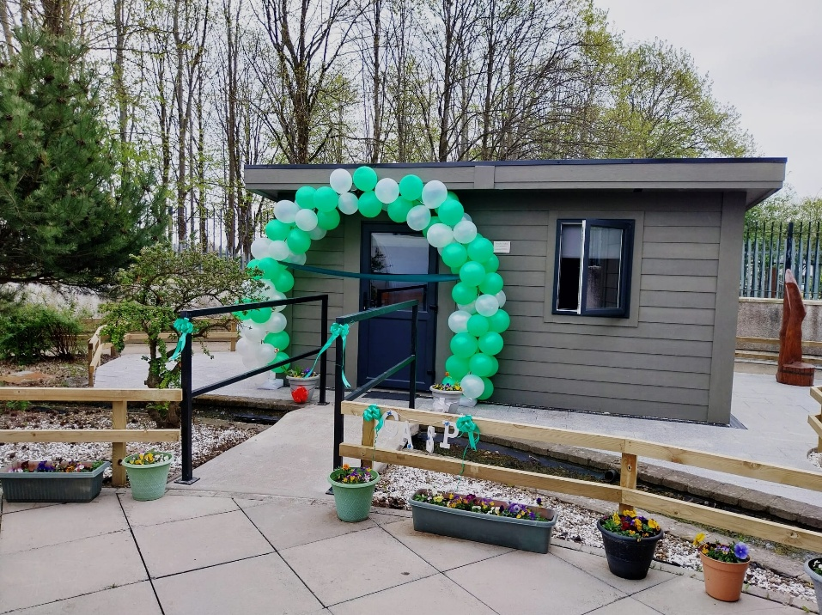

CASP Dublin in 2024
A strength of CASP is that we offer a range of services under one roof. Our system allows us to assess clients who come through our door and triage them to the services that best meets their need. This provides for an integrated web of support. During 2024, our various services had 7845 contacts with 818 service users.

Many of our service users are actively addicted, with 124 using our drop-in service, 64 attending the methadone clinic, 196 using the needle exchange service and 64 attending the primary care nurse.
We key worked 143 individuals. This is a system of providing tailor-made support for a period to clients who take up the offer to liaise with one of our three key workers. There were 1108 contact interventions with these service users.

As well as those in active addiction, we engaged with those who are in recovery, mostly through the recovery cafes which were attended by up to 75 individuals at each café weekly. These were held throughout the year on Wednesdays and Mondays. They preceded fellowship meeting, CA and AA respectfully. 14 Recovery Café service users completed Reiki Level 1 training and 4 completed Reiki Level 2 training in 2024.

We support recovery through a range of holistic therapies. In 2024, we had 264 sessions benefiting 79 service users.

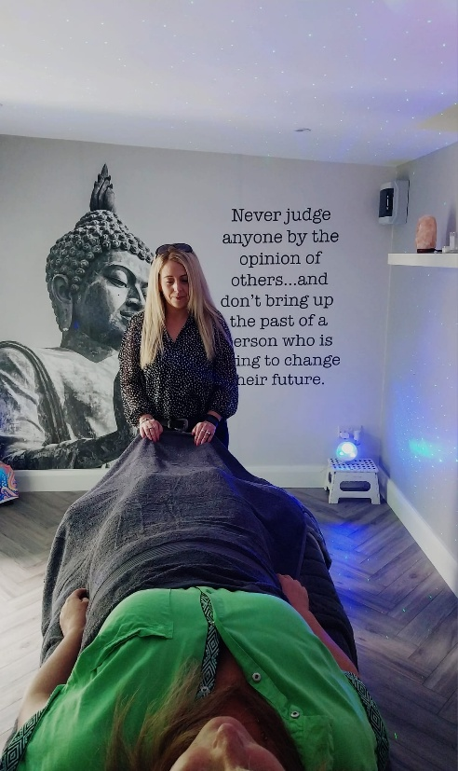
We also had a substantial programme for individuals coping with a family member in addiction. This consisted of one-to-one supports and groupwork. We engaged with 77 individuals in one-to-one support. Our family support groups – Tuesday Evening Drop-In (attended by 10 individuals), The Back to Basics Education Programme (attended by 30 individuals), Meditation Group (attended by 40 individuals) and the Friday Night Group (attended by 14 individuals) catered for a total of 94 family members of persons in addiction.

CASP is a community-based service, and we work in close collaboration with other local services. These include the Clondalkin Drug and Alcohol Task Force Treatment and Rehabilitation Subgroup meetings, Family Support Network and main Task Force meetings, Family Support networks and community safety meetings.

CASP Clondalkin services’ statistics in 2024
The following pages set out in detail, each CASP service. The main features of the service during the year are highlighted in an introduction. This is followed by a table describing the service, the frequency of its delivery and the numbers of beneficiaries. A summary chart of the quantum of all services is to be found on page 45.

Counselling
CASP offers a counselling service for our service users. We have a team of four accredited counsellors offering counselling and therapy in one-to-one and group settings. Our counselling practice uses techniques such as brief intervention and cognitive behavioural therapy to help clients better understand their addiction, become aware of triggers and patterns of problem substance use, and foster a willingness to change.
In 2024, 124 clients availed of our service, 50 of which were new clients in that year. A total of 1776 appointments were made throughout the year. Throughout the year, we continued to manage waiting lists which can mean a wait of a week or sometimes two weeks for counselling. We developed a practice of linking a service user into other available CASP services such as holistic therapies during that short wait-time, in addition to support provided by a project worker or family support worker while the person is waiting for counselling.

 |  | Counselling 2024
 | Casp Type ↓ | Sub Type ↑ | Individual Count | Record Count
 | Counselling
 |  | Initial Assessment | 50 | 52
 |  | 1:1 Counselling | 107 | 1232
 |  | Link In -5 min check up | 6 | 11
 |  | Crisis Intervention | 12 | 17
 |  | 1: 1 meeting (not counselling) | 5 | 5
 |  | no show | 77 | 180
 |  | Cancelled by client | 75 | 279
 | Total |  | 124 | 1776

Staffing | Service | Service- user profile | Numbers | Methods | Results
1 Senior Counsellor  1 FT counsellor)  1 FS counsellor | Provision of individual counselling | People who are affected by addiction (own or other’s) | 124 individuals availed of counselling.  52 new clients in 2024. 1776  appointments made  50 Initial assessments were completed. | Use of techniques such as brief interventions / CBT /CRA/SFBT.  Teaching clients’ skills by using the framework to create and reach goals and improve coping skills.  Explore self- determination and help them to find their strengths in adversity, | Ability to self-actualize.  Better understanding of self in adversity, using and honouring the client’s right to self- direct.  To discover strengths / determination.  Non-confrontational counselling that promotes behaviour change by assisting clients to resolve and  overcome mixed

 |  |  | 1596 individual sessions took place.  334 remote sessions were delivered (phone call and video call WhatsApp.)  17 crisis interventions took place  180 appointments were no  shows/ cancelled by client. | using change techniques.  To help the client work out a plan for solving their difficulties.  To assist exploration of interests, abilities, aptitudes, and opportunities.  To encourage and develop special abilities and right attitudes.  To inspire successful endeavours and celebrate achievement as individuals progress toward attainment of goals. | emotions and challenges and realise their fullest potential.  Improved physical health as food, showers, needle exchange and access to a nurse is provided.  Improvements also to mental health and well-being as the drop ins serves as a social outlet to an extremely marginalised group.  Improved relationships between Project Workers and active substance misusers.  Reduction in discarded injecting paraphernalia in the community and needle exchange service is provided during drop-in sessions.  Social skills are developed, in addition to the building of social capital as a result of the reduction in isolation of service users.

Drop In
Throughout 2024, CASP maintained a drop-in service, Monday to Friday, for service users. The drop-in offers practical attention to basic needs such as food, laundry services, access to clean clothing as well as advice on important issues such as housing and health. The drop-in serves as a gateway to other CASP services such as holistic therapies, needle exchange counselling, family support and more. Referrals to other services can also be made through the drop-in. In the main, our drop-in service is availed of by some of our most vulnerable clients with multiple challenges, including homelessness and poverty.
In 2024, 124 service users attended the drop-in and there were 1165 visits in total. 1092 meals were served, and laundry services were used 40 times and showers were taken 42 times.

 |  |  | Drop-in stats 2024
 | Date and Time client entered ↑ | Drop-in session ↑ | Individual Count | Meals | Tea/Coffee | Laundry | Showers | Count
 | January 2024 | Daytime | 21 | 49 | 18 | 0 | 0 | 51
 | February 2024 | Daytime | 19 | 55 | 20 | 2 | 2 | 59
 | March 2024 | Daytime | 13 | 54 | 24 | 0 | 0 | 55
 | April 2024 | Daytime | 27 | 87 | 33 | 0 | 0 | 91
 | May 2024 | Daytime | 29 | 89 | 32 | 2 | 1 | 94
 | June 2024 | Daytime | 27 | 84 | 33 | 2 | 2 | 87
 | July 2024 | Daytime | 35 | 102 | 57 | 5 | 3 | 106
 | August 2024 | Daytime | 31 | 117 | 46 | 11 | 7 | 128
 | September 2024 | Daytime | 37 | 112 | 49 | 7 | 4 | 121
 | October 2024 | Daytime | 47 | 131 | 61 | 3 | 13 | 140
 | November 2024 | Daytime | 34 | 111 | 61 | 6 | 5 | 125
 | December 2024 | Daytime | 33 | 101 | 24 | 2 | 5 | 108
 | Total |  | 124 | 1092 | 458 | 40 | 42 | 1165

Inputs | Service | Service User Profile | Numbers | Results:  Short Term | Results:  Medium Term | Results  Long Term
2 Project Workers are rostered daily to host drop- in sessions, 9:30 – 1 & 2 – 3:30pm.  Project workers role also includes inputting data into electronic data base, writing incident reports as necessary and updating clients’ files, as required.  Funding was used to buy food, toiletries, and washing powder.  Use of equipment including cooker, washing machines and showers. | Drop ins took place Monday to Friday from 9:30 – 3:45 (excluding 1 – 2pm).  Services provided include support, information and advice, needle exchange, food, clothes, laundry facilities and access to a nurse on Mondays, Tuesdays and Fridays.  In 2024, 124 service users availed of drop-in services 1165 times.  In 2024, the following services were provided:  1092 meals,  458 tea/coffee  40 laundry services  42 showers | Substance misusers and homeless people. | 22 individuals per week on average | Improved physical health as food, showers, needle exchange and access to a nurse are provided.  Improvements also to mental health and well-being as the drop ins serves as a social outlet to an extremely marginalised group.  Improved relationships between Project Workers and active substance misusers.  Reduction in discarded injecting paraphernalia in the community and needle exchange service is provided during drop-in sessions.  Social skills are developed, in addition to the building of social capital because of the reduction in isolation of service users. | Improved relations between clients and between staff and service users leading to service users becoming more engaging with other aspects of the CASP service.  Social skills are developed, in addition to the building of social capital because of the reduction in isolation of service users. | Improved engagement of service users with staff and with other internal CASP services.  Reduction of BBVs due to drop- in clients accessing the needle exchange while attending the drop- ins.  Reduction of deaths of service users due to lifestyle, i.e. homelessness, lack of proper nutrition, lack of basic hygiene and warm clothes, in addition to a reduction in suicide due to greater social capital created by attending drop- in sessions.

Prison Links
The primary focus of the activity is on the provision of ‘in reach services’ to prisoners from Clondalkin, Lucan, Palmerstown and Newcastle areas, which focuses on their substance misuse and related issues such as, post release treatment, family support, coping strategies whilst in prison and in particular in the 8 -10 week period post release where individuals are vulnerable to falling into old patterns of behavior.
The Community Prison Links (CPL) Worker liaises with Probation, Integrated Sentence Management Officers, TEOs, prison counselling services and other prison staff in relation to addiction treatment services. The families of people in prison are also supported, if they chose to engage, through information being provided and referrals to CASP Family Support service.
From January to the end of December, the CPL Worker had 207 interventions with 45 clients.
All visits have been physical in 2024 which has been preferential to video link. One-to-one physical visits appear to have better outcomes for individuals with service users showing greater capacity for reflection between each visit and have a greater ability to engage at a higher level as a result.
In 2024, our Prison Links Worker made 189 prison visits with 45 clients. Visit times vary from 15 to 30 minutes, depending on the prison.

 |  | Prison Links 2024
 | Casp Type ↓ | Sub type ↑ | Individual Count | Record Count
 | Prison Link | Meeting (1:1) | 1 | 1
 |  | Phone Call | 3 | 12
 |  | liaising with other services | 1 | 1
 |  | admin | 1 | 1
 |  | 1:1 Prison Visit | 45 | 189
 |  | Prison Links Initial Assessment - Returning Client | 1 | 1
 |  | no show | 3 | 3
 | Total |  | 45 | 207
 | Confidential Information - Do Not Distribute
 | Copyright © 2000-2024 salesforce.com, inc. All rights reserved.

Staffing | Service | Service User Profile | Numbers | Methods | Results
1 Prison Links Worker | Key working and addiction specific support to people in prison from the CASP catchment area who are problematic substance users. | People in prison with problem substance use issues from Clondalkin, Lucan, Newcastle and Palmerstown. | 189 prison visits with 45 clients | Using brief intervention methods to help clients better understand and take control of their situation by addressing their issues. | Clients use the experience of incarceration to build better lives.

Key Working
Key working is offered to our clients if appropriate for them. This involves one-on-one support based on assessment of individual needs, the development of a care plan, and the referral onwards to appropriate supports within CASP or elsewhere. We have three staff dedicated to key work. Once contact is made by a problem substance user requesting support, basic details are sought over the phone by our receptionist. Every service user is then offered a key worker. We recognise that, in some cases, the key working relationship is very active and, in other cases, less so. Key working takes place over 12 weeks with a mid and end review at 6 and 12 weeks. Further key working is possible if required.
Through key working, referrals can be made to counselling or other CASP services, such as holistic therapies or recovery cafes. Salesforce data and Health Research Board (HRB) compliance are monitored during this time. Our key working service was marginally affected by some staff deficits due to illness.
 |  | Key Working 2024
 | Casp Type ↓ | Sub type ↑ | Sum of Individual Count | Record Count
 |  | Initial Assessment Support Work (HRB) | 64 | 64
 |  | Brief Solution Intervention (HRB) | 1 | 1
 |  | Support Work (HRB) | 15 | 57
 |  | Developing Care Plan (HRB) | 12 | 18
 |  | Link In -5 min check up | 33 | 137
 |  | Crisis Intervention | 2 | 2
 |  | Meeting (1:1) | 76 | 264
 |  | Phone Call | 105 | 439
 |  | Interagency Work | 5 | 7
 |  | liaising with other services | 3 | 4
 |  | advocacy | 3 | 3
 |  | admin | 29 | 56
 |  | 3 way meetings | 2 | 2
 |  | no show | 26 | 43
 |  | Cancelled by client | 10 | 12
 |  |  | 143 | 1108
  Total
 | Confidential Information - Do Not Distribute
 | Copyright © 2000-2024 salesforce.com, inc. All rights reserved.

Inputs | Service | Service-user profile | Numbers | Results: Short Term | Results: Medium Term | Results: Long Term
Key working and case management took place from 9:30 – 6:30  Monday to Friday in 2024. | Case management or key working services were provided to any service users that uptake on an offer of this service. | Substance misusers presenting to CASP for support in terms of their addiction and related issues | 1108 intervention sessions took place in 2024  with 143 individuals. | Treatment goals are reviewed with the client to meet changing needs and circumstances.  The service user is encouraged to avail themselves of psychosocial interventions and therefore, motivation to make positive life changes is increased and the risk of relapse is reduced.  Service use is supported to address social problems, e.g family problems, housing, employment | Service users improve access to education, improves their health and social capital and maintains stability or a substance free lifestyle.  Service users and project workers build rapport and the service user begins to engage in the key working process.  Substance misuse related advice and information is provided so service users have the information to reduce the harm caused by substance misuse (especially risk of overdose and infections such as blood-borne virus infections). Consent is given for key workers to refer and share  information with appropriate services both internally and externally so service users can begin to holistically address their addiction and other needs. Goals of service users are identified, and a strategy is agreed to achieve these goals. Blocks in progression are identified, and support and advocacy are provided to overcome these  barriers | S Service users improve access to education, improves their health and social capital and maintains stability or a substance free lifestyle.

Needle Exchange
CASP offers a safe needle exchange service. Service users wishing to access clean needles and crack-pipes and foil for heroine smoking can do so in a safe indoor environment. Through this service, we use the opportunity of private contact with service users to educate regarding harm reduction and to refer them as necessary. In 2024, CASP offered this service to 196 individuals who had 877 one to one sessions.
Date of intervention ↑ | Sum of Individual Count | Record Count
January 2024 | 34 | 56
February 2024 | 45 | 68
March 2024 | 46 | 69
April 2024 | 34 | 60
May 2024 | 41 | 67
June 2024 | 37 | 64
July 2024 | 43 | 80
August 2024 | 41 | 63
September 2024 | 45 | 88
October 2024 | 43 | 85
November 2024 | 55 | 103
December 2024 | 41 | 74
Total | 196 | 877

Date | Needles Dispensed | Syringes Dispensed | Crack Pipes Dispensed | Total Dispensed | Record Count
January 2024 | 316 | 235 | 44 | 551 | 56
February 2024 | 732 | 402 | 51 | 1134 | 68
March 2024 | 306 | 202 | 68 | 508 | 69
April 2024 | 415 | 265 | 54 | 680 | 60
May 2024 | 506 | 379 | 44 | 885 | 67
June 2024 | 332 | 222 | 63 | 554 | 64
July 2024 | 450 | 331 | 77 | 781 | 80
August 2024 | 397 | 232 | 47 | 629 | 63
September2024 | 314 | 221 | 78 | 535 | 85
October 2024 | 370 | 301 | 62 | 671 | 13
November2024 | 554 | 377 | 104 | 931 | 103
December2024 | 320 | 260 | 92 | 580 | 74
Total | 5012 | 3427 | 784 | 8439 | 877

Inputs | Service | Service- user profile | Numbers | Methods | Aims
2 Project Workers rostered from 9:30 – 3pm Monday to Friday.  Equipment is provided to service users that are supplied by the HSE except for the large container bags. | New injecting paraphernalia, non-aluminum foil and crack pipes to be distributed to substance misusers as required, in addition to harm reduction / health promotion information including safer injecting techniques. | Injecting and smoking substance misusers and crack cocaine smokers. | In 2024,  196 clients attended for needle exchange services 877 times. | Greater engagement of substance misusers with Project / Outreach Workers.  Problem substance users are beginning to access a wider range of services. | Reduction of Blood Borne Viruses (BBVs) and greater take-up of the broad range of CASP services among target groups.  Reduction of risk of BBVs for injecting problem substance users and crack smokers through not sharing injecting paraphernalia and pipes, in addition to increased knowledge of the target group on safer practices.  Reduction of respiratory problems from smoking heroin using aluminum foil  Increased contact with cohort of clients not currently availing of CASP services.

Family Support
Our Family Support Service works with families where problem substance use is an issue. Our focus is on adult family members other than the problem substance user. We strive to enable those people to understand the dynamics of family and addiction, to develop a focus on self-care and to manage more constructively their relationship with the problem substance using family member. This takes place through one-to-one sessions, group work, educational processes, and referrals both within CASP and elsewhere. Holistic therapies such as Reiki are an important and popular part of our support work.
In 2024, over 1299 family support interventions took place including 146 group-based sessions. 77 individuals participated in one-to-one work and 56 in group-based work.
CASP also organizes three community events per year, (excluding our Recovery Event in September) - a Christmas celebration an event marking
International Women’s Day and a family fun day during the summer.
Our community events were well attended in 2024 and provided a significant connection for CASP with the community in which we are rooted. All CASP staff were involved in organising and running the family fun day, the International Women’s Day event and the Christmas celebration. There were almost 170 participants in our three 2024 events.
Family Support 2024
Sub type ↑ | Sum of Individual Count | Record Count
Initial Assessment Support Work (HRB) | 22 | 22
Developing Care Plan (HRB) | 3 | 3
Link In -5 min check up | 11 | 12
Crisis Intervention | 2 | 3
Meeting (1:1) | 51 | 346
Home Visit | 3 | 3
Phone Call | 63 | 373
liaising with other services | 2 | 2
advocacy | 1 | 1
e mail | 4 | 6
no show | 4 | 4
Cancelled by client | 11 | 18
Total | 77 | 795
Total Sum of Individual Count
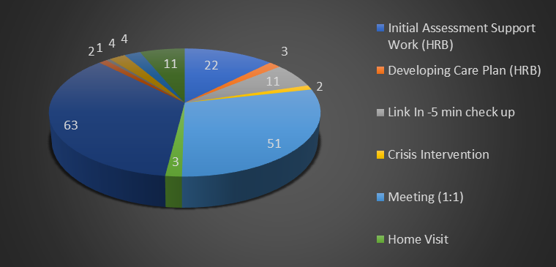
Total Record Count
 |  | Family Support Group 2024
 | Date of Session → |  | May 2024 | Total
 | Program Session: CASP Course Type ↑ | Program Session: Program/Service ↑ | Record Count | Sum of Individual Count | Record Count
 | Family Support Group | Back to Basics |  | 6 | 54
 |  | Back to Basics 2024/2025 |  | 14 | 75
 |  | Empowerment 2024 |  | 6 | 54
 |  | Friday Night Group 2024 |  | 14 | 436
 |  | Health and Wellbeing 2024 |  | 6 | 54
 |  | Meditation Group 2024 |  | 23 | 180
 |  | Meditation Group November 2024 |  | 9 | 36
 |  | Meditation group Oct 2024 |  | 8 | 40
 |  | Tuesday evening drop in |  | 10 | 370
 | Total |  |  | 56 | 1299

Inputs | Service | Service User Profile | Numbers | Results: Short Term | Results: Medium Term | Results: Long Term
1.5 WTE until June 2024 and after June 2024, 64 hours per week Family support workers  (access to counselling when appropriate)  Other CASP staff, counsellors to support the running of specific actions,  Venue  Consumables/materials and related costs specific to each programme  Mobile Phones  Computer tablets for working from home when needed | One-to-one family support sessions  Family support groups  Initial assessments  Friday night family support group  Back to Basics Group  Mindfulness and meditation Tuesday evening group  Healing and meditation group  Tuesday evening drop in  Holistic therapies  Service of Commemoration Christmas event.  Community Fun Day | Family members and partners of problem substance users | 795 family support interventions took place  77 individuals attended individual family support sessions.  27 individuals attended family support groups  23 new service users underwent initial assessments:  36 sessions of a Friday night family support group took place attended by 14  Individuals  10 sessions with 9 participants of Monday morning group, Back to Basics Group  43 individuals attended 20 sessions of the Healing and meditation group Meditation group  34 sessions of Tuesday evening drop in were attended by 11 individuals.  79 individuals had 264 holistic sessions  110 individuals attended the Service of Commemoration Christmas event.  45 adults and 50 children attended our Community Fun Day. | Family members feel less stressed due to the support gained from the service and feel that their voice is heard.  Family members feel less isolated by speaking with family support workers. | Family members identify their goals for the future.  Life limiting beliefs are challenged and begin to be overcome  Improvement in selfcare and stress management  Confidence is improved  The wider family may benefit due to the family member referring them to services  Enhanced quality of life due to referrals made to suitable services, as appropriate.  Internal referrals to counselling/groups further enhancing the feelings of being supported and empowered to make positive changes.  By attending groups, family members feel less isolated. | Awareness of what can and can’t be controlled is developed  Focusing on their own needs is prioritised  Development of new coping strategies /skills and actions  Improvement in health and wellbeing  Looking after their own mental health is undertaken

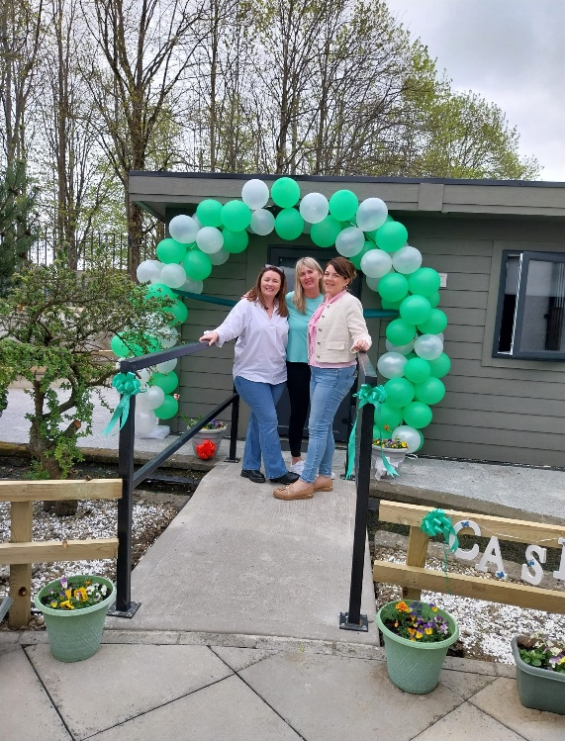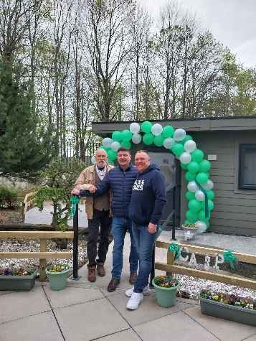

Recovery Café
CASP has been strengthening its support for recovery in the last number of years. Our specific initiatives around this are the provision of recovery cafes at the CASP building on Monday and Wednesday evenings, in advance of Cocaine Anonymous and Alcoholics Anonymous fellowship meetings which follow on those evenings. We also participate in Recovery Week, a week of community events related to supporting recovery led by the Clondalkin Drug and Alcohol Task Force.
Our Recovery Cafes strengthened during 2024 with over 40 people attending on most evenings. A significant number are now “newcomers” attending the fellowships for the first time. The cafes compliment and strengthen the fellowship experience as they provide an opportunity for informal peer support, essential in recovery, and for a deeper connection between those seeking recovery and CASP as a support for that journey.
 | Recovery Café 2024
Program Session:↑ | Program Session: Program/Service ↑ | Sum of Programme Session: Anonymous Attendees | Average Individual Count | Anonymous Attendees | Record Count
PWOR Group | Recovery Cafe |  | 75 | 3368 | 98
Total |  |  | 75 | 3368 | 98
In 2024 CASP developed a mindfulness programme open to those attending the cafes which was very well received.

Inputs | Service | Service-user profile | Numbers | Results: Short Term | Results: Medium Term | Results: Long Term
3 Project Workers and 1 volunteer to facilitate the recovery cafes. | 86 evenings were hosted from January to December 2024. | People who are in recovery from addiction and people who are ‘recovery curious’ and desire recovery from addiction. ‘. | 75 individuals attended Recovery Cafes in 2024 | Reduction in relapses due to isolation and loneliness. | ImImprovement in mental health and well-being. | Improved self-esteem and confidence among those attending meeting new people and having positive conversations without relying on a substance.
1 holistic therapist at each evening once a month.  2 musicians who sing and play the guitars live once a month. | These cafes were attended by 55 individuals |  |  | Developing positive peer relationships and friendships with other people in recovery | Increased social capital, including opportunities through these interactions of employment opportunities through peer networks. | Reduction in social anxiety.
Kitchen of CASP to cook and serve the food, tea and coffee. | To celebrate September being Recovery month, CASP hosted two events on September 25th and 30th, 2024.  The event on the 25th comprised of a celebration morning from 10:30 – 1pm comprising food, holistic therapies including reiki, auricular acupuncture, meditation and mindfulness workshops and sound healing.  The second event on September 30th took place at our Recovery Café from 6:30 – 8pm. Dr. Katriona O'Sullivan, an award-winning author, Professor at NUI Maynooth, and researcher spoke at the event about her life story from a childhood of poverty and adversity to recovery and academia. | 42 individuals attended the Recovery Events |  | Improved attendance at CA and AA meetings as CA meeting take place at 8pm following the Recovery Café on Mondays and AA meets at 8pm following the Recovery Café on Wednesday evenings. This will continue to benefit some of the service users in terms of maintaining and promoting recovery. | Promotion of the range of CASP services to those in the recovery community and beyond those that are opiate addicted. | Improved relationships between CASP and the recovery community leading to more engaging with other aspects of the CASP service.

Primary Care
CASP is responsive in relation to the medical dimension of a health care approach to problem substance use. We host the HSE methadone maintenance programme at our facility, supporting the doctors, pharmacists and general assistants in administering this. We also have a nurse on site at times during the week to provide health care advice and referral to appropriate services for service users.

Inputs | Service | Service-user profile | Numbers | Results: Short Term | Results: Medium Term | Results: Long Term
20 hrs week; nurse | Continued client care | MMT clients (& where possible resources to other staff in CASP re issues arising for differing client cohorts) | 268 medical interventions on 41 individuals took place in 2024 | Immediate access to primary health care facilitates and access to medical interventions when required. | Referring to appropriate health, social or other services as required. | Increased longevity for individuals through appropriate and continued assessment and treatment.
 | Supporting methadone clients for GPs |  |  | Referring to appropriate health, social or other services as required. | Improved engagement by clients through fostering bounded and respectful relationships | Continued health related education including harm reduction to support individuals to improve and build on factors that increase positive health and self- care.
Management of clinical care within CASP
BBV testing, vaccination & referral where appropriate

Community Development
CASP is first and foremost a local community-based service. This requires us to work collaboratively with other agencies and participate in local structures designed to address aspects of the cause and impact of substance misuse. These structures include the Clondalkin Local Drug and Alcohol Task Force (CLDATF) and its subgroups, and community safety structures.
In 2024 we were actively involved in such partnerships, participating in the Treatment and Rehabilitation and the Finance subgroups of the CLDATF. We engaged in important spaces to reflect on the changing substance misuse landscape with other organisations, such as the Family Support Network and the CPL Managers Network.
Our collaborative work included working on the Clondalkin Recovery Week and inputting into developing responses to the growing cocaine and crack cocaine issue in the community.

Inputs | Service | Service-user profile | Numbers | Results: Short Term | Results: Medium Term | Results: Long Term
Acting Manager,  Family support  Project workers  Community development principles are incorporated within all practice internally. | In 2024, the following meetings were attended by CASP reps both in person and remotely: Community Safety Forum meetings: 6  Ho Hosting of agency visits: 2  5 Rights Platform meetings  2 CCPL Managers Network meetings  Tr Treatment and Rehab Subgroup: 4 meetings were attended.  Clondalkin Family Support Network: 8 meetings were attended.  11 task force meetings  5 CDTF finance subgroup meetings  1 meeting of the Local Policing Forum. | Community of Clondalkin, with a focus on the designated disadvantaged areas of Clondalkin and Balgaddy.  45,165 is the population of Clondalkin | 45,165 | Service users are supported to gain skills to participate fully in society.  The needs of the CASP target group are included in all actions both internally and externally and the best use is made out of internal and external resources.  Issues in terms of community safety are discussed and actions agreed, i.e. accountability of local authority in terms of community safety and capital. | Reduction in, marginalization and social exclusion  Capacity and leadership are developed.  Political priorities are influenced, notably to address poverty and inequality.  Supporting social inclusion representatives in making effective interventions in various structures and in political and policy forums.  Reduction in issues reducing community safety and greater relationship between the community and the statutory services, in particular the guards and SDCC. | Long term sustainable growth which improves the lives of people who live in the community.  Reduction in intergenerational poverty.  Improvements in quality of life for community members.

Quantum of services delivered by CASP Dublin Services 2024

Premises at which services delivered | Description of services |  | Scope and quantum of services delivered | Number of service users availing of service | Associated staff resources
CASP, Muriel Boothman Centre, Ballyowen Meadows, Fonthill road, Clondalkin, Dublin 22 | Provision of staff for effective running of dispensing Methadone Clinic |  | Staffing of 7 clinics per week | 64 | Primary care nurse,
CASP, Fonthill Road, Clondalkin | Key working |  | 1108 support related activities | 143 | 7 PW staff, Full/Part time,
CASP, Fonthill Road, Clondalkin | Drop in services |  | 10 sessions per week  1165 actions including food, showers, and laundry | 124 | 2 PW staff, (min 2 per session)  Admin/cleaner
CASP, Fonthill road, Clondalkin, | Needle exchange |  | 877 exchanges | 196 | 2 PW staff, (min 2 per session)  Reception staff  Admin/cleaner
CASP, Fonthill road, Clondalkin, | Recovery Cafes |  | 2 sessions per week | 75 | 3 PWs and 1 Volunteer
CASP, Fonthill Road, Clondalkin | Primary care health for those on methadone |  | 5 clinics per week  268 medical interventions provided | 64 | P/T nurse  .57 WTE
CASP, Fonthill Road, Clondalkin, Dublin 22 |  | Family support services | 795 individual support sessions for family members | 77 | FS staff = 1.83 WTE
CASP, Fonthill Road, Clondalkin, Dublin 22 |  | Family Support Group work | 54 sessions of the Back-to-Basics Programme  40 sessions of Family Peer Support Group  37 sessions of Tuesday evening drop in  15 sessions Meditation Group | 30  14  10  40 | FS staff = 1.83 WTE
CASP, Fonthill Road, Clondalkin, Dublin 22 |  | Co-ordination/management of booking system for holistic service | 264 holistic sessions | 79 | P/t Holistic practitioner = .29 WTE
CASP, Fonthill Road, Clondalkin, Dublin 22 |  | Provision of counselling services, | 1776 sessions | 124 | 4 counsellors, Full/part time = 3.03 WTE Management, cleaning, reception
CASP, Fonthill Road, Clondalkin, Dublin 22 |  | Management and participation in local/regional forums,  CDATF & sub groups  MWRDAF  PPN  H&S  Financial management  LPF  Right Platform | N/A |  | Snr team,  .43 WTE, cleaner  .1.74 WTE Finance/admin/ reception  .74 WTE CEO
Above services relate to HSE CHO 9 services only, however Finance/Admin and CEO post also cover requirements for CASP CSMT, (Mid-West services). Staffing costs relate to CHO 9 services

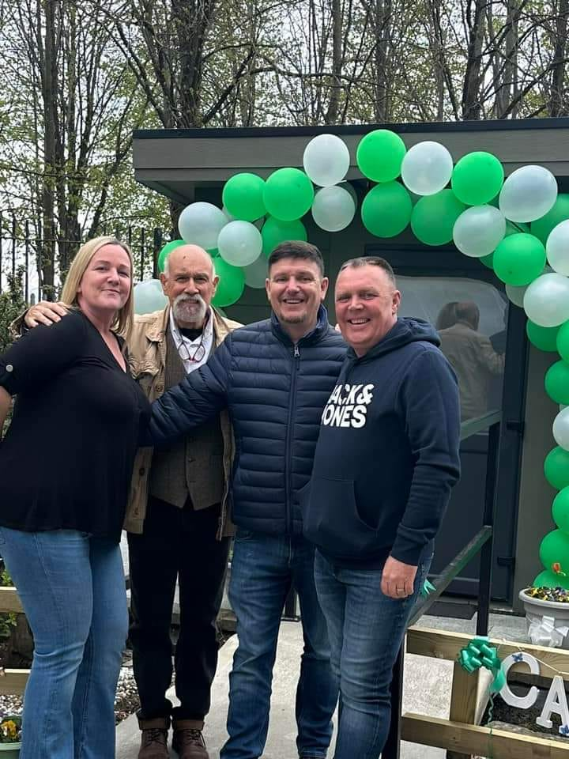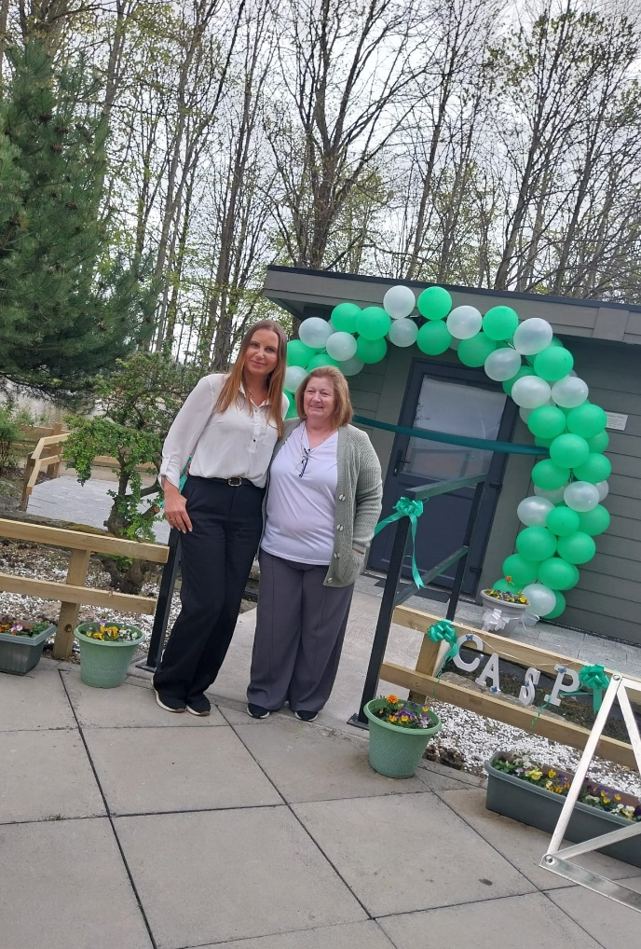

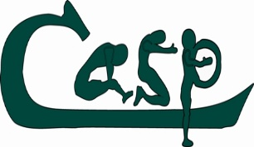
CASP Dublin Service Users Feedback Report 2024

There were a total of 73 respondents to the survey which was conducted across CASP Dublin Services in 2024.

Q1. Consent to participate

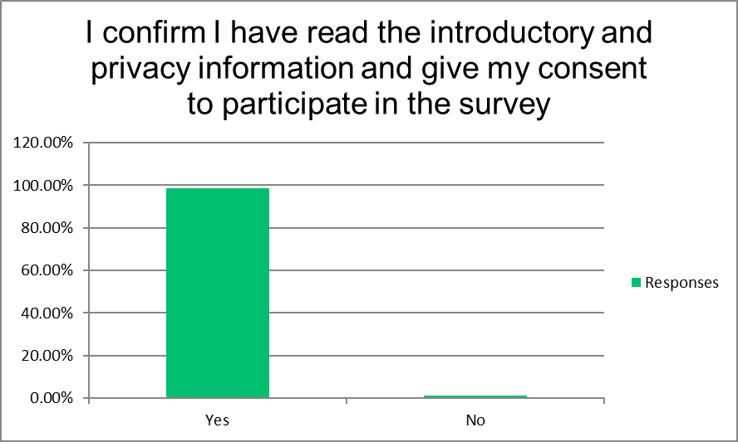
Q2.

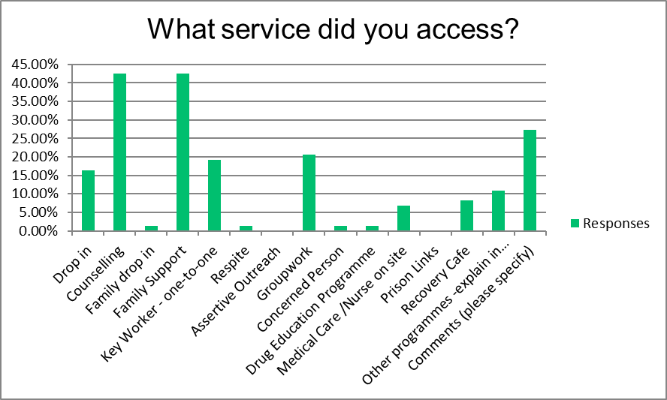
Answer Choices | Responses
Drop in | 16.44% | 12
Counselling | 42.47% | 31
Family drop in | 1.37% | 1
Family Support | 42.47% | 31
Key Worker - one-to-one | 19.18% | 14
Respite | 1.37% | 1
Assertive Outreach | 0.00% | 0
Groupwork | 20.55% | 15
Concerned Person | 1.37% | 1
Drug Education Programme | 1.37% | 1
Medical Care /Nurse on site | 6.85% | 5
Prison Links | 0.00% | 0
Recovery Cafe | 8.22% | 6
Other programmes -explain in the comments | 10.96% | 8
Comments (please specify) | 27.40% | 20
 | Answered | 73
 | Skipped | 0
Q3.
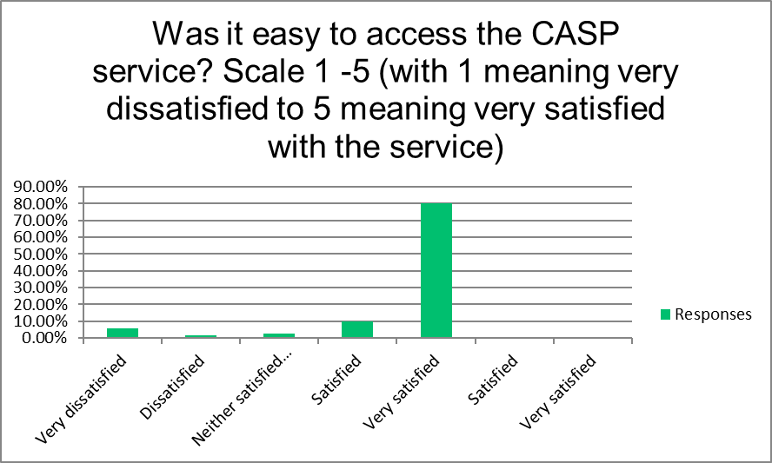

Answer Choices | Responses
Very dissatisfied | 5.63% | 4
Dissatisfied | 1.41% | 1
Neither satisfied nor dissatisfied | 2.82% | 2
Satisfied | 9.86% | 7
Very satisfied | 80.28% | 57
Satisfied | 0.00% | 0
Very satisfied | 0.00% | 0
 | Answered | 71
 | Skipped | 2

Q4.
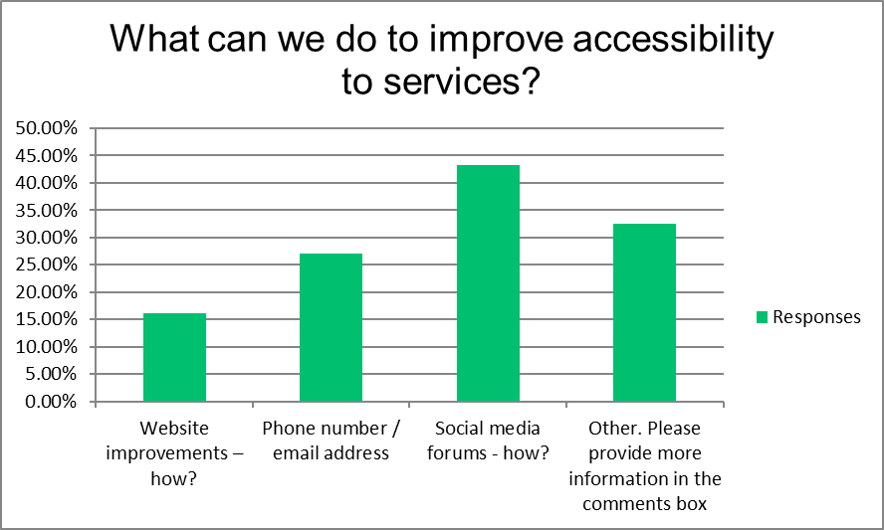
Answer Choices | Responses
Website improvements – how? | 16.22% | 6
Phone number / email address | 27.03% | 10
Social media forums - how? | 43.24% | 16
Other. Please provide more information in the comments box | 32.43% | 12
Comments (other) |  | 46
 | Answered | 37
 | Skipped | 36

Q5.
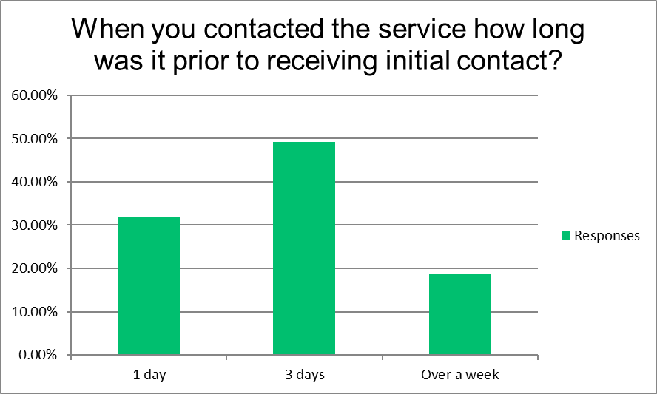
Answer Choices | Responses
1 day | 31.88% | 22
3 days | 49.28% | 34
Over a week | 18.84% | 13
If over 7 days, how many days? |  | 7
 | Answered | 69
 | Skipped | 4

Q6.
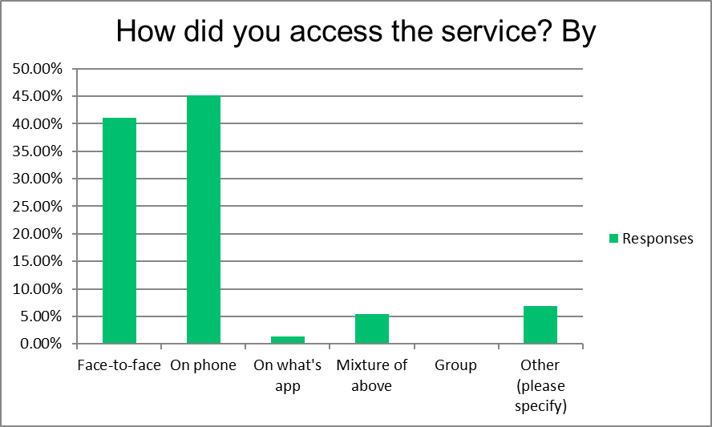
How did you access the service? By
Answer Choices | Responses
Face-to-face | 41.10% | 30
On phone | 45.21% | 33
On what's app | 1.37% | 1
Mixture of above | 5.48% | 4
Group | 0.00% | 0
Other (please specify) | 6.85% | 5
 | Answered | 73
 | Skipped | 0

Q7.
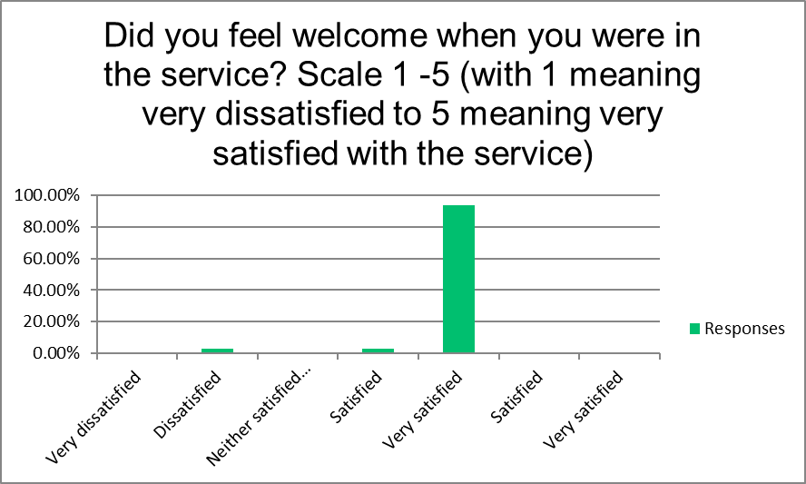
Answer Choices | Responses
Very dissatisfied | 0.00% | 0
Dissatisfied | 3.03% | 2
Neither satisfied nor dissatisfied | 0.00% | 0
Satisfied | 3.03% | 2
Very satisfied | 93.94% | 62
Satisfied | 0.00% | 0
Very satisfied | 0.00% | 0
Comments |  | 16
 | Answered | 66
 | Skipped | 7

Q8.
What was good or what could we do better - see question 7?
Answered 65
Skipped 8

Q9.
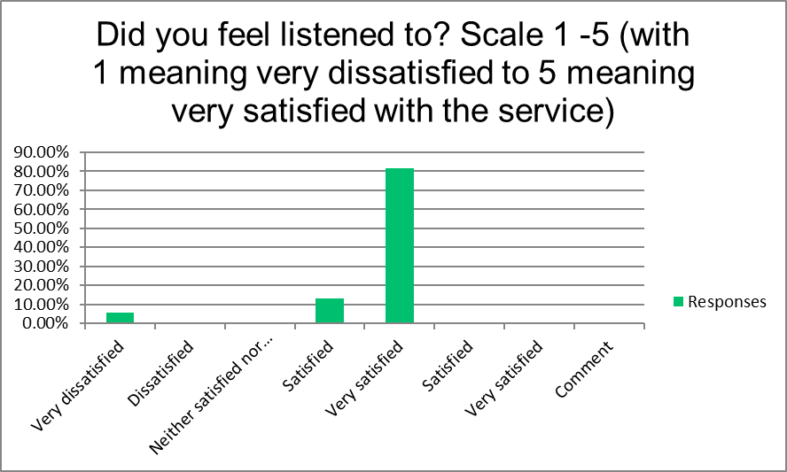
Answer Choices | Responses
Very dissatisfied | 5.71% | 4
Dissatisfied | 0.00% | 0
Neither satisfied nor dissatisfied | 0.00% | 0
Satisfied | 12.86% | 9
Very satisfied | 81.43% | 57
Satisfied | 0.00% | 0
Very satisfied | 0.00% | 0
Comment | 0.00% | 0
 | Answered | 70
 | Skipped | 3

Q10.
In relation to Q9 please tell us more about your experience. Please comment
Answered 66
Skipped 7

Q11.
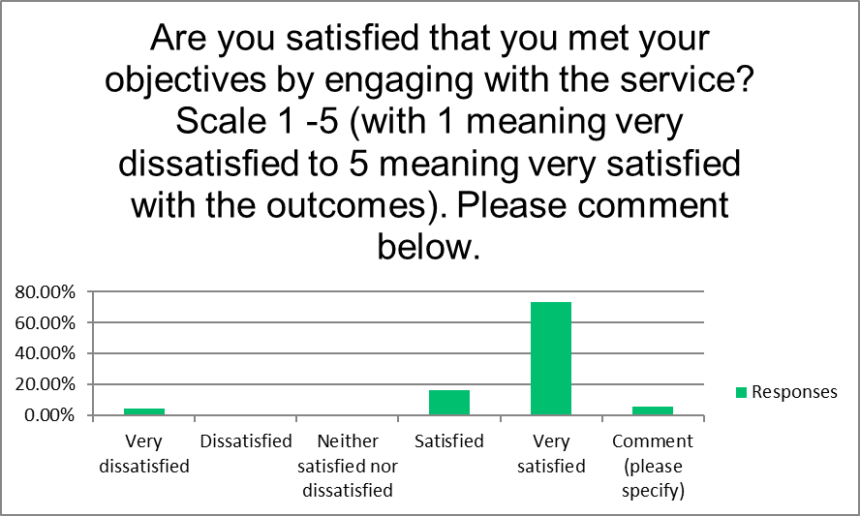

Answer Choices | Responses
Very dissatisfied | 4.41% | 3
Dissatisfied | 0.00% | 0
Neither satisfied nor dissatisfied | 0.00% | 0
Satisfied | 16.18% | 11
Very satisfied | 73.53% | 50
Comment (please specify) | 5.88% | 4
 | Answered | 68
 | Skipped | 5

Q12.
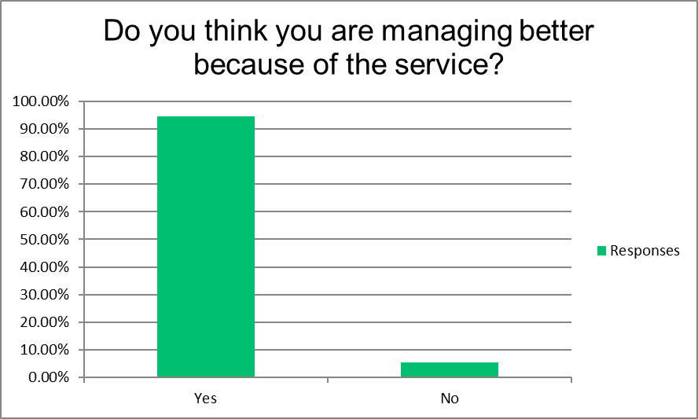
Answer Choices | Responses
Yes | 94.44% | 68
No | 5.56% | 4
 | Answered | 72
 | Skipped | 1

Q13.
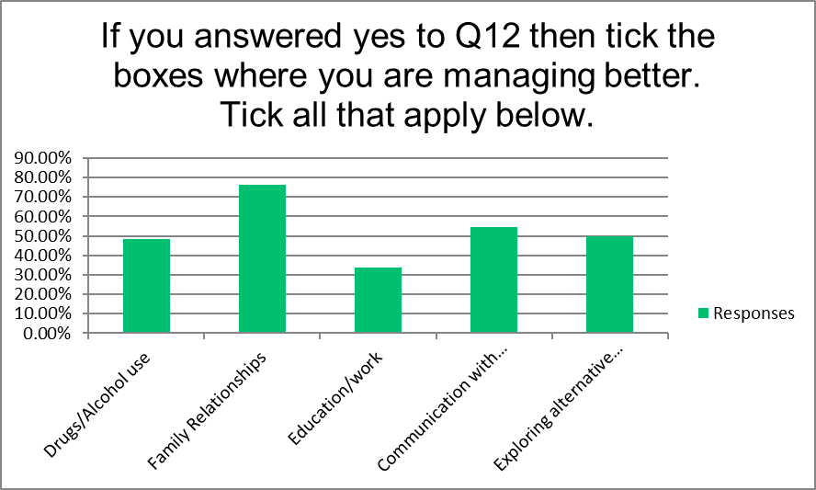
Answer Choices | Responses
Drugs/Alcohol use | 48.53% | 33
Family Relationships | 76.47% | 52
Education/work | 33.82% | 23
Communication with others | 54.41% | 37
Exploring alternative solutions | 50.00% | 34
Comment |  | 23
 | Answered | 68
 | Skipped | 5

Q14.
What could we do better in helping you to meet your objective/s?
Answered 55
Skipped 18

I would like to always linked in to casp, sometimes in good other times I need the support more
everything is good Everything is fine at the moment Get us onto our family doctor I'm happy with the support I'm getting now.
Nothing Different i got everything i needed From Casp, Support and Guidance I'm happy enough
I’m happy with my service Nothing from my experience I think knowing that you are there if we as a family need further help, is quite comforting
Not make people feel so uncomfortable To maintain contact and help moving forward when it's the next stage
Everything is good and helped me a lot I just think you we’re wonderful to talk too I can’t think of anything
Do what I’m asking for in reasonable time The services are just amazing Nothing, very happy with the service.
making me not an alcoholic More outgoing Not much I’m very happy to date. Help me get in to rehab
no faults Have a women's group there was a lovely group that i did with lorna and i got great healing and support from it but it’s no longer due to funding that wud be lovely if it returned
nothing (x10) Honestly I don't think you could have done any more for me. I live 80 kilometres from the service it would be great if it was rolled out nationwide. To continue to meet with me to ensure I’m staying on track looking after a hectic family situation
everything is good Continuing with my counselling as its helping me extremely and without it I be lost
Think casp is a great service nothing I would change Maybe do meditation between addict and family
Nothing my choice to leave Maybe more support in how I can move on or heal & help with anxiety over traumas that happened as parent of an addiction
Everything I asked for help with to help myself I received Cant fault it
I'm getting the help I need in casp I really cant say because I am really satisfied with the help I am receiving
You could help me by meeting my needs for medication so I don't get very sick but in saying that I was prescribed antibiotics for a gum & kidney infection which I really appreciated Contact them more often because of mental health nobody s saying it /afraid
Nothing, We have only great things we could say about your Service. Thanks Not a whole lot, just keep doing what you’re doing.
More advertising, people I have recommended Casp too believe casp is only if YOU are on drugs. More advertising for family support, prison link, drop in.
Nothing, you were all super. The holistic services were really great, they meant I gave myself self care when it was needed
Nothing. You were there to point me in the right direction Nothing yous are helping every day I’m in there from the moment I walk through the door
Maybe a refresher in a few months to see how things are going in the family.

Q15.
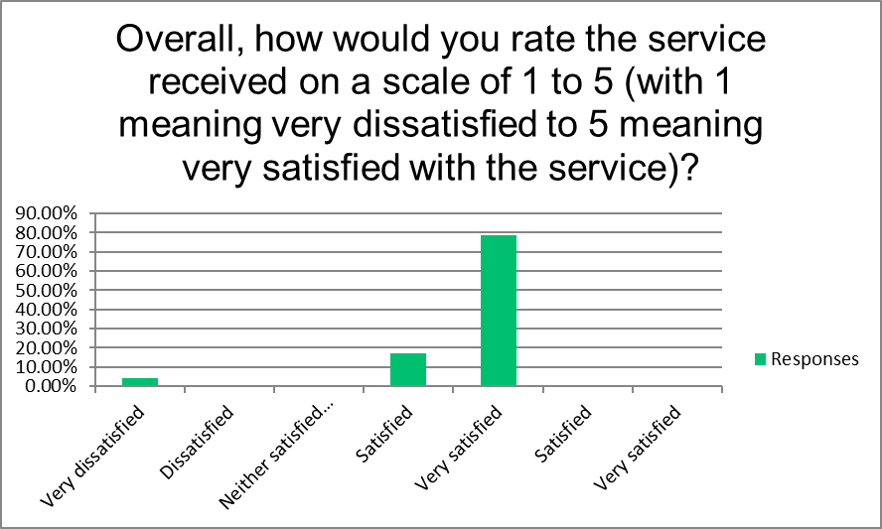
Answer Choices | Responses
Very dissatisfied | 4.29% | 3
Dissatisfied | 0.00% | 0
Neither satisfied nor dissatisfied | 0.00% | 0
Satisfied | 17.14% | 12
Very satisfied | 78.57% | 55
Satisfied | 0.00% | 0
Very satisfied | 0.00% | 0
 | Answered | 70
 | Skipped | 3

Q16.
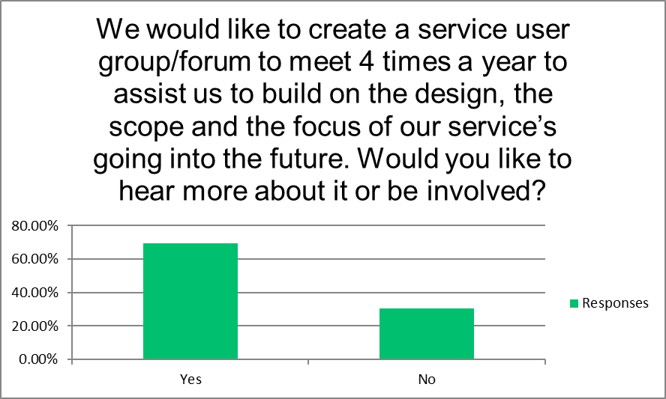
Answer Choices | Responses
Yes | 69.44% | 50
No | 30.56% | 22
Comment (please provide your contact details so we can contact you) |  | 32
 | Answered | 72
 | Skipped | 1

About CASP CSMT

Principal Activity
CASP CSMT provides community based, community-focused addiction treatment services that aims to support young people and their families living in the Mid-West region, Clare, Limerick City/County and North Tipperary.

VISION AND MISSION
CASP CSMT believes that change comes from within. This process involves identifying the issue and exploring it together to determine the necessary steps for the most suitable recovery plan.

CASP CSMT aims to provide a holistic, ethically based, community-focused drug and alcohol addiction treatment service. Our focus is on the physical, psychological, social, and emotional needs of the service user and their families who are living with the impact that addiction has on their daily lives.

CORE VALUES
We believe that empathy and compassion are a core strength of our organisation.
We strive to build good trusting relationships with each client in an empathetic and non-judgmental care setting. We feel that this aids in reducing negative behaviours which can lead to a better and more fulfilling life.

What we do?

The CASP CSMT team, continues to deliver on behalf of the MWRDAF a programme of activities that focus on under 18s, young adults and families who are either directly or indirectly involved/impacted by substance use. In line with The Mid-West Regional Drugs & Alcohol Forum Action Plan 2015 and the objectives of the developing action planning for the new strategic plan of 2024 – 2027.

Staff are trained in evidence-based approaches which have been proven to have positive outcomes for youths and families dealing with substance use issues. We utilise the Adolescent Community Reinforcement Approach (ACRA), the 5-step model and Motivational Interviewing to engage and support young people and their care givers.

Plans for the Future

Plans for the Future
Looking ahead to 2025 and beyond, the CASP Community Substance Misuse Team (CSMT) will continue to strengthen its role as a leading community-based support for young people and families affected by substance use across the Mid-West region. Building on the progress made in 2024, our priorities for the year ahead focus on growth, accessibility, innovation, and evidence-based practice.

1. Expanding Reach and Accessibility
CSMT aims to engage with at least 150 new referrals across Limerick, Clare, and North Tipperary. We plan to expand our presence through additional outreach clinics and community-based sessions, particularly in rural areas where access to addiction services remains limited.
Our goal is to ensure that every young person and family who needs support can access it—regardless of location, background, or circumstance.

2. Enhancing Therapeutic Interventions
We will continue to deliver approximately 1,200 one-to-one sessions with young people and 300 sessions with family members or concerned persons, drawing on proven methodologies such as the Adolescent Community Reinforcement Approach (A-CRA), Motivational Interviewing, and the 5-Step Family Intervention Model.
Further integration of Eye Movement Desensitization and Reprocessing (EMDR) therapy will also enhance our trauma-informed care for clients aged 18 and over.

3. Promoting Holistic Wellbeing
CSMT will expand its holistic and wellness supports, offering acupuncture, mindfulness, and stress-reduction programmes to up to 50 clients as part of their ongoing recovery plans. We believe that addressing emotional and physical wellbeing alongside therapeutic work strengthens outcomes and supports sustained recovery.

4. Strengthening Prevention and Early Intervention
In 2025, CSMT will deepen its collaboration with schools, youth services, and family programmes to promote education and awareness around substance use. By engaging earlier with at-risk young people and their caregivers, we aim to reduce harm, delay first use, and build resilience through positive coping skills and pro-social connections.

5. Building Partnerships and Collaboration
Our work thrives on partnership. In 2025, CSMT will continue to collaborate with statutory, voluntary, and community organisations — including Tusla, CAMHS, Foróige, EPIC, YAP, and the Mid-West Regional Drugs and Alcohol Forum (MWRDAF) — to develop integrated service responses. We will also strengthen links with Technological University of the Shannon (TUS) and other educational partners to support training, research, and placement opportunities for future professionals in the addiction and social care fields.

6. Investing in Research and Evaluation
Following the successful launch of our 2024 research initiative, we will continue to evaluate outcomes and strengthen our data collection processes. This will allow us to measure impact, identify emerging trends, and ensure that CSMT’s services remain aligned with best practice and the needs of young people and families.

7. Supporting Staff Development
CSMT recognises that the quality of our service depends on the wellbeing and expertise of our team. In 2025, we will continue to prioritise professional development opportunities, reflective practice, and clinical supervision to ensure our staff remain supported, skilled, and motivated.

Our Commitment for 2025
The coming year will see CSMT continue to grow as a responsive, compassionate, and evidence-driven service—one that empowers young people to make positive changes, rebuild relationships, and lead fulfilling lives free from the harms of substance misuse.
We remain dedicated to our core values of dignity, compassion, and support, ensuring that every young person and family who walks through our doors feels seen, heard, and valued.
Together with our partners, funders, and communities, CASP CSMT will continue to build safer, stronger, and more connected communities throughout the Mid-West.
Aims of the Organisation
CASP CSMT aims to support the young person and their families living with the impact of drug and alcohol related issues. We do this through the provision of individualized practical and educational interventions.

Referral Agencies
CASP CSMT continue to receive referrals from the following organisations;
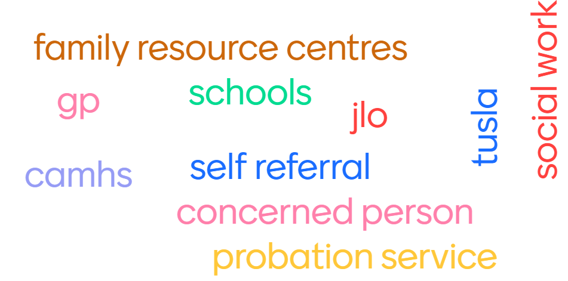

What to expect as a young person?
- Professional expertise
- Encouraging1:1 support
- Direction to improve life
- Improve coping skills
- Trusting relationship
- Ability to manage drug or alcohol use
- Awareness of own drug and alcohol use and consequences of such
- Non-judgemental support

What to expect as a care giver
- Support and skills to engage with adolescents
- Promoting self-care and well-being
- Emotional and psychological support
- Knowledge and understanding of youth drug and alcohol use
- Non-judgmental support

CASP CSMT believes that change comes from within, this process involves identifying the issue at hand and exploring it with a view to making some positive life changes.
We understand that at an early age young people may experiment with drugs and alcohol amongst other things– it is our job to help them find their way safely through this period of their life.

CASP CSMT in the Mid-West
CASP CSMT are based at Arthurs Quay House, Limerick City providing vital support services to young people and their families from this easily accessible central location.
Community outreach support is a large part of our organisation’s strategy for engagement. Within this CASP CSMT continues to operate several drop-in centres localised in the Mid-West region, subject to availability and ease of access for the service user. In Limerick County staff are present in the following clinics, Newcastle West, Caherconlish, Kilmallock, Abbeyfeale, Rathkeale, Croom, Murroe, Cappamore and Hospital; in Clare County: Kilrush, Shannon, Killaloe, Ennistymon, Lisdoonvarna and Ennis and in Tipperary North: Roscrea, Templemore, Thurles, Newport and Nenagh.

CASP CSMT in 2024
2024 was a dynamic and productive year for the CASP Community Substance Misuse Team (CSMT), marked by continued expansion, collaboration, and innovation across the Mid-West region.
The team provided therapeutic support to young people aged 13–24 and their families throughout Limerick, Clare, and North Tipperary, using evidence-based interventions such as the Adolescent Community Reinforcement Approach (A-CRA), the 5-Step Family Intervention Model, and Motivational Interviewing. Over the course of the year, CSMT engaged with more than 100 clients through one-to-one sessions, group work, and holistic supports.
A key milestone for 2024 was the initiation of a comprehensive research project to evaluate service outcomes and strengthen data-driven practice. This research will guide the future direction of CSMT and ensure that the voices of young people and families remain central to service design.
The team also expanded its collaborative partnerships across the Mid-West. New and renewed relationships were forged with organisations such as Doras, CAMHS, EPIC (Empowering People in Care), YAP (Youth Advocacy Programme), Foróige, and the Technological University of the Shannon (TUS). These partnerships enhanced referral pathways, reduced service duplication, and improved access to supports for vulnerable young people.
In addition to direct client work, CSMT staff contributed to a wide range of community and educational events, including:
- The Tipperary CYPSC Networking and Development Day, promoting cross-sector collaboration among youth and family services.
- The Airmid Mental Health & Wellbeing Conference in Shannon, attended by 28 community members seeking information on mental health supports.
- The Return to Exercise Group for young adults in recovery, combining physical activity, nutrition, and relapse prevention education.
- Regular outreach sessions in local communities such as Our Lady of Lourdes, which helped increase visibility and trust in the service.
Throughout the year, the team continued to focus on accessibility and inclusion, offering services from Arthurs Quay House in Limerick City as well as multiple outreach clinics across rural areas. This regional presence remains vital for young people and families who might otherwise struggle to access support due to transport or geographical barriers.
A key clinical development in 2024 was the introduction of Eye Movement Desensitization and Reprocessing (EMDR) therapy, following the completion of professional training by a staff member. EMDR is now being integrated into care plans for suitable clients aged 18 and over, offering new therapeutic options for trauma-related challenges linked to substance use.
CSMT’s client feedback throughout the year was overwhelmingly positive. Young people and families reported improved understanding of addiction, stronger communication, reduced substance use, and greater confidence in managing challenges. The service continues to prioritise co-production—working in partnership with clients to design and refine programmes that meet their real-life needs.
2024 demonstrated CSMT’s unwavering commitment to prevention, early intervention, and recovery. Through professional expertise, compassion, and collaboration, the team strengthened its role as a cornerstone service for young people and families affected by substance misuse across the Mid-West.

Return to Exercise Group
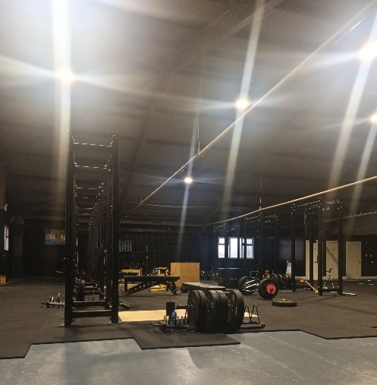
The group was initiated for young adults from our service who were in recovery. The group was weekly and provided healthy nutritional education and an exercise plan that could be built on to provide a ‘relapse-prevention’ programme for the individual service users as they transitioned from the service.

Tipperary CYPSC Networking and Development Day – May 2024
The event was for members of the Tipperary CYPSC and its Outcome Subgroups. An opportunity to take some time to meet in person and network, bringing together members from a range of services and groups across Tipperary. On the day 31 organisations attended and opportunities were explored for closer collaboration.
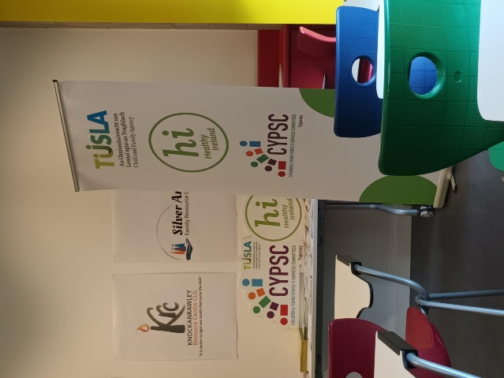



CSMT collaborated with a wide host of new organisations
CSMT met with a host of current community partners to strengthen the relationship and referral pathway. They were; Doras who support and promote the human rights of asylum seekers, refugees and migrants. This development was to review the possible barriers to accessing the CSMT service.

We collaborated with CAMH’s across the Mid-West to create a mutual platform to design a joint working protocol for supporting their team and the families they work with.

- Engaged with TUS (Technological University of the Shannon) and supported the 3rd year students of the Addiction Studies Degree and the 4th year Social Care students with modules relating to ‘working with vulnerable young people.

- Provided an outreach programme to the Our Lady of Lourdes community on the last Tuesday of each month during the early part of the year.

- Presented the support available to all GAA Ladies players in Limerick through their Children’s Officers.

- Supported a parents group with Foroige in Newcastle West.

- Met with EPIC (Empowering People In Care) and YAP (Youth Advocacy Programme) to review referral opportunities going forward.

Airmid Mental Health & Wellbeing Conference (Shannon)
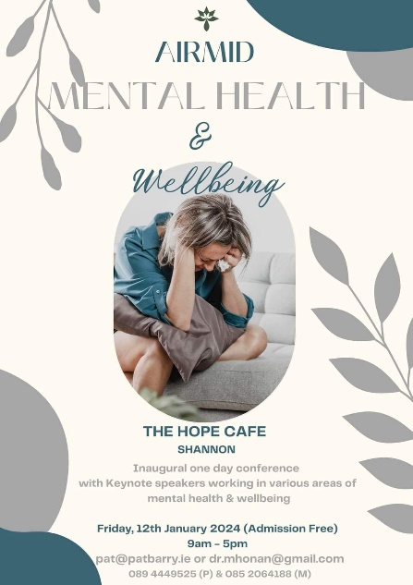
The conference facilitated 28 members of the Clare community to hear about the variety of support services available to families that promote heathy mental health.

STATISTICAL SUMMARY

In this section of the report, we give a statistical summary of 2024 at CSMT, examining several of the more important aspects of the service throughout the year.

Chart 1 below illustrates new referrals received throughout 2024 which total 137. Referrals received are a different component to the information generated from the Health Research Board (HRB), as our referral data is strictly in the calendar year and report the treatment. The flow of referrals were below the month-on-month referrals for 2024.
Chart 1

Chart 2 below gives a comparison of the referrals in 2021, through 2022, 2023 & 2024.

Chart 2
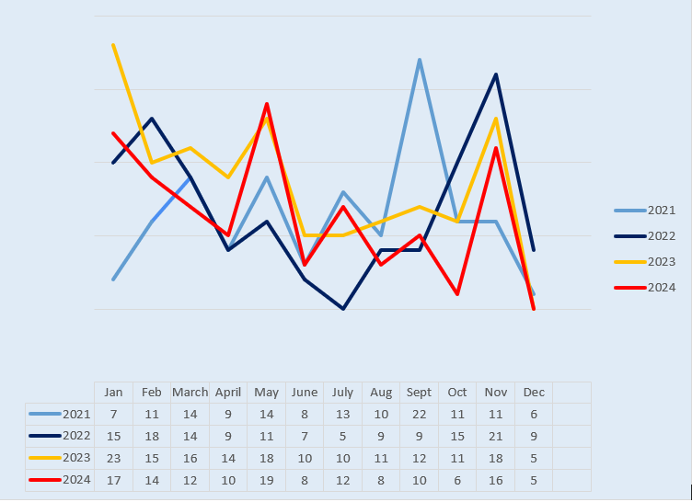
Chart 3 examines the age of clients referred and is broken down to show the two main age groups, of 18 years and under and 19 years and older. As we can see most of our clients (75%) in 2024 were 18 years and under, this shows the need for a service like CSMT in the Midwest region. Since 2022 the age profile in the service has reduced i.e., had an average age in 2022 of 17.5 years old and is now down to 16 years old in 2024.
Chart 3

Chart 4 below illustrates the client gender of those who attended CSMT in 2024. The data shows a similar pattern to most years i.e., a steady increase in females seeking treatment. The average number of persons seeking help for substance misuse in Ireland, being 62% for males to 38% for females (Ni Luas et, al. 2024). The Health Research Board states, however, that this proportion can vary depending on the primary drug and the treatment programme.

Chart 4

Chart 5 shows referrals by region covered by CSMT. Just over half of referrals this year are in the Limerick area. We have seen an increase in referrals in Clare during this period. In 2024, 47.5% of referrals were from Limerick, 29% were from Clare and 23.5% were from North Tipperary.

Chart 5

Chart 6 shows the source of referrals in 2024. With 50% of clients being referred by family or self, this leaves the rest of our referrals from agencies and education. What is also shown is that we received an increased number of referrals from Tusla, Social Workers, Doctors and CAMH’s across the Mid-West.

CHART 6

Chart 7 shows the comparison of referral sources for 2022, 2023 and 2024.

CHART 7

The next section examines the clients that attended CSMT throughout 2024, This information is acquired from HRB reporting and gives an outline of the type of client that we see. This information is entered by the staff all through the year and gives exact data on our clients and the work done with them. The team provided 103 clients with treatment interventions.

Chart 8 shows the reason given by the client for the referral
CHART 8

It is worth noting that 82% of clients had no previous involvement with CSMT and were new referrals.

Chart 9 shows the age of the client at referral reported on HRB (not including CP’s)
CHART 9

Chart 10 shows the information on the highest level of educational accomplished by the clients that attended CSMT in 2024. Education can play a role on all four dimensions; it can improve social capital by opening up opportunities to develop new networks of friends outside the confines of formal treatment and self-help groups, it can improve physical capital by enhancing career options and job opportunities which can influence their living standards and it can improve cultural capital by exposing people to new values, beliefs and attitudes and instilling a revised work ethic grounded in the demands of educational pursuits.

Therefore, at CSMT we try to help clients stay in education for their benefit when these situations arise.

Chart 10

Furthermore, we also know from referrals there was:

One service user who didn’t go to school at the time of the referral, there were 15 who had left school before they were 16 years old and 34 were still in school during their involvement with CSMT.

Chart 11 shows the employment status of clients in 2024 and as can be seen, 42% of our students remain in education, which as explained in the previous chart is valuable in helping clients resolve their substance misuse issues. With 22% of clients unemployed it is important that we also help then navigate a path to either education, training, or employment. This reiterates the importance of pro-social resources.
Chart 11

Chart 12 shows the outcome of treatment on closing to the service or at the end of 2024. The chart demonstrates that 59% of clients completed their treatment or their treatment with us is ongoing. We can also see that 21% of clients did not want to go any further with treatment after the initial assessment and 12% of clients never returned after their first assessment.

Chart 12

When a service user finishes up with CSMT or is not contactable their respective file is reviewed and a closure form is completed by the key worker. This closure form provides data that relates to outcomes from the time with CSMT. The data for 2024 shows;

91 service users closed

Outcomes for these sessions included:
- ACRA programme- Functional analysis raising awareness of triggers for substance misuse.
- Increased pro-social behaviour.
- CRAFT model of work with concerned persons
- 5 Step Programme
- Solution focused intervention through a collaborative approach
- Reduction of drug & alcohol use
- Raised awareness of effects of substance misuse, poly drug use.
- Lessened the impact of substance misuse on the family unit.
- Provided a safe place to discuss issues.
- Supporting young people affected by a parental addiction, this includes providing emotional support; education around the nature of addiction and increasing knowledge of various substances. These young people may be particularly vulnerable to substance misuse themselves and this work is seen as preventative.
- Improved communication in the family by practising communication skills with the young people.
- Assisted and advocated for young people to achieve goals on their action plan, e.g., looking for courses and activities that the young person may be interested in.
- Education and awareness around substances so that informed choices can be made by the young person.
- Referrals to other agencies where appropriate, e.g., SICAP, Bushypark, Aislinn residential
- Assessments carried out for Aislinn residential and pre- and post-treatment support provided.
- Improved well-being including mental and physical health.
- Improved understanding of opportunities available and support

Main Drugs Presenting in 2024

Chart 13 the referrals show Cannabis herb (weed) 65%, Alcohol 14%, Cocaine 11% and benzodiazepines 8% are the main substances being misused by client that are presenting themselves to CSMT in 2024. It is often found by key workers when working through the Function Analysis that clients are using alcohol when they use other drugs (poly-drug use). This data has remained consistent over the past number of years.

Chart 13

Psychoeducation Group
We worked with 2 clients this year. The reduction of referrals is maybe a consequence of the current practice/trend in courts with cases being regularly deferred. CSMT is responding to this need and have regular contact with the court to discuss the programme moving forward and developing the course in conjunction with the courts here in Limerick. The programme consists of evidence-based practices including assessment, functional analysis of use, happiness scales and identifying pro-social outlets.

Course Description
The course is organised in 4 sessions, one each taking place weekly. All of the courses are held in Limerick City (subject to demand). Motivational Interviewing (M.I) techniques are used throughout the course. This is a collaborative method of communication with particular emphasis on the language of change. We also use Community Reinforcement Approach (CRA) which is a comprehensive behavioural program for treating substance problems. The course follow the format outlined below:
Pre-screening
- Contacting clients and arranging times for them to come to the office for an assessment
- Signing of Consent / confidentiality forms
- Explaining to the clients what the course entails and what is expected of them.
- Introduction to the Happiness Scale: is intended to estimate the current happiness of each client in specific areas of life.
Session 1
- Introductions, Group Contract & Course Outline
- Function and Analysis of Substance, Use explores the antecedents and positive and negative consequences of a client’s substance use.
- Discussion on the Physical and Psychological Effects of Drugs.
Session 2
- Completion of the Dudit Tool which is a screening instrument to assess the severity of substance users’ drug use.
- Nourishing & depleting analysis, to review the impact activities have on your body battery.
- Leisure questionnaire to map your daily activities and review them.
Session 3
- The Legal Implications of a Conviction particularly in regard to employment prospects, travel and Garda vetting.
- The Wheel of Change: This tool was used to help clients understand why addiction can be so difficult to change, and the stages they go through in the process of changing their behaviour.
Session 4
- Alternative Relaxation Techniques: Auricular acupuncture was used which involved placing needles or beads on the client’s outer ear.
- Happiness Scale: is intended to estimate the current happiness of each client in specific areas of life after the completion of the course.
- Evaluations: Clients provide feedback by filling a simple questionnaire.

2024 CSMT - Client Testimonials (from the service user feedback questionnaire)
- ‘We live in West Clare and have to travel over an hour to Ennis to get to your service. For families without a car or 2 full-time working parents that can't get much time off work, it would be much better for our locality to have a service in Kilkee or Kilrush’ (mother of service user).

- ‘Our young person has a much better understanding of themselves and situations. They are more confident. They are in a better head space now and that is because of all the support they received. It’s great to have someone that understands’ (mother of service user).

- ‘I suppose really for me it’s acknowledging my behaviour and been shown more strategies to change them’ (service user).

- ‘The person was very generous with their time. They explained the process very well. They showed empathy and understanding. They discussed everything fully to understand the situation and provide the right level of support and advice’ (service user).

CSMT Service User Feedback Report 2024
There were a total of 38 respondents to the survey which was conducted across 2024 for any clients who exited the service and in December to January for those who remained in the service.

Q1. In 2024 the survey was offered to only CSMT clients

Q2. What service did you access/attempt to access? Tick all that apply.

Answer Choices | Responses
Young Person | 44.74% | 17
Concerned Person | 7.89% | 3
Groupwork | 0.00% | 0
Counselling | 36.84% | 14
Family Support | 23.68% | 9
Drug Education Programme | 26.32% | 10
Acupuncture | 23.68% | 9
Other programmes -explain in the comments | 2.63% | 1
Comments (please specify) | 10.53% | 4
 | Answered | 38

Q3. How did you reach out to CSMT?

Answer Choices | Responses
Phoned the service | 52.94% | 18
Emailed the service | 2.94% | 1
Submitted a contact through the website | 0.00% | 0
Other - tell us how in the comments box | 44.12% | 15
Other (please specify) |  | 21
 | Answered | 34

Q4. If you contacted the CSMT service by phone did you get a prompt response?

Answer Choices |  | Responses
Yes |  | 96.77% |  |  | 30
No - see comment box |  | 3.23% |  |  | 1
Left a message -see comment box |  | 0.00% |  |  | 0
Comment - what was the outcome of the phone call? |  |  |  |  | 13
 |  | Answered |  |  | 31
Comments -
Got a date to meet to get to know each other
Very helpful - I was put in touch with keyworker who was and still is extremely helpful
Keyworker got support for our young person
Was waiting for a space for our daughter which took a while and we felt at the time it wasn't quick enough

Q5. Was it easy to access the CSMT service? Scale 1 -5 (with 1 meaning very dissatisfied to 5 meaning very satisfied with the service)

Answer Choices | Responses
Very dissatisfied | 2.63% | 1
Dissatisfied | 0.00% | 0
Neither satisfied nor dissatisfied | 2.63% | 1
Satisfied | 26.32% | 10
Very satisfied | 68.42% | 26
Satisfied | 0.00% | 0
Very satisfied | 0.00% | 0
 | Answered | 38

Q6. What can we do to improve accessibility to our service?

Comments (Q6)
More access on social media.
More advertising.
Have contacts for you within schools
I never have a problem contacting the services.
It took me ages to find this service.
I had to take several steps to get through because the Garda didn't have the current info, so it ended up being a series of phone calls to find the service.
More news updates might drive engagement
I knew nothing of your service until Silver Arch and Ascend mentioned you ,so more social media awareness
All contact was well received with no area I can see for improvement
We had no problem as keyworker returned a call to my mam
Excellent as it is.

Q7. When you contacted the service how long was it prior to receiving a follow up contact?

Q8. Were you satisfied with the frequency of appointments offered?

Comments
Yes
Very Satisfied, our keyworker works on the schedule we need.
Our keyworker was fantastic. She is such a lovely person and so helpful. An angel.

Q9. How did you access the service?

Q10. Did you feel welcome when you were in the service? Scale 1 -5 (with 1 meaning very dissatisfied to 5 meaning very satisfied with the service)?

Q11. What was good or what could we do better to make you feel welcome - see Q10?
Friendly warm atmosphere made to feel at ease.
I was really impressed how welcome I was made when I first started a lovely environment of friendly people.
It was very welcoming.
Counsellor is lovely.
So far great and needed service.
I get tea and a warm welcome.
Could not have felt more welcomed!!
Always feels welcome here.
Nothing service is very welcoming.
Very informal and relaxed. Understanding and compassionate
The counsellor is brilliant at making you feel heard.
My counselor is very kind and very welcoming always made feel at home.
All was good and helpful.
I don't think there's anything more - just maybe reach out to the Garda JLO's and make sure they have your direct contact information so they can easily access your service.
I felt listened to.
Our Contact was extremely welcoming friendly and made that space relaxed.
We couldn't find any faults.
Nothing to improve.
Meeting once a week was good.
Not a lot I think the service is great.
The person was very generous with their time. They explained the process very well. They showed empathy and understanding. They discussed everything fully to understand the situation and provide the right level of support and advice.
Excellent service.
My son felt welcome and enjoyed his visits.
Quick response, great service.
It was mostly communication with our daughter very little with the parents.
Our keyworker made me feel very welcome from the start and I don't think they could have done anymore for me. They were even willing to help me in the future if I need it.
I felt comfortable talking to them. I had support and wasn’t lost anymore.

Q12. Did you feel listened to? Scale 1 -5 (with 1 meaning very dissatisfied to 5 meaning very satisfied with the service)

Answer Choices | Responses
Very dissatisfied | 0.00% | 0
Dissatisfied | 0.00% | 0
Neither satisfied nor dissatisfied | 0.00% | 0
Satisfied | 23.68% | 9
Very satisfied | 76.32% | 29
Satisfied | 0.00% | 0
Very satisfied | 0.00% | 0
Comment | 0.00% | 0
 | Answered | 38

Q13. Are you satisfied that you met your objectives by engaging with the service? Scale 1 -5 (with 1 meaning very dissatisfied to 5 meaning very satisfied with the outcomes). Please comment below.

Answer Choices | Responses
Very dissatisfied | 2.63% | 1
Dissatisfied | 0.00% | 0
Neither satisfied nor dissatisfied | 2.63% | 1
Satisfied | 21.05% | 8
Very satisfied | 71.05% | 27
Comment (please specify) | 2.63% | 1
 | Answered | 38

Q14. Do you think you are managing better because of the service?

Answer Choices | Responses
Yes | 97.37% | 37
No | 2.63% | 1
 | Answered | 38

Q15. What could we do better in helping you to meet your objective/s?
Nothing very satisfied.
I was really pleased and couldn’t find a fault.
As I said, so far great and we hope it will continue this way.
Keep doing what you're doing.
Everything is good
Group support would be a good addition and social group for parents.
I’m very happy.
More frequency of meetings.
Nothing I'm happy with the help my son has received.
We live in West Clare and have to travel over an hour to Ennis to get to your service. For families without a car or 2 full time working parents that can't get much time off work, it would be much better for our locality to have a service in Kilkee or Kilrush.
You have helped me get so far , thanks 👍
They couldn't do anything better then what they already do.
Honestly we got all the help and support we needed both our keyworkers, they are remarkable people.
Nothing to improve.
I suppose really for me it’s acknowledging my behaviour and been shown more strategies to change them.
No comments here. I have found the support service to be extremely helpful.
Fantastic prompt service 👍
I was very happy with how my son felt welcomed and listened to.
Keep up with the good work as you do now.
May speak with the parents of the child more often. Not everything a child says is true.
Nothing. I never thought this would happen in my family and she was there to help and guide me. I would have been lost without her.

Q16. If you answered yes to Q14 then tick the boxes where you are managing better. Tick all that apply below.

Answer Choices | Responses
Drugs/Alcohol use | 61.11% | 22
Family Relationships | 69.44% | 25
Education/work | 19.44% | 7
Communication with others | 44.44% | 16
Exploring alternative solutions | 33.33% | 12
Other | 8.33% | 3
Comment |  | 8
 | Answered | 36

Comments –
Helped with anxiety as well.
Help to get a house.
Being sober not needing substances.
Our young person has a much better understanding of themselves and situations. They are more confident. They are in a better head space now and that is because of all the support they received. It’s great to have someone that understands.
Supporting my son to recover in the community with help from Silver Arch.
We are all getting on great and have an excellent relationship with each other.

Q17. Overall, how would you rate the service received on a scale of 1 to 5 (with 1 meaning very dissatisfied to 5 meaning very satisfied with the service)?

Q18. We would like to create a service user group/forum to meet approximately 3 times a year to assist us to build on the design, the scope and the focus of our service’s going into the future. Would you like to hear more about it or be involved?

CONTACT US

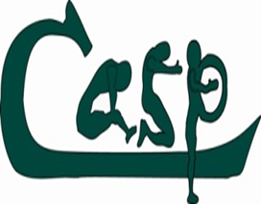Head Office, Muriel Boothman Centre, Fonthill Road, Clondalkin, Dublin22.

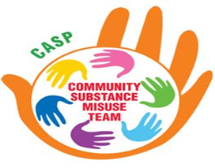Midwest Regional Office, 2nd Floor, Arthurs Quay House, Limerick.

www.casp.ie

