“Ensuring Excellence”
Chrysalis Community Drug Project Strategic Plan, 2023-2025
October 2022
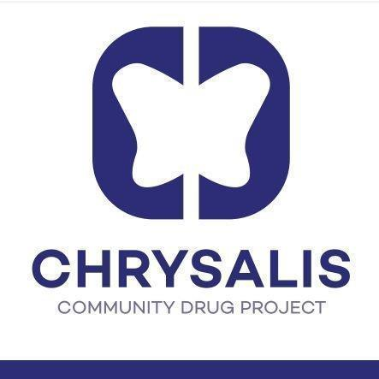
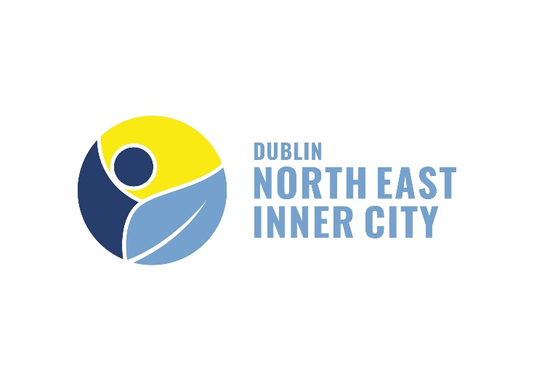

Consultation and report by Alan McKenna on behalf of the Chrysalis Community Drug Project

Table of Contents
Table of Contents 1
Foreword 2
Chair - Esmonde Keane 2
CEO - Passerose Mantoy 3
Introduction 4
Chrysalis Community Drug Project: An Overview 5
Chrysalis 2019-2022 7
Service User Demographics 10
Strategic Planning Process 13
Key Findings and Recommendations 15
Service Provision 15
Findings
Recommendations
Compliance/Accountability 17
Findings
Recommendations
Duty of Care 18
Findings
Recommendations
Funding 21
Promotion & Social Media 21
Research 22
Summary of Key Recommendations 24
Appendices 26
Appendix 1.1 - Board Personal Interview and Employee Focus Group Questions 26
Appendix 1.2 - Additional Questions for Management 28
Appendix 1.3 - Service User Focus Group Questions 28
Appendix 2.1 - External Stakeholder Google Forms Questionnaire Question List and Type 29

Foreword

Chair - Esmonde Keane
Chrysalis Community Drug Project has, since 1998 been working within Dublin 7 and, since 2019, in Dublin 1 also in reducing the harm caused by drug and alcohol use. The enclosed strategic report prepared by Alan McKenna on behalf of the Chrysalis Community Drug Project seeks to plan the route by which we develop and improve our offering to our service users and wider communities of Dublin 1 and Dublin 7 in the period from 2023 to 2025.
The service which Chrysalis provides is, as always, dependent on funding being secured against a background of rising prices and continuous pressures to meet wages and other outgoings.
The core of Chrysalis is, as it always has been, the people who work tirelessly within the organisation including our staff, volunteers, and students. We have been lucky to have had Passerose Mantoy as our Chief Executive along with our team leaders and those who work and have worked tirelessly within the organisation both before and since the outbreak of Covid 19. Our team at Chrysalis have shown phenomenal adaptability and willingness to change and adapt during the Covid crisis and, as we emerge from same, the organisation is in a strong position to further develop.
I would like to thank the board members of Chrysalis for all of their help and support and individual expertise that they have so willingly made available to the organisation over many years. I would also like to thank Alan McKenna for all of his work and insight into this strategic report and above all to our entire staff, volunteers and students who have, during difficult times and circumstances, worked so well with our service users in achieving real and life changing goals and look forward to its continuing development over the period covered by the strategic review.
Esmonde Keane,
Chairperson

CEO - Passerose Mantoy
When we were looking for the core of this Strategic Plan, the Board and the Staff all agreed on the framework of excellence – excellence in three key areas, compliance, duty of care to service users and staff.
For the last 24 years Chrysalis has been proactive in a collaborative and inclusive effort to respond to the needs of alcohol and drug users in Dublin North Inner City. We have adapted to emerging drug trends from new synthetic drugs to crack/cocaine. We have advocated on behalf of our service users in relation to issues such as dual diagnosis and homelessness.
Our response to the drug and alcohol crisis has been comprehensive, and we, as a team, have actively engaged with service users along the continuum of care to carry our Mission ‘to reduce harm and empower people to live healthier and more fulfilled lives’. In 2021 we worked with 991 individuals through keyworking, case management, counselling and groupwork. The delivery and quality of service provision wouldn’t have been possible without the commitment and dedication of our team of staff and volunteers.
As a leading addiction service, it is our endeavour to excel in our practice and serve our service users to best standards; to support our staff and volunteers to reach this goal we aim to provide quality training and supervision. We also thrive in the area of compliance by adhering to the requirements set by our funder, the HSE, and by the Charity Regulations but also by foreseeing new areas of due diligence.
I would like to take this opportunity to thank the Board of Management who have been extremely supportive over the years, and the formidable team whose skills and loyalty have underpinned our work.
Passerose Mantoy,

Chief Executive Officer

Introduction
This document aims to review the consultation recently carried out to inform the Chrysalis Community Drug Project’s Strategic Plan for the period of 2023-2025. This consultation took place between May-August of 2022, and consisted of three key methods of data collection:

- Personal interviews and focus groups (Chrysalis staff, Board of Directors, and management incl. Team Leaders and CEO);
- External stakeholders questionnaire;
- Service User focus groups.

The plan itself is based primarily on data collected from the aforementioned key stakeholders, although relevant academic literature, organisational documents and datasets provided by the Health Research Board heavily inform the nature of qualitative data this consultation aimed to collect, as well as the key themes of the Strategic Plan itself.

This document begins by providing a brief introduction to Chrysalis CDP, its goals and values, and the services it provides. It then offers a more concentrated overview of Chrysalis in the years since its previous strategic planning consultation in 2018, highlighting the most relevant organisational developments and changes to service provision taking place over the period of 2019-2021. Data compiled by the Health Research Board is then used in order to provide an insight into the demographics of Chrysalis’ service users according to the most recently available figures for the year 2021. These sections will help to contextualise the next, which provides a brief overview of the consultation process itself. The document then sets out to discuss the findings of the consultation, covering the three key data collection phases of discussions with those working within Chrysalis and also the Board of Directors, the questionnaire for external stakeholders with whom Chrysalis maintains a professional relationship, and the two focus groups conducted with service users attending the project’s peer-led Recovery evenings. Lastly, the key recommendations are briefly summarised in the form of an action table.

Appendices consist of the questions posed to the Board of Directors and employees (Appendix 1.1), Chrysalis’ management (1.2), Service Users (1.3), as well as a detailed overview of the Google Forms questionnaire for external stakeholders (2.1).

Chrysalis Community Drug Project: An Overview
The Chrysalis Community Drug Project has been dedicated to offering support to drug users and their families in the North Inner City since 1998. Their most established operation is located at 33 Manor Street in Dublin 7. Across its operations in the Dublin 7 and Dublin 1 areas, Chrysalis provides a range of services to individuals with complex needs, including, but not limited to:

- Assessments,
- Case Management (including issues related to substance use, housing, medical supports, etc),
- Keyworking,
- Counselling (both generic and specific to addiction),
- Dissemination of informative materials related to Harm Reduction,
- Recovery Aftercare Groups,
- Community Detox Support,
- Peer-led Initiatives.

Chrysalis describes its core values as being related to the belief that “everyone living with problem substance use should be empowered to fulfil their full potential and have access to the same opportunities and rights as others.” Their mission is to “deliver a safe, compassionate and quality service to individuals and families living with problem substance use in the local community. (They) do this to reduce harm and empower people to live healthier and more fulfilled lives.”

Following research carried out in 2018, Chrysalis identified a need to expand service provision further to also cover the Northeast Inner City, opening a second branch in Dublin 1 in 2019. With this came a need to considerably increase the number of employees and volunteers working with the organisation in order to enable the D1 operation to deliver the same quality of services as its D7 counterpart. This is where the research issue arises. While both centres have received positive feedback from external stakeholders and service users alike, and thus have been undeniably successful in their goal of delivering quality services to individuals with complex needs, restrictions enforced by the government as a consequence of the COVID-19 pandemic circa March 2020 have forced the project to reconsider many of the programmes set out in its 2019-2021 Strategic Plan. These restrictions, namely mask protocol and social distancing guidelines, have also affected the delivery of existing services, with certain peer-led initiatives, such as the Recovery Evening, split into smaller groups to ensure that social distancing can be enforced, or postponed indefinitely, in the case of the Chrysalis Football Team. The Manor Street centre has not been in a position to accept walk-ins, though one-on-one meetings have been permitted on-site on an appointment basis. Digital appointments also take place where possible. As such, this strategic planning consultation aims to investigate areas in which Chrysalis has room to improve following the lifting of the majority of public health restrictions implemented as a result of the COVID-19 pandemic.

Chrysalis 2019-2022
Chrysalis’ most recent Strategic Plan, with the tagline “Treatment in Partnership”, was published in 2018, covering the period of 2019-2021. The research exercises leading to the publication of this document concentrated on precisely identifying the prevalence and nature of problematic substance use within the service’s catchment area of Dublin 7, and within Dublin North Inner City more broadly. In order to accomplish this, consultations were carried out with all key stakeholders ranging from service users, employees, volunteers, and board members of Chrysalis, as well as key external stakeholders representing the local health, medical and social services with which Chrysalis maintains a strong positive working relationship. As this approach to strategic review and planning has proven highly effective previously, similar data collection methods and stakeholders were agreed upon for this 2023-2025 plan.

A key result of the “Treatment in Partnership” strategy was the expansion of Chrysalis’ catchment area across the North Inner City, now encompassing both Dublin 7 and Dublin 1. Consequently, it was necessary to expand the team of frontline practitioners to more than double its pre-2018 size in order to ensure that quality case management would be available to all prospective service users in the new Dublin 1 operational area. This was an extremely ambitious and rapid expansion, at the heart of which was Chrysalis’ mission to deliver safe, holistic and high quality services to individuals and families with complex care needs across the local community, reducing harm and empowering service users to live healthier, more fulfilled lives by equipping them with bespoke care plans based on thorough needs assessments. Case management of this nature is an area in which Chrysalis has historically excelled and is held in high regard for in services across Dublin’s North Inner City.

Unlike with previous Strategic Plans, it is difficult to compare budgets, service user statistics and outcomes from recent years in order to ascertain whether or not Chrysalis has made tangible progress since 2018, as COVID-19 public health restrictions were imposed nationally less than halfway through the period of 2019-2021 intended to be covered by the “Treatment in Partnership” plan. Many recommendations presented following this consultation process were unfortunately deprioritised due to the rapidly changing needs of the local community as a consequence of the public health crisis and national-level restrictions put in place to combat it. As such, assessing each individual action Chrysalis intended to take as part of its 2019-2021 plan and determining whether or not it has been successful in doing so is a fruitless exercise. Chrysalis has been remarkably effective in skilfully and efficiently responding to the unprecedented circumstances brought about by the public health crisis, adapting service delivery to continue meeting the needs of service users to the best of the team’s ability in spite of the precarious, unstable conditions under which they must operate. This is all mentioned so as to highlight the fact that the previous three years have been highly atypical for Chrysalis, between a rapid and ambitious expansion into an entirely new catchment area, and a requirement to abandon many aspects of its Strategic Plan through no fault of its own. Everyone involved with the project, from the volunteers and employees to the management and directors, worked tirelessly to ensure that the organisational expansion could continue as planned, and that its established base of service users could continue to access high quality care at a highly stressful time in their recovery.

It is also worth noting that, while the mission and values underpinning service provision are the same in the new D1 frontline team as in the more established D7 team, the nature and setting of said service provision is considerably different. This is as a result of the D1 team being spread out amongst clinics and primary care centres within Chrysalis’ expanded operational area rather than spending the majority of their time in a more centralised Hub, as is the case with the D7 team and their sites on Manor Street in Stoneybatter. As Chrysalis’ main priority was using its increased funding to firmly establish its new team of Case Managers across the clinics and the D1 community, a level of uncertainty began to arise surrounding whether or not the project’s culture and values had been preserved over the course of the expansion. Consequently, the CEO approved and supervised the production of a student research report aiming to clarify the level of knowledge of Chrysalis’ staff and Board members of the project’s core values and culture.

This project was carried out over the period of May-September 2021 and involved 27 semi-structured interviews with the aforementioned stakeholders. It found that overall, the client-led culture of Chrysalis had translated well to its new Dublin 1 clinical operations in spite of a lack of face-to-face contact between the Dublin 7 and Dublin 1 teams, though this lacking relationship between the two teams did lead to a natural scepticism of one another. Consequently, the research project suggested that, once permissible under the COVID-19 public health restrictions, members of both teams ought to be enabled to engage with one another in-person wherever possible, through team-building sessions and group supervision. It also suggested that the project’s onboarding process be reviewed in light of the expansion into D1, allowing new hires to shadow members of staff across the organisation in order to gain a robust understanding of how Chrysalis’ core values and culture manifest in both holistic and clinical settings, a suggestion which Chrysalis implemented in the months following. This followed the revision of the project’s supervision procedures as a result of a similar research project conducted by a student researcher in the years prior, and is indicative of a positive trend whereby Chrysalis avails of its student interns’ research capabilities in order to facilitate tangible change to internal policy and procedure.

In line with Chrysalis’ expansion, the CEO and Board of Directors identified a need to expand middle management within the organisation. As a result, Chrysalis created the title of Team Leader in order to allow the CEO to oversee operations across the project’s expanded catchment area. Though initially part-time, Chrysalis now has two team leaders working for the service – one primarily in D7 and one primarily in D1. This expansion of middle management has been a largely welcome addition to Chrysalis, the creation of these roles creating room for career progression within the service. With that said, this reform has not been without its growing pains. For the more tenured members of staff, Chrysalis’ management personnel have remained identical since the beginning of their time with the project. Such members of staff express having highly approved of the previous management style, and some are concerned that the expansion of middle management may jeopardise this. However, the introduction of these middle management roles has undoubtedly been necessary for a service expanding as dramatically as Chrysalis has since 2018.

Finally, during the Summer of 2022 and thus coinciding with the strategic planning consultation process, Chrysalis gained access to an additional site on Manor Street. With this, the team based in Dublin 7 has had the opportunity to separate their appointments with service users of Chrysalis from their many administrative responsibilities, with office spaces created in the new building so that the original site of 33 Manor Street may be dedicated entirely to the service users. This has been a welcome development, as prior to the procurement of a second site on Manor Street, service users only had access to the ground and basement levels of the building, whereas all three floors can now be used for appointments and peer-led exercises.

Service User Demographics
The operational area of Chrysalis consists of Dublin 7 and Dublin 1, covering most of Dublin’s North Inner City. The primary criteria that any individual must meet in order to be considered eligible for attending Chrysalis are as follows:

- The person must be affected by substance misuse either directly or indirectly;
- The person must be over the age of eighteen;
- The person must reside in or have a connection to the Dublin 7 (Chrysalis Manor Street) or North East Inner City (Chrysalis Dublin 1) areas.

As such, although the majority of those who attend Chrysalis are from the Dublin 7 and Dublin 1 postal areas, the service remains open to working with individuals residing outside of the direct catchment area on the conditions that they have a link to it, such as attending a day programme or working in the area, or regularly receiving medical treatment there. Where possible, Chrysalis will also work with individuals who availed of its services in the past but have since relocated outside of the catchment area. Using data collected by the Health Research Board under the National Drug Treatment Reporting System (NDTRS), the table below contains a breakdown of the areas of residence of service users who received an intervention (inclusive of case management, keyworking and care planning) from Chrysalis during the calendar year 2021:

County of Residence | Total
Dublin | 508
Louth | 1
Meath | 1
Wicklow | 2
Total | 512

From this, it is clear that the overwhelming majority of those who avail of services provided by Chrysalis reside in County Dublin, with 508 of a total 512 individuals reported to the Health Research Board as having done so recorded as such. However, as Chrysalis’ eligibility criteria merely states that an individual presenting to the Service need only have a connection to, rather than a current address within, the local area, a small number of service users (4) from the nearby Counties of Louth, Meath and Wicklow have also received interventions from Chrysalis. Upon examining the Local Health Offices (LHO) of the 512 service users, further demographic details become clear:

Local Health Office (LHO) | Total
Dublin North | 17
Dublin North Central | 246
Dublin North West | 164
Dublin South City | 43
Dublin South East | 3
Dublin South West | 4
Dublin West | 16
Dun Laoghaire | 2
Ireland Unknown | 14
Louth | 1
Meath | 1
Wicklow | 1
Total | 512

This demonstrates that, although a strong majority of service users fall under the key areas of Dublin North Central and Dublin North West (410), a significant portion do not (102). This is a testament to the reputation Chrysalis has for providing quality care to, and securing positive outcomes for, its service users, as many individuals residing in areas outside of the operational area of the Dublin North Inner City present to Chrysalis for treatment rather than a similar service located closer to their place of residence.

This HRB dataset also sheds light on a number of other key areas of demographic information regarding the cohort of service users to which Chrysalis caters, namely that the majority (68.75%) are male, unemployed (82.62%), and were referred to the service specifically as a consequence of problematic drug use (80.08%). This overview of Chrysalis’ service user demographics demonstrates that the average individual who avails of Chrysalis’ services is a White Irish male, over the age of thirty, who has a history of problematic drug use and is currently residing in the North Inner City area of Dublin. They have a high likelihood of experiencing homelessness (40.82%) or other forms of precarious housing conditions (4.88%), having left school early without passing the Leaving Certificate Examinations (67.38%).

It is demonstrably true to say that Chrysalis is effective at providing positive outcomes for its average service user. However, this demographic information poses the question of whether, in spite of its unprecedented level of expansion in recent years, Chrysalis has done enough to present itself as a service open to all individuals within its operational area. The demographics of Dublin’s North Inner City have changed dramatically since Chrysalis’ founding in 1998, and for an established service which provides interventions to as many individuals per annum as Chrysalis, it is worth noting that the profile of service user engaging with the project has not diversified in line with the population at large.

Strategic Planning Process
The formal strategic planning process began in May of 2022, during which a brief literature review was performed in the area of the effects of COVID-19 public health restrictions on community-based addiction treatment programmes so as to inform the semi-structured interview scripts followed during the data collection phase, and a number of preliminary planning meetings were carried out with the CEO and Finance Officer of Chrysalis. A provisional timeline was also agreed upon at this point, as were the actions that would form the basis of the data collection necessary to produce a thorough Strategic Plan for the period of 2023-2025. In order to ensure the data collected was representative of all of Chrysalis’ key stakeholder demographics, it was agreed that recommendations for the service ought to be informed by feedback collected from all salaried staff (Case Managers, Key Workers, Receptionists, Administrators), members of the Board of Directors, and service users who are willing to engage with the strategic planning process.

As this is quite a lot of ground to cover over a relatively modest period of time, it was agreed that the Board would be interviewed individually but remotely in order not to interfere with their obligations outside of the voluntary role of Board Member; the employees would be interviewed on-site in four separate focus groups (two from Dublin 7, two from Dublin 1); and the service users interviewed would be those in attendance at the Recovery Evening meetings. Lastly, contact details of key external stakeholders were provided by the CEO and Team Leaders, specifically selecting individuals who are familiar with Chrysalis and the services it provides across the North Inner City. A Google Forms questionnaire (Appendix 2.1) was created and circulated amongst these stakeholders during the months of July and August in order to collect feedback on the key areas of Service Provision, Compliance/Accountability, and Duty of Care.

During the initial planning meetings for this process, the CEO suggested that following Chrysalis’ expansion, it ought to be the project’s goal to not just maintain its existing positive reputation and high quality service provision, but to ensure Chrysalis strives for excellence in every aspect of its operations. As such, the theme for this year’s Strategic Plan, covering the three-year period of 2023-2025, is “Ensuring Excellence”. Though “duty of care” was initially imagined to pertain to the staff and volunteers of Chrysalis, it became clear following early interviews with management and members of the Board of Directors that duty of care to service users is equally important to a service which aims to be client-centred as is the goal of Chrysalis. As such, the list of questions prepared for the two service user Focus Group sessions were heavily influenced by the concept of duty of care to those who seek care from Chrysalis. In summary, the purpose of the consultation was to establish recommendations as to what could be done at an organisational level in order to ensure Chrysalis strives for excellence in every aspect of its day-to-day operations.

Individual interviews with Board members were semi-structured in nature, following the same general script of core questions while allowing for follow-up questions as necessary. These interviews ranged from 25-40 minutes in length, and notes were compiled on each upon examining the resulting audio recordings. The group interview with the CEO and two Team Leaders of the service lasted approximately 1-hour and 30-minutes, and was conducted on-site in Manor Street, Dublin 7. Focus group sessions with employees of the service were also conducted in Manor Street, and between 1-hour and 30-minutes and 2 hours were allocated for these, inclusive of breaks and disruptions. Lastly, the two Service User focus groups were also held in Manor Street, lasting approximately 45-minutes each. An identical approach to notetaking was employed in each of these sessions.

The seven remote interviews conducted as part of this consultation were carried out over Zoom and used the in-programme call recording functionality to capture audio and video from the interviews. A backup recording was also created for each interview using the interviewer’s mobile phone. In-person interviews were recorded using a Blue Yeti microphone and the Audacity computer programme, with the same approach employed to backup recording. Any files and notes resulting from this consultation have been stored safely on an external hard drive, and all copies shall be deleted following publication of the Strategic Plan, in line with best practice.

Key Findings and Recommendations
As mentioned previously, the three key areas identified at the beginning of the strategic planning process in which Chrysalis aims to achieve and/or maintain a reputation for excellence are Service Provision, Compliance/Accountability, and Duty of Care (to staff and service users). As such, findings and recommendations from the consultation shall be outlined in this order. Although these three concepts formed the basis of the questions posed to stakeholders during the data collection process, comments and suggestions not directly related to these areas did arise at various points in the consultation. In the interest of transparency and thoroughness, recommendations outside of the original scope of the strategic planning process will also be included in this section.

Service Provision

Findings
The majority of the Board of Directors and management team agree that service provision is Chrysalis’ strongest area and can be considered excellent. Most frontline staff are also in agreement regarding its quality, although some have raised concerns over the impact of COVID-19 public health restrictions on Chrysalis’ ability to work with low threshold clients. With these restrictions having largely been lifted in recent months, there is a strong appetite amongst frontline staff and service users alike to reintroduce services postponed as a result of the pandemic. Since the period during which the staff focus groups were conducted, a number of said services have already returned to their prior state (incl. On-site Recovery Evenings in Manor Street), which has been a very welcome development.

The hybrid model of service provision has proven popular amongst the majority of Case Managers, with many believing that it ought to be offered to service users on a case-by-case basis. With that being said, the importance of face-to-face programme delivery to the majority of service users cannot be overstated, with all those in attendance at the Recovery Evening focus groups agreeing that in-person, peer-led initiatives of this nature are beneficial to their recovery.

Frontline staff take pride in having continued to provide vital services in line with public health restrictions, and although the need to have transitioned into focusing on service users who are considered medium threshold during this time is widely understood across the organisation, services for low threshold individuals, namely the Manor Street drop-in service, are sorely missed.

Of the respondents to the external stakeholder questionnaire, 7.7% rated the ability of Chrysalis to provide relevant support to its services users as 3/5, 53.8% as 4/5, and 38.5% as 5/5, the majority thus holding a belief that Chrysalis is either very strong or excellent in the area of service provision.

Recommendations
The most commonly echoed piece feedback regarding Chrysalis’ Service Provision across all stages of the consultation process for this Strategic Plan has been that the peer-led, more socially oriented services put on hold in line with public health restrictions have been sorely missed by frontline workers and service users alike. When asked whether Chrysalis had met any expectations they might have had prior to presenting to the service for the first time, one focus group participant stated that it had not, that they had been encouraged to seek care from Chrysalis by a friend who had had a positive experience with it in the past and was now in recovery, and that many of the services and programmes that had appealed to them during their conversation were no longer offered by the time they began attending Chrysalis in 2020-2021. From this it is clear that the reintroduction of currently inactive events and services such as the Community Open Day, and expansion of peer-led, relationship-building initiatives such as the Chrysalis Football Team, ought to prioritised heavily over the next three years so as to lower the threshold for entry to a level resembling Chrysalis’ pre-pandemic operations. Thankfully, Chrysalis is in a very strong position to facilitate this return to form, with its procurement of a second building in Stoneybatter leaving the entirety of 33 Manor Street available for such endeavours.

Service users in attendance at the focus group sessions shared that, although they find the Recovery Evenings immensely beneficial to their wellbeing, they would like to be presented with more opportunities to interact with individuals attending Chrysalis who are not in recovery, but still dealing with active addiction. Such socially oriented programmes were once facilitated by Chrysalis but were required to cease in line with public health restrictions. Focus group participants who had availed of the opportunity to attend such events in the past, both while in active addiction and in recovery, highlight their importance in empowering service users in recovery to share their experiences, offer practical advice, and develop a relationship with those in active addiction, while those yet to reach recovery see these events as an opportunity to develop a support network of individuals with similar lived experiences to them who have managed to follow their care plans and reach a state of recovery. As such, it is clear that events of this nature should be reintroduced and promoted heavily over the coming years.

Chrysalis would benefit from actively pursuing and developing relationships with universities and colleges within Dublin and even elsewhere in the country. In doing so, the service may gain access to a more stable, reliable flow of young professionals from social care, social work, psychology and research backgrounds, leading to a symbiotic relationship whereby students are given the opportunity to gain professional experience, and Chrysalis may avail of their expertise to assist with the day-to-day running of the operation. Chrysalis has already begun work to formalise such relationships by reaching out to Technological University of Dublin Grangegorman which has its campus in the Dublin 7 catchment area. However, as Chrysalis itself has expanded in services and team size in recent years, so too must its relationships network within the Higher Education sector. As such, it is highly recommended that Chrysalis continues to foster working relationships with other institutions within Dublin over the next three years, potentially expanding its network even beyond the capital in the future.

The lack of access to outpatient beds has been highlighted as a cause for concern not just within Chrysalis, but across the sector at large. Frontline staff feel that Chrysalis should prioritise lobbying its funders and external stakeholders in order to secure access to such outpatient care for service users in need of it. Management is acutely aware of this and uses its position on a number of Subgroups to voice concerns on the issue. It is clear from speaking with everyone involved with Chrysalis, from the directors to staff to service users, that this is an area in which the service must continue its advocacy efforts over the next three years.

Although Chrysalis’ expansion has made accessing care under the project more feasible to a larger cohort of people than ever before, barriers to access remain for many subsections of the local community. For instance, Chrysalis’ main buildings are not easily accessible to those with physical disabilities. As such, Chrysalis ought to investigate the feasibility of availing of wheelchair-accessible rooms provided off-site by external stakeholders, and even outreach visits to the homes of prospective or current service users so as to work towards equality of access for all.

Compliance/Accountability

Findings
The Board of Directors and management agree that this is an area in which Chrysalis has grown much stronger in recent years. The implementation of the eCASS Salesforce case management system has proven to be a largely positive development with regards to streamlining the storage of service user data, though this did come with its initial difficulties for staff who were unfamiliar with such a system.

Chrysalis takes matters of compliance and accountability very seriously for a project of its size. Although it does not currently have a dedicated Human Resources department to ensure compliance internally, its association with Ibec is effective in maintaining a high level of compliance with national policy and best practice within the sector. Since its previous strategic planning consultation, Chrysalis has also remained sufficiently compliant to satisfy all transparency requirements necessary for Service Level Agreements, an indication of the importance of compliance to Chrysalis’ culture, and the benefits of working with an external stakeholder such as Ibec to maintain excellence in the area.

As Chrysalis has expanded rapidly in recent years, so too has the level of compliance expected of its volunteers, employees and management. Internal policies are widely understood, approved of, and adhered to by all, but levels of familiarity with external stakeholder policies such as the HSE and clinical settings in which some frontline staff are based are in need of further clarification.

Of the respondents to the external stakeholder questionnaire, 53.8% rated their satisfaction with Chrysalis’ handling of relevant personal information pertaining to their shared clients as 4/5, while 46.2% rated this as 5/5. This demonstrates that, from the perspective of external stakeholders, Chrysalis is viewed within the range of very strong-excellent regarding issues of compliance and accountability.

Recommendations
As Chrysalis’ reach expands, it grows increasingly important to remain vigilant in the area of compliance. The project would benefit from developing a checklist covering all areas of compliance relevant to Chrysalis in order to ensure that internal policies and procedures are regularly reviewed and updated as needed to remain compliant with policy at a governmental and external stakeholder level, as well as best practice within the sector at large. By implementing a timeline for review, Chrysalis can ensure that its excellent standard of compliance is prioritised and maintained over the years to come.

Chrysalis has demonstrated a clear commitment to centring service users in their treatment and recovery and empowering them through a number or peer-led initiatives. It is important that this principle of empowerment is present throughout all levels of the organisation. Positive steps have been taken in recent years through the introduction of the Service Users’ Working Group, but in order to guarantee accountability to its clients and their wishes, it is important for Chrysalis to continue to promote this to interested service users, and ensure that suggestions emerging from its sessions are given thorough consideration by management and brought to the Board of Directors as appropriate.

Duty of Care

Findings
The Board of Directors and management are in agreement that duty of care, to both employees and service users, has remained high in the face of both the pandemic and the expansion into Dublin 1. The introduction of middle management roles in recent years has increased potential internal progression opportunities for Chrysalis staff and allowed the CEO to oversee the project’s expanded operations more efficiently.

A number of staff view the introduction of blended working as a favourable development, allowing those who wish to avail of it the opportunity to plan out their working week more clearly and balance their frontline work with their administrative responsibilities. Many employees agree that wages are but one aspect of duty of care from management to the team, with training, leave entitlement and the ability to work on projects and in areas of personal interest being similarly important to job satisfaction, all of which are areas in which Chrysalis has a highly positive record.

Although it must first be disclaimed that the service users spoken with as part of the Focus Group sessions were all in recovery rather than active addiction, and so are not a wholly accurate representation of the cohort of clients that Chrysalis works with at large, it must be stressed that of the stakeholders consulted with, the most overwhelmingly positive view of Chrysalis’ standard of care has been expressed by the service users themselves, indicating an extremely high level of satisfaction with Chrysalis’ duty of care to services users amongst those directly impacted by it.

During the focus group sessions, service users spoke highly of the holistic, welcoming atmosphere cultivated by the project. For those whose experience of care has typically been more clinical in nature, this has set Chrysalis apart from any other service they have engaged with. The staff in particular, from those working in the reception, to the Case Managers who assess the individual needs of each service user presenting to Chrysalis and assist them in following a bespoke, client-centred care plan, have been heralded as instrumental to service users’ positive outcomes.

The importance of peer-led initiatives such as the Recovery Evenings hosted in Manor Street on Tuesdays and Thursdays cannot be overstated. Service users shared that, as instrumental as the keyworking and case management services provided by Chrysalis have been in helping them enter recovery, it is the peer-led services that truly help them to maintain their sobriety by allowing them to speak openly about their experiences to a group of peers with similar backgrounds and difficulties in a safe and familiar environment.

The culture within Chrysalis is such that one service user attending the Recovery Evenings shared their experience of relapsing, having previously been in recovery. Upon re-engaging with the service, the individual expressed fears of judgement resulting from their recent relapse, the feelings of shame emerging from this rendering them apprehensive to return to the project. However, upon contacting Chrysalis, re-engaging with case management services, and returning to the Recovery Evenings, the service user did not feel judged by the Chrysalis team nor their peers for experiencing a relapse, and was welcomed back “with open arms”. This is representative of Chrysalis’ goal to always centre the individual client in their own care, prioritising their duty of care to service users rather than simply disengaging clients who do not adhere to a strict, unnegotiable care plan.

Recommendations
As Chrysalis has experienced a period of unprecedented growth since the publication of the previous Strategic Plan in 2018, it has become increasingly important that the more tenured members of the team are enabled to express their views and suggestions, and that their feedback is carefully considered by line management. Although management has already introduced internal and external supervision opportunities in an attempt to operationalise this, there still exists an appetite amongst many Case Managers for additional supervision opportunities with a greater concentration on navigating professional relationships within the workplace and resolving any difficulties which might arise from them. Thus, investigating the possibility of introducing such a programme of supervision is instrumental to maintaining the morale of Chrysalis’ staff following a period of considerable expansion and managerial restructuring within the project.

Newcomers to the Chrysalis team in the past had at times struggled with comprehending the role descriptions of a medium-sized organisation like Chrysalis, having mostly come to Chrysalis from a larger service in the local area with a more elaborate organisational structure. In order to ease these confusions going forward, Chrysalis has reviewed its onboarding process and clearly outlined the project’s organisational structure and role descriptors, as well as introducing a mentoring system for new additions to the team. Some Case Managers who joined the service before these changes were enacted expressed frustrations with their briefs changing before they became fully comfortable with their new roles within Chrysalis. As such, it is important to make applicants to all Chrysalis vacancies aware that the nature of their work is heavily reliant on discretionary funding, and may evolve depending on the projects currently being prioritised by funders, while also highlighting the positive developments to the project’s onboarding process and assuring applicants that high quality training will be provided to ensure that they are comfortable and capable of fulfilling any brief they are assigned.

With Chrysalis’ unprecedented level of expansion in recent years, many staff are left unsure of how best to navigate professional relationships with third-party stakeholders to whom they are accountable. As such, the development of a training seminar or programme concentrating on nurturing and maintaining relationships with stakeholders such as the HSE and addiction clinics is highly advisable, as Chrysalis’ expansion into the Dublin 1 area has seen a considerable diversification in the external stakeholders with which the service engages.

It is instrumental for Chrysalis to concentrate on maintaining a high level of job satisfaction amongst its employees. Chrysalis has a strong record of advocating for wage increases for its staff, and a commitment to providing job satisfaction is already observable in its funding of training opportunities, provision of leave exceeding the industry standard level, and willingness to implement policy proposals put forward by the team. This principle could be enshrined even further by allowing individual members of staff more autonomy not just through blended working, but also by ensuring that any member of staff who proposes a new project or initiative is directly consulted at each stage of the approval process.

Chrysalis would benefit from reviewing their student internship/placement programme over the coming years in order to attract additional young professionals. As Chrysalis, not unlike any other community-based project of a similar size, has a significant reliance on volunteers and students in assisting with service delivery and research, ensuring that students are aware of the project, the work it does, and its potential to kickstart their professional careers through facilitating more hands-on experience than many more recognisable organisations within the sector would be extremely helpful in guaranteeing a reliable source of young volunteers. Following a review of the programme, Chrysalis would benefit from promoting its services at university and college careers events, or even organising to deliver presentations to students enrolled in relevant courses.

Funding
With the lifting of the majority of public health restrictions in recent months, Chrysalis would benefit from examining the feasibility of exploring fundraising opportunities for the project. As Chrysalis has recently secured a second building on Manor Street, with 33 Manor Street remaining in use specifically for sessions with service users and peer-led initiatives, the project would benefit from organising Open Days to allow members of the local community to visit the establishment, raising its profile and contributing to the destigmatisation of the addiction services locally, and potentially making members of the general public more receptive to contributing monetarily to Chrysalis. Chrysalis should also continue to prioritise applying for additional funding through grants schemes in order to support both its established services, as well as any research projects it may see fit to develop and commission over the coming years.

Promotion & Social Media
In recent months, Chrysalis has become more adept at cultivating a social media presence, with its profiles on Facebook, Twitter and Instagram being updated on a regular basis. The project currently has 930 Likes on Facebook, 681 Followers on Twitter, and 609 Followers on Instagram, and will benefit from using these platforms to promote its work, and advertise events taking place on-site such as its recently held Open Day.

Chrysalis must become more open to capitalising on positive media coverage when it arises, as such coverage can be rare for a project of its size. In recent months, a popular Irish podcast titled “Talking Bollox”, hosted by two young men from the local community, released an episode in which one of the hosts’ mothers was interviewed about her experience of addiction and recovery. During this interview, she spoke glowingly about Chrysalis and the role it played in her recovery, praising a specific Case Manager with the service as having made an invaluable difference to her standard of living. When such positive feedback of the service is shared on a platform like this, Chrysalis should be open to making contact with those responsible with a view to using this coverage to promote the project, its dedicated staff, and the services it provides.

Interviews of this nature are not uncommon on Irish podcasts, and Chrysalis would benefit from exploring opportunities to promote its services on relevant podcast, radio, and television programmes. One such platform, “The Two Norries Podcast”, is centred around discussions of criminality, mental health, addiction, and recovery, and has featured interviews with representatives from a number of community, social justice and mental health services in the past.

When asked whether Chrysalis does enough to spread awareness of its work among the general public, a number of service users participating in the Focus Group sessions discussed the usefulness of the internet and social media in promoting Chrysalis to prospective service users within the local area. While it is evident that Chrysalis is not currently in a position to create a specialised role within the organisation for advertising and marketing, it would be worth the project’s time to consider commissioning an online marketing strategy incorporating Search Engine Optimisation (SEO) and targeted social media advertisements aimed at those residing in the North Inner City. The service has recently expanded the remit of four members of staff to include managing Chrysalis’ social media output and commissioning such a strategy would also create an appealing upskilling opportunity for interested employees, volunteers and students.

Research
By increasing its research output, Chrysalis is likely to raise its profile not just across the city of Dublin, but even nationally. As demonstrated by the results of the External Stakeholder Questionnaire, Chrysalis is already held in high esteem within its operational area. However, applying for research funding will help to diversify its funding streams as well as establish Chrysalis as a project with a dedication to staying up to date with developing trends within the addiction sector.

Through building relationships with universities and colleges locally, Chrysalis has the potential to gain access to a network of experienced researchers with whom research opportunities secured or currently being pursued by the project can be shared. While Chrysalis is not currently at a size or level of funding whereby a dedicated Researcher role or research department is possible to create, this approach will ensure that Chrysalis can develop a source of funding and build its reputation through research while still operating within its means. Chrysalis’ recent efforts to foster a relationship with TUD Grangegorman are an encouraging step, and the project would benefit from doing the same with other institutes of higher education across Dublin in order to expand its network of research professionals over the next three years.

As mentioned previously, the demographics of Chrysalis’ base of service users are not representative of the demographics of Dublin North Inner City as a whole. Though this is not surprising, it is unreasonable to assume that members of the local community who do not fall into the typical White, middle-aged Irish male category simply do not have a need to access services such as Chrysalis. As such, it would be beneficial to conduct research over the coming years into the prevalence of addiction within such subgroups of the community, and the potential barriers they may encounter preventing them from accessing care. In doing so, Chrysalis may be able to develop targeted interventions for specific minority groups within the local community.

Summary of Key Recommendations
Area | Recommendation | Lead | Priority | Deadline
Service Provision | Reinstate lower threshold (incl. peer-led) services to encourage engagement across the continuum of care | Team Leaders, CEO | High | Ongoing
 | Continue to advocate on behalf of service users in various fora | Team Leaders, CEO | Medium | Ongoing
 | Investigate methods for increasing the accessibility of service provision for physically disabled individuals/those who cannot receive treatment on-site (e.g. outreach, remote appointments) | Team Leaders, CEO | High | 2025
Compliance & Accountability | Maintain an excellent level of compliance by strictly adhering to the requirements of external stakeholders (e.g. HSE, Charities Regulator), such as through the creation of an internal policy review checklist | Finance Officer, CEO | Medium | Ongoing
 | Establish Service Users’ Working Group and operationalise feedback | Team Leaders, CEO | Medium | 2025
Duty of Care | Continue to provide internal and external supervision to staff in line with their needs | Team Leaders, CEO | Medium | Ongoing
 | Continue to advocate for wage increases and recognition of the role of Case Manager as distinct from that of Project Worker | Team Leaders, CEO | High | Ongoing
 | Develop training programme for team concentrating on best practice in inter-agency, multidisciplinary work | Team Leaders, CEO | Low | Ongoing
 | Review the student placement/internship programme and its promotion | Team Leaders, CEO | Low | 2023
Funding | Diversify funding streams (research, grants) | Team Leaders,  CEO | High | Ongoing
Promotion & Social Media | Facilitate on-site events open to the general public (e.g. Open Day) | Team Leaders, CEO | Low | 2023
 | Explore promotional opportunities via traditional and social media | Team Leaders, CEO | Low | 2023
 | Social media training for relevant staff | Team Leaders, CEO | Low | 2023
 | Commission social media strategy | Team Leaders, CEO | Low | 2023
Research | Develop relationships with third-level institutions and expand research network | Team Leaders, CEO | Low | Ongoing
 | Proactively commission bespoke research projects, e.g. Barriers to entry for minority groups and the development of targeted interventions for such cohorts | Team Leaders, CEO | Medium | 2025

Appendices

Appendix 1.1 - Board Personal Interview and Employee Focus Group Questions
General:
- Since the publication of the previous Strategic Plan, Chrysalis has grown exponentially in size, expanding its catchment area across to Dublin 1. The upcoming strategy will prioritise improving and maintaining existing services over continued expansion: do you agree with this?

- The upcoming strategic plan will cover Chrysalis’ desire to guarantee excellence in the areas of service provision, compliance with legislation and best practice, and duty of care to its employees. Can you think of any other criteria an organisation like Chrysalis must meet in order to be considered “excellent”?

Service Provision:
- Are there any areas of service provision in which you feel Chrysalis has excelled since the previous Strategic Plan was implemented in 2019?
- (NOTE: Examples include case management, keyworking/care planning, addiction clinics, recovery evenings, counselling, community detox support...)
- Any areas in which Chrysalis is weaker, or has room to improve?
- How do you think improvements could be made in this respect within the 2023-25 period?

- What does excellence in service provision look like to you (to do with client-centred range of service, ease of access, cost-effectiveness, how long service users engage?)
- Could this definition be applied to Chrysalis?

- Were there any changes in service provision brought about by COVID-19 public health restrictions that you feel Chrysalis can learn from going forward? (REMEMBER: Chrysalis became less of a drop-in and more of an appointment-based service during public health restrictions... most of the e.g. peer-led services put on hold)

Compliance:
- Do you feel that Chrysalis is a compliant and accountable organisation (in relation to adherence to legislation, data protection, employment, equality & diversity, health & safety and best practice)?
- Any key areas in which Chrysalis excels, or has room to improve?

- Have the organisational expansion and COVID-19-related public health restrictions made it more difficult for Chrysalis to remain compliant with relevant legislation and best practice in the time since the previous strategic plan?

- Are there any drawbacks to maintaining a high level of compliance?

- Has this been relatively easy to maintain?

Duty of Care:
- As you know, Chrysalis underwent an unprecedented level of expansion in the years prior to the pandemic. As far as you are aware, has Chrysalis managed to maintain its high standard of duty of care to its ever-growing staff despite the expansion (in relation to, e.g. wages, progression, training, flexibility, ability to work on projects that interest them, etc)?

- How would you define excellence in relation to duty of care to employees? … Employee satisfaction
- Does Chrysalis meet the conditions of your definition?

- What factors make Chrysalis a more appealing place to work than other organisations in the same sector?
- Could anything more be done in the short-term to ensure that Chrysalis is an excellent place to work?

Other:
Can you think of any other criteria an organisation like Chrysalis must meet in order to be considered “excellent”?

Appendix 1.2 - Additional Questions for Management
- Have the pandemic and associated public health regulations highlighted any particular strengths or weaknesses of Chrysalis as an organisation?
- What did you find most difficult about working through these regulations?
- Did anything positive emerge from these restrictions? (Think in terms of your personal working life, Chrysalis' approach to service provision, etc...)

- Do you agree with, and understand the argument for, the high level of compliance and accountability to which Chrysalis adheres?

Appendix 1.3 - Service User Focus Group Questions
- What were your hopes and expectations of what Chrysalis might do for you when you first connected with the service?

- Were these expectations met?

- Do you feel that you have a clearer understanding of how to reach your recovery goals after attending Chrysalis?

- Do you find there to be a solid mix of case management and social services offered?

- Are you satisfied with the level of privacy Chrysalis provides you with? Confident that whatever you share as a client will remain confidential?

- Do you feel that Chrysalis are easy to reach during an emergency/crisis?

- Did your expectations change over the course of your engagement with Chrysalis? How so?

- Did Chrysalis address your personal needs and issues effectively?

- Does Chrysalis create an environment in which you feel safe to speak openly about your experiences and difficulties?

- Could anything be changed about the way in which Chrysalis organises its services to make them more useful to you and your recovery goals?

Appendix 2.1 - External Stakeholder Google Forms Questionnaire Question List and Type
QUESTION 1: Have you had professional contact with a member of Chrysalis CDP within the last 3 years?
TYPE: Binary
MANDATORY: Yes
RESPONDENTS: 13
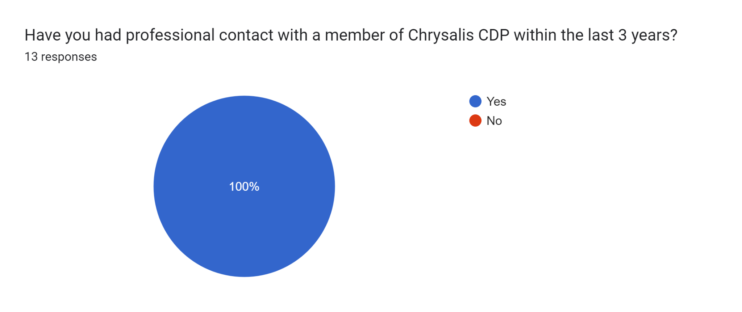

QUESTION 2: Which organisation(s) were you employed by/involved with at the time of your contact with Chrysalis?
TYPE: Open
MANDATORY: Yes
RESPONDENTS: 13
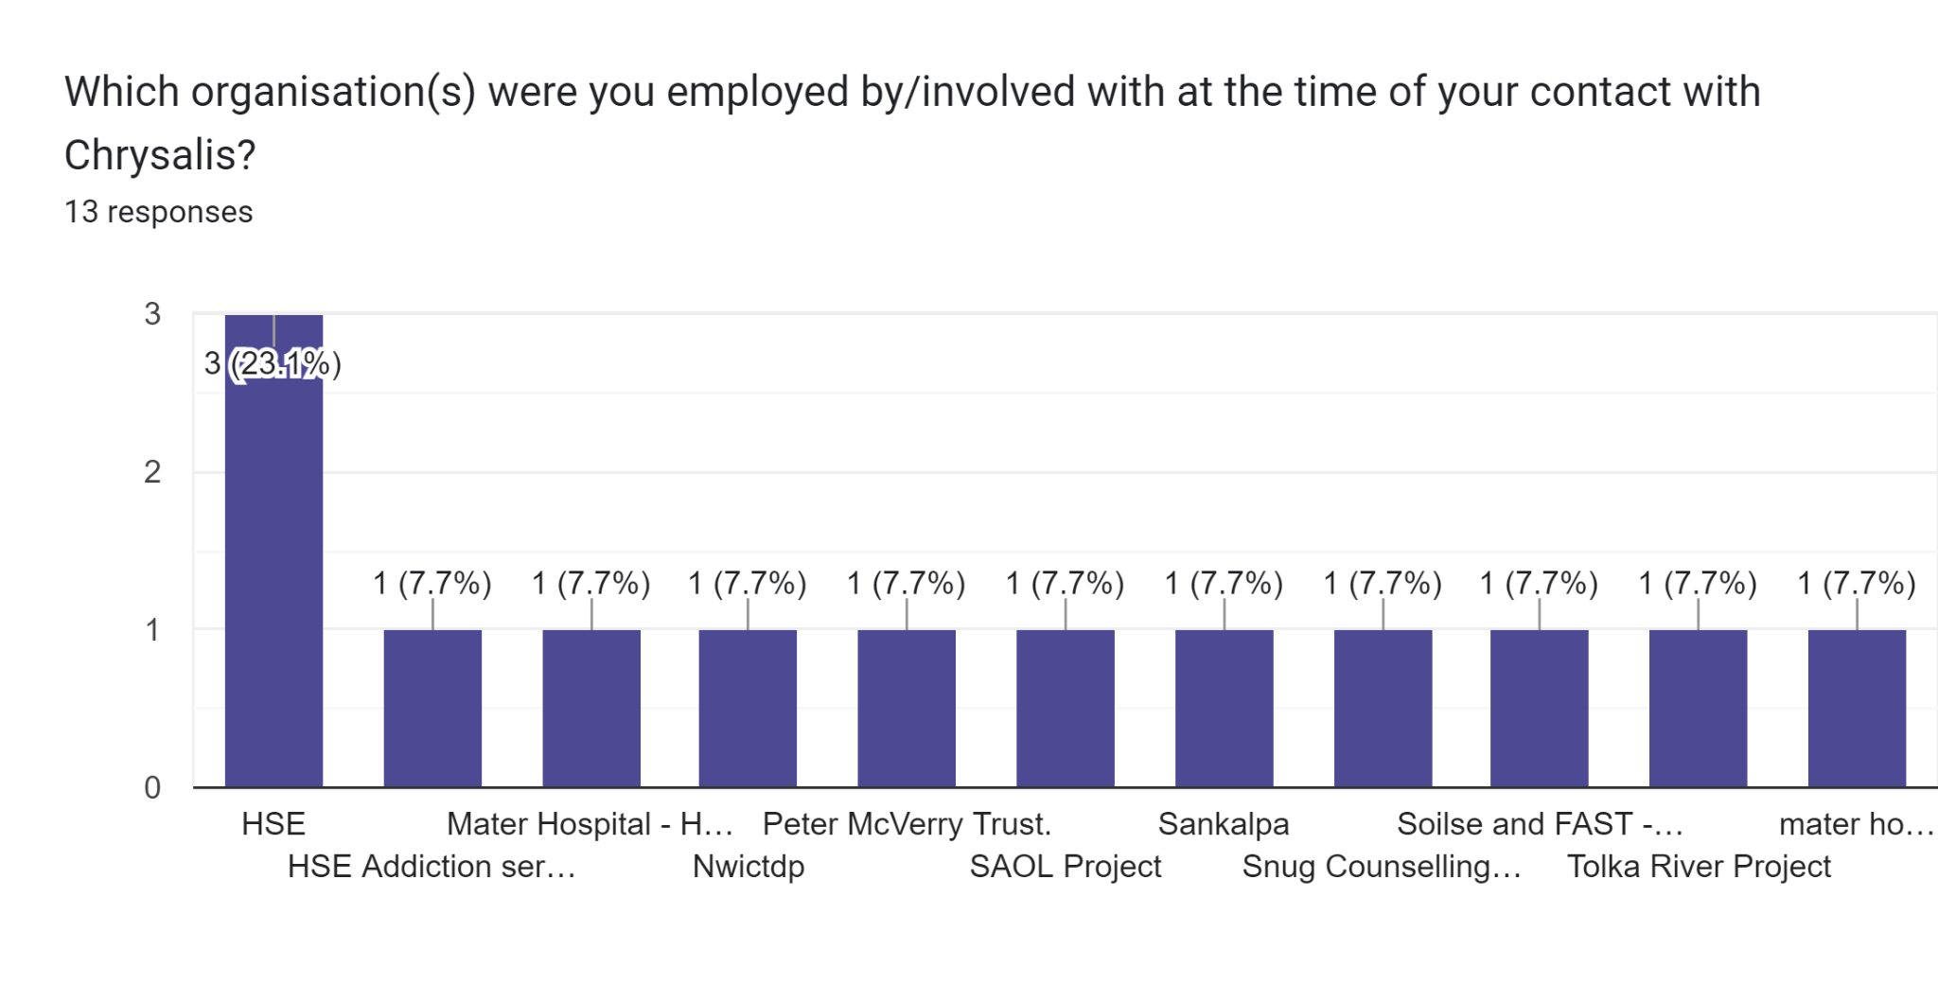

QUESTION 3: Approximately how often have you interacted with a member of the Chrysalis team in a professional capacity over the last 3 years?
TYPE: Multiple Choice
MANDATORY: Yes
RESPONDENTS: 13
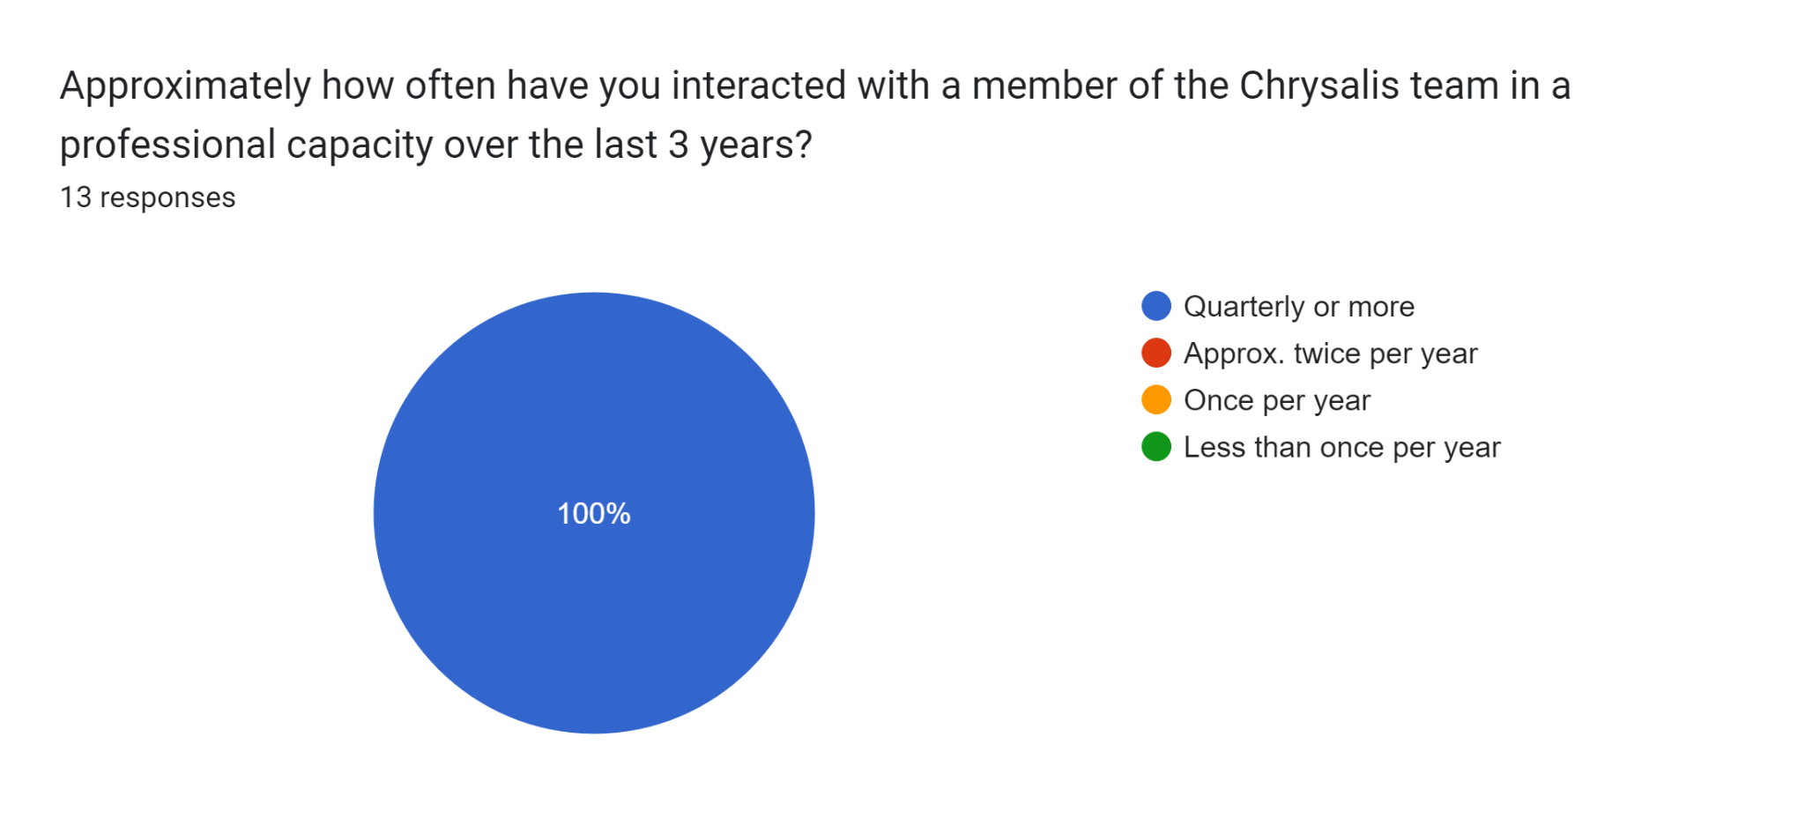

QUESTION 4: How would you rate your familiarity with the services provided by Chrysalis CDP?
TYPE: Linear Scale
MANDATORY: Yes
RESPONDENTS: 13
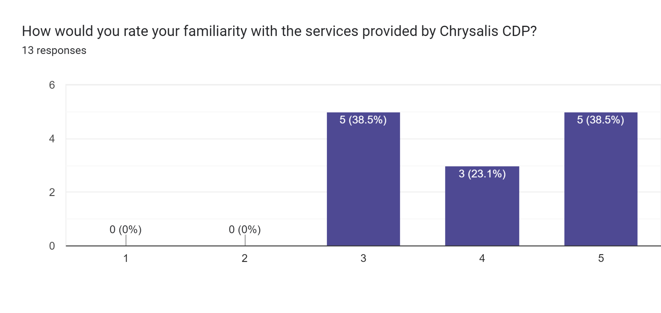

QUESTION 5: Please, in general terms, explain the nature of your professional relationship with Chrysalis.
TYPE: Long-answer
MANDATORY: Yes
RESPONDENTS: 13
Professional, excellent staff to deal with
As a referral pathway or if someone was struggling socially in early recovery
hospital discharges, keyworker access and support for the homeless
Referral agent, Other professional day -day work
Send referrals for key working and case management for patients on discharge. Chrysalis team support patients links to healthcare OPD’s and collateral with the person's consent
Case managers form Chrysalis are part of the multidisciplinary team in City Clinic
Referrals both ways
Referring participants from Peter McVerry Trust for Chrysalis.
Referral to case managers
Employed as nurse in Addiction services
Counsellor in another service in the same area
we refer people from our service to Chrysalis and we accept referrals from your service
Funder

QUESTION 6: How would you rate the communication skills of the Chrysalis team member(s) you corresponded with? (Clarity, promptness, responsiveness, etc)
TYPE: Linear Scale
MANDATORY: Yes
RESPONDENTS: 13
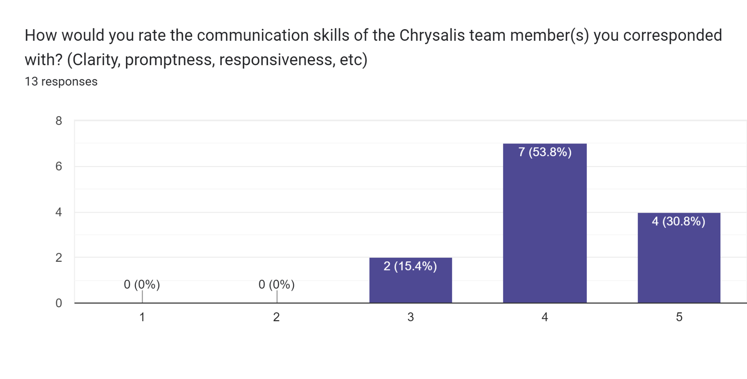

QUESTION 7: Please rate your level of agreement with the following statements
TYPE: Multiple-choice Grid
MANDATORY: Yes
RESPONDENTS: 13
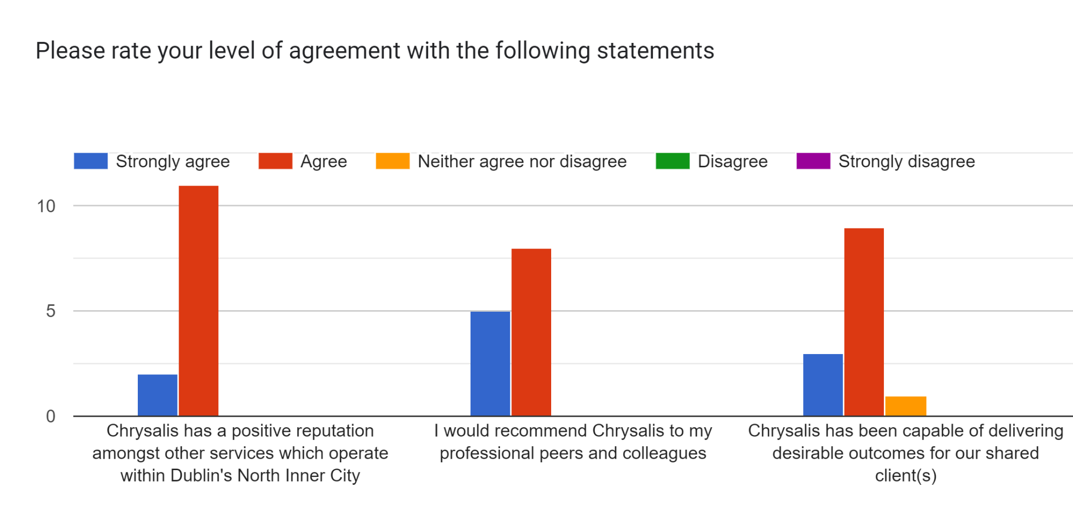

QUESTION 8: In your professional experience, how would you rate Chrysalis' ability to provide relevant supports to its service users?
TYPE: Linear Scale
MANDATORY: Yes
RESPONDENTS: 13
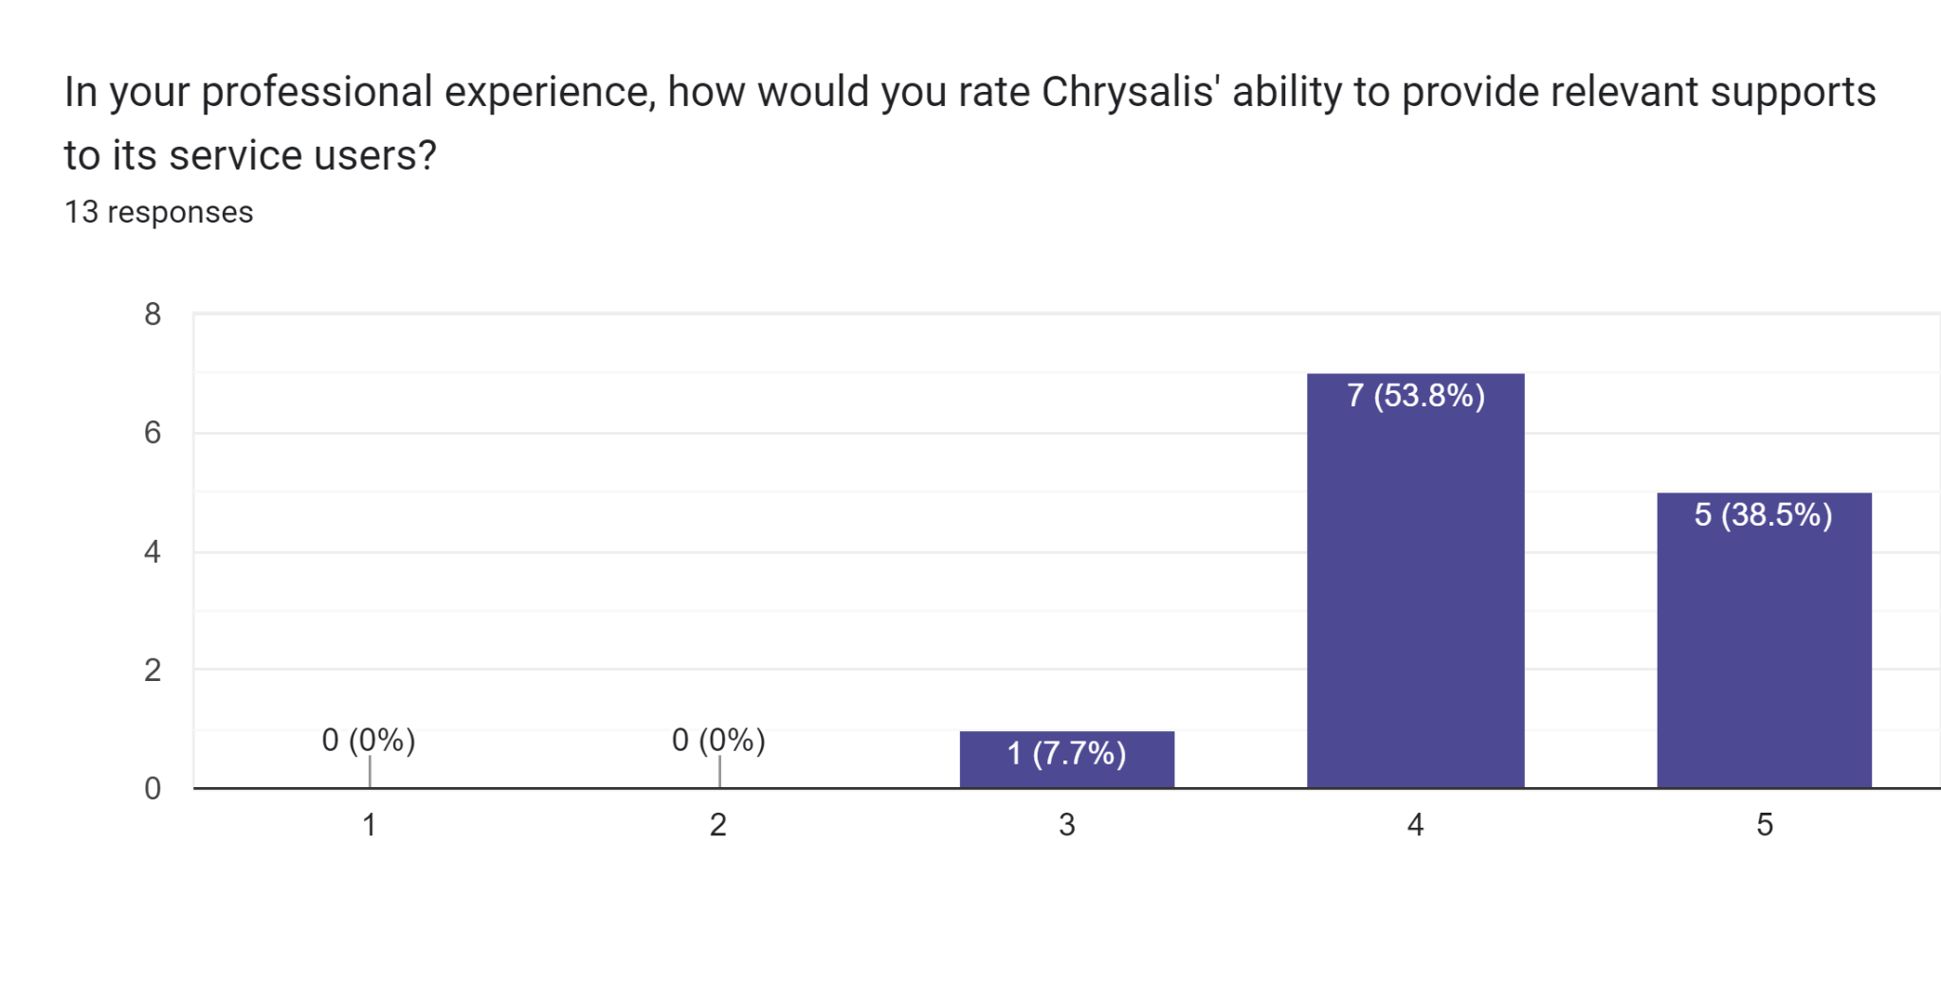

QUESTION 9: How satisfied were you with Chrysalis' handling of relevant personal information pertaining to your shared client(s)?
TYPE: Linear Scale
MANDATORY: Yes
RESPONDENTS: 13
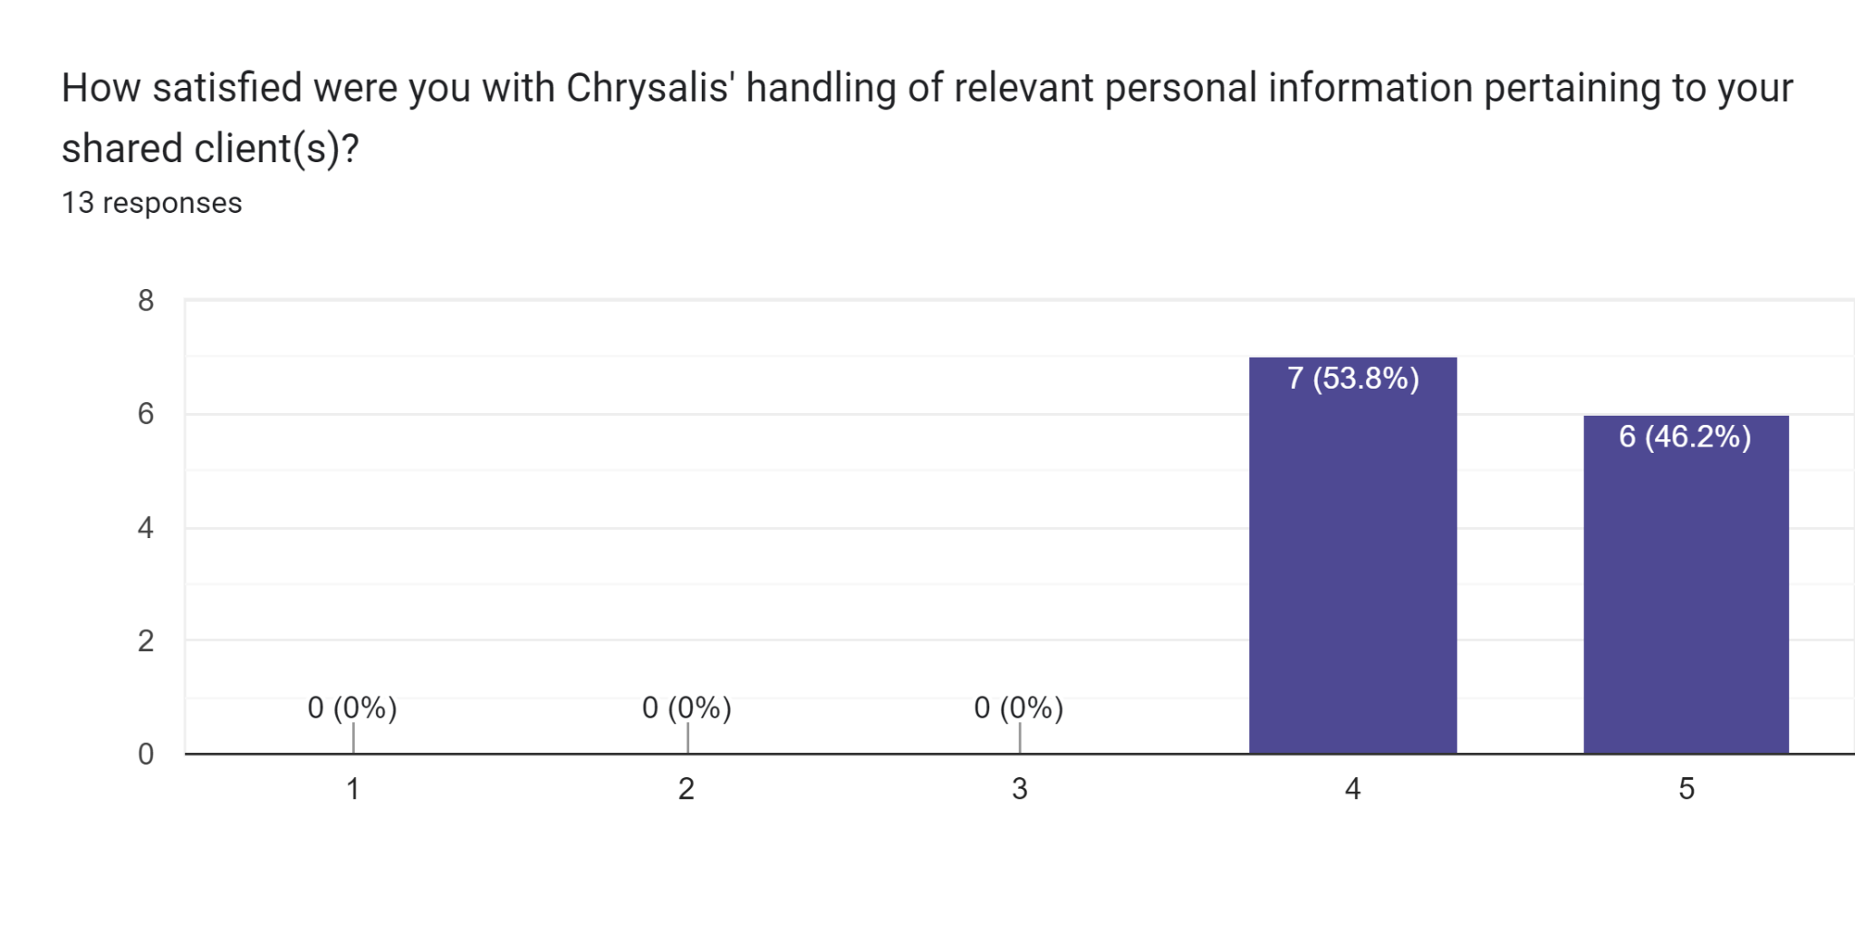

QUESTION 10: In your experience, have you found that members of the Chrysalis team are suitably trained to achieve the desired outcomes for your shared clients?
TYPE: Multiple Choice
MANDATORY: Yes
RESPONDENTS: 13
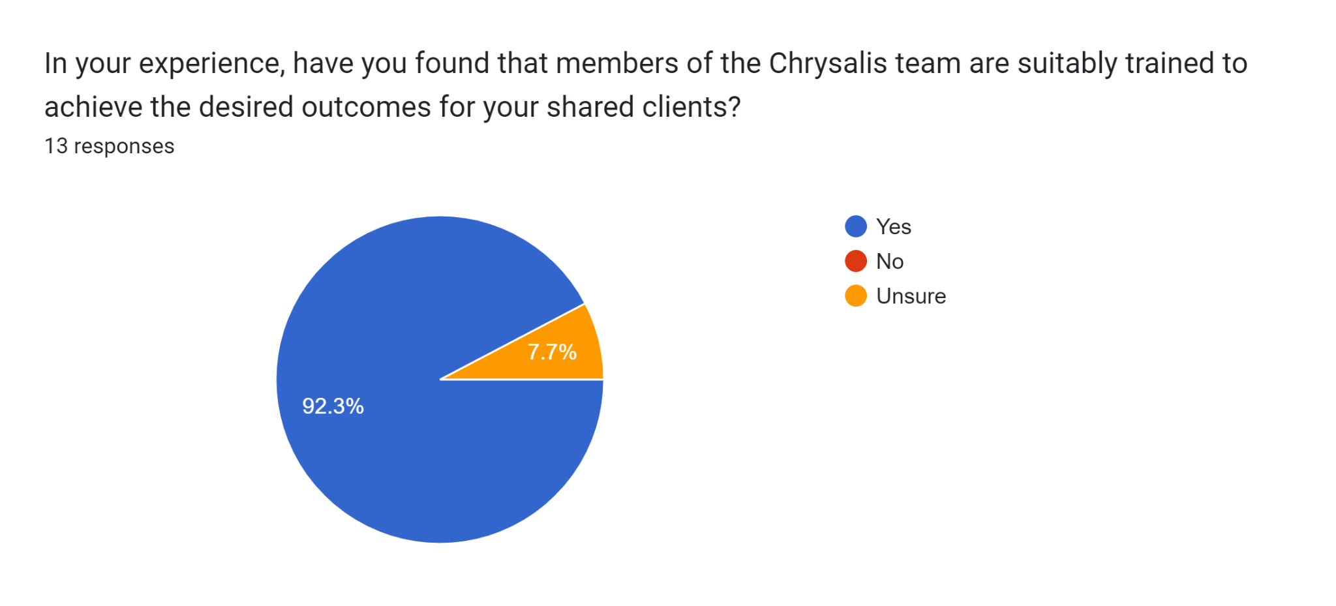

QUESTION 11: Please indicate how much improvement Chrysalis requires in the following areas:
TYPE: Multiple-choice Grid
MANDATORY: Yes
RESPONDENTS: 13
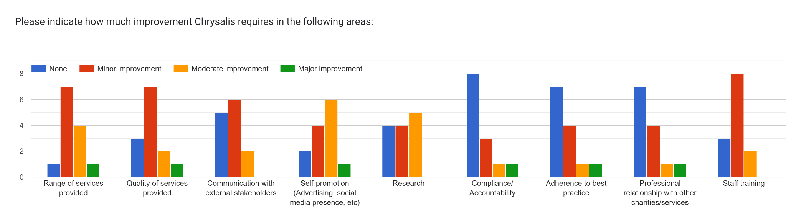

QUESTION 12: Besides Service Provision, Compliance and Duty of Care, are there any other areas that Chrysalis should prioritise improving over the 2023-25 period in your view?
TYPE: Long-answer
MANDATORY: No
RESPONDENTS: 8 (3 invalid)
No
More clarity on the range of services offered.
more recovery centred, creating pathways from addiction to recovery for all
accessibility to hostels, in reach service
It would be great to be able to provide in reach visits to hard-to-reach groups during hospital admission to begin to establish relationships to be continued on discharge
no

QUESTION 13: Any additional comments or feedback?
TYPE: Long-answer text
MANDATORY: No
best of luck
Chrysalis may need to Define themselves and what they provide to whom, as their new roles D1 managed by Chrysalis has confused who Chrysalis are in my opinion.
Keep up the great work - the team are a huge support to our patients and MMUH team
None
Sometimes responses to queries have been slow to come back, but they always do. Staff very efficient when engaged. Well done.
no
Chrysalis is a valuable service in the area

